Governors Report – Summer 2023
Computing
Matthew Ferris-Rice
Achievements
During this academic year computing has continued to be taught both in discrete computing lessons alongside computing foci within dimensions topics. In this academic year we had the opportunity to restart some of our trips to the apple store. Two classes had the opportunity to attend coding sessions at the Apple store. These trips had been suspended due to the Covid pandemic, but restarted during the summer term. By keeping good relations with staff we aim to book trips for all classes next year. I have also updated the basic skills certificates in order to make these more accessible to all pupils of all ages and stages throughout the school. This data has been captured at regular intervals throughout the year and pupils have been given certificates to show their progression.
CPD
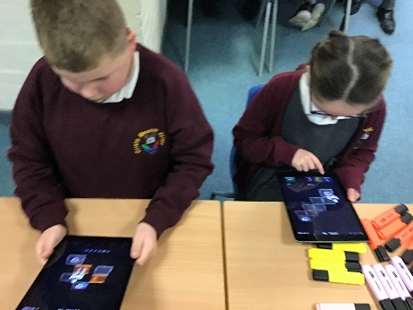
This year I have again taken part in the School Improvement Liverpool Primary Computing subject leader meetings each term. As a result of the pandemic these courses have moved to online sessions permanently. This has given the providers the opportunity to have a range of guest speakers, who have been able to highlight national and regional updates within the subject. A major strength of these being online is that the courses are recorded and shared, which allows for these to be watched again in order to ensure all information provided can be analysed in order to explore how these could be implemented within our setting.
Also within this year I have worked closely with new teaching staff in order to help them identify appropriate lesson foci as well as software appropriate within their classes. I engaged them in peer teaching and informal lessons observations, in order to provide them ongoing support. In addition to this I have worked with staff members around the school on a one to one basis, whenever they have required support with all things computing related.
Quality of teaching and learning
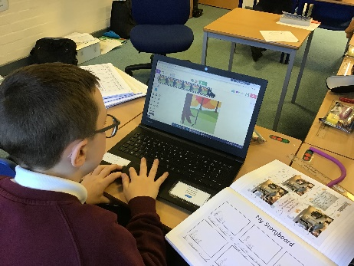
As the leader of computing within Orrets Meadow I have continued to monitor and review the quality of teaching within my subject. Throughout the year I carried out an initial staff survey focusing on a broad range of computing strands and terminology. The result of this was extremely positive with the majority of staff feeling confident in both their knowledge of the curriculum, as well as delivering this. Some staff members where uncertain about particular terminology pertaining to online safety risk, i.e. phishing, malware, etc. I distributed a purple mash resource defining these online safety risks and discussed these with the relevant staff.
With a focus on online safety I also lead an assembly for pupils to consolidate their learning within class about how we stay safe online, pegi rating and what to do in a range of situations. I remained involved throughout the year with pupils around the school, in the form of pupil voices. These were completed at the end of the autumn and spring terms in order to assess pupils developing knowledge and overall enjoyment of the subject. I’m pleased to report that after the first term 95% of pupils reported that they enjoyed their lessons; this increased to 100% by the end of the spring term. Pupils were also more able to derive lesson content from general time spent on the computers, as well as being more aware of how they could get help during their lessons (almost half of them now list their friends which shows an increase in peer support an mentoring).
A record of teaching and learning has become more consistent throughout each class and the computing scrapbooks have continued to be used in order to show high levels of pupil engagement, creativity in lessons, as well as a range of unplugged and plugged activities. These books are becoming more consistent with the intended learning from the lessons being displayed within the books.
I had several opportunities throughout the year to visit classes around the school throughout discrete computing lessons, as well as computing lessons within dimensions. I completed learning walks and found an extremely consistent approach throughout the school. There were high levels of engagement, clear learning goals and a range of technology being used.

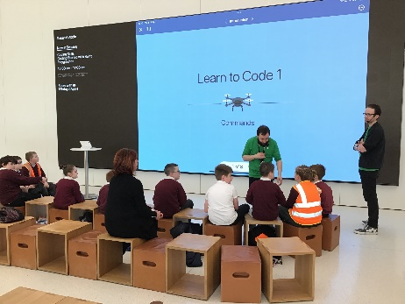
Strengths
The development of the use of computing scrapbooks has helped me as a lead to evidence the fantastic learning opportunities our pupils receive, but as an extra positive it has helped pupils to reflect and discuss on what they have been able to learn and achieve throughout the year. I am also extremely pleased to report that computing has continued to be a well-loved subject this year and pupils have remained highly engaged. A key underpinning of this is the staffs’ willingness to engage with new ideas and expertly implement these within their lessons. It has been brilliant to witness the ongoing development of computing throughout the school, especially how unplugged activities and computational thinking is being made accessible to all pupils. The library has had a range of computing focused books added this year and a literacy spine has been developed for computing.
Having discrete teaching of computing throughout the year has been extremely beneficial for pupils; they are not only exciting, engaging and allow children to build on their abilities as end users, but they enable pupils to focus on developing their basic digital literacy skills. The teaching of computing is extremely varied at Orrets Meadow as the teachers are extremely adept at differentiating all lessons in order to meet the range of abilities within their class as well as look for opportunities to engage in cross curricular learning and enhance pupils’ capital culture through the median of technology.

Ways forward
Focus | Action Required | Intended Completion
Continue to monitor and analyse computing certificate data. | - Collect and analyse basic skills certificate data on a termly basis.  - Give staff intended dates for data collection. | September 2023  December 2023  March 2024  July 2024
Incorporate the use of more hardware throughout each strand of the computing curriculum. | - Review and audit the current hardware within the school.  - Explore connections with the Wirral computing hub in order to loan microbits for class use. | Ongoing throughout the year
Educational visits to the apple store. | - Remain in contact with the apple store for opportunities.  - Explore the new booking system for 23/24 in order to explore cross curricular sessions. | Ongoing throughout the year
Review and promote the computing literacy spine. | - Review the books currently on the computing literacy spine in order to ensure they are placed most effectively.  - Encourage staff to share these texts with pupils. | Ongoing throughout the year

