 | RA 029B Contingency Plan v3 17th August 2021 | RISK ASSESSMENT  RECORDING FORM

Location or School  Address: Orrets Meadow | Date assessment  Undertaken Insert date | Assessment undertaken.  by: Jeanne Fairbrother and C Duncan
Activity or  situation Contingency Plan School opening | Review  date: Weekly review or as appropriate for the activity | Signature: C Duncan

Background information

Contingency Plan School opening COVID 19 v3 17th August 2021

The DfE Contingency framework: education & childcare settings guidance was updated 17th August 2021. The contingency framework describes the principles of managing local outbreaks of Coronavirus (COVID-19) (including responding to variants of concern) in education and childcare settings, covering:
- the types of measures that settings should be prepared for
- who can recommend these measures and where
- when measures should be lifted
- how decisions are made
DfE guidance states that schools should have an ‘outbreak management plan’, this is the same as the contingency plan outlining how they would operate if any of the measures described in the document were recommended for their setting or area. It clearly states what a good contingency plan should cover:
• roles and responsibilities
• when and how to seek public health advice
• details on the types of control measures you might be asked to put in place

For each control measure you should include:
• actions you would take to put it in place quickly.
• how you would ensure every child, pupil or student receives the quantity and quality of education and support to which they are normally entitled.
• how you would communicate changes to children, pupils, students, parents, carers and staff.
See page 9 Guidance: Contingency framework: education and childcare settings
This risk assessment applies to:
- primary schools
- secondary schools (including sixth forms)
- special schools, special post-16 providers and alternative provision
- 16 to 19 academies
- infant, junior, middle, upper schools
Please note that this risk assessment has been created in line with the current government guidance. It contains sample control measures that fit with the system of controls contained in Government guidance. One size does not fit all, and schools should make this model risk assessment their own and reflect specifics of what they are doing and any local guidance, particularly from local HPT’s in line with DfE expectations.

Control measures in purple indicate different measures are in place for different settings. Please choose the setting that applies and delete the others to make this reflect your school/setting:
- All settings
- Early years
- Primary schools
- Secondary Schools & post 16 settings
- Special schools
- Wraparound and out of school providers

Legislation and guidance
Health and Safety at Work Act etc. 1974
Management of H&S at Work Regulations 1999
Workplace (Health, Safety and Welfare) Regulations 1992
DfE Actions for schools plus associated COVID 19 Guidance
Public Health England Guidance

1) Hazard / Activity | 2) Who can be harmed and how? | 3) What controls exist to reduce the risk?  Have you followed the hierarchy of controls (eliminate, substitute etc)? | Risk Score  Consequence  X Likelihood | 4) Any further action.  This should be included in the action plan (5), below
Collaboration with local authorities during localised outbreak of COVID 19 cases  All settings unless indicated | Staff, pupils, visitors, contractors increased risk of transmission of COVID 19 | - Local authorities, directors of public health (DsPH) and PHE health protection teams (HPT’s) are responsible for managing localised outbreaks.  - School liaises and responds to guidance from DsPH& local HPT’s | 3X2=6
Failure to assess the risks of COVID 19 transmission in school.  All settings unless indicated | Staff, pupils, visitors, contractors increased risk of transmission of COVID 19 | - School has assessed the reasonably foreseeable risks of transmission of COVID 19. See RA 029A School opening COVID 19 v2 Aug 2021  - The risk assessment is regularly reviewed as circumstances in school and the public health advice changes.  - School monitors whether the controls in place are effective and working as intended. | 3X2=6
Failing to have adequate outbreak management plans to allow for stepping measures up and down.  All settings unless indicated | Staff, pupils, visitors, contractors increased risk of transmission of COVID 19 | - School has RA 029A School opening COVID 19 v2 Aug 2021  risk assessment for following the latest guidance.  - School has this contingency plan risk assessment with measures it will use if staff or pupils test positive for COVID 19 or, to step measures up or down, if required by local DsPH in the event of a local outbreak. | 3X2=6
Communication  All settings unless indicated | Staff, pupils, visitors, contractors increased risk of transmission of COVID 19 | - School will communicate its plan for addressing any imposed restrictions with parents, staff, pupils and other relevant parties regarding:  - opening arrangements.  - access for specific targeted groups where applicable, such as certain year groups, vulnerable pupils and children of critical workers.  - any reviews of the school’s protective measures as part of school’s risk assessments.  - any arrangements for remote working  - School will keep all relevant parties up to date with the circumstances of any imposed restrictions and how these affect the school as the situation develops. | 3X2=6
Return to school  All settings unless indicated | Staff, pupils, visitors, contractors increased risk of transmission of COVID 19 | - School recognises that testing is voluntary.  - Where advised to do so by a Director of Public Health and/or the local HPT, the school will encourage staff to undertake LFD tests at home prior to their return to school and/or for a period following their return.  - The headteacher will inform staff, pupils, and parents, prior to the return to school, whether any further restrictions, such as the use of bubbles and face coverings, have been resumed. | 3X2=6
Testing | Staff, pupils, visitors, contractors increased risk of transmission of COVID 19 | All settings  - School contingency plans reflect the possibility of increased use of testing by staff or more frequent testing if advised by local HPT’s.  Secondary schools and FE colleges  Cases identified in the test-on-return period should not trigger extra measures or escalation to the DfE helpline.  - If advised by local HPT’s school/college will reintroduce asymptomatic test sites (ATS) (where they have been stood down).  - If advised by local HPT’s school/college will consider how ATS could be implemented in a way that does not negatively impact the education provided to their pupils and students. | 3X2=6
Thresholds for extra action | Staff, pupils, visitors, contractors increased risk of transmission of COVID 19 | For most education and childcare settings  - School understands the extra action thresholds - whichever of these thresholds is reached first:  • 5 children, pupils, students or staff, who are likely to have mixed closely, test positive for COVID-19 within a 10-day period: or  • 10% of children, pupils, students, or staff who are likely to have mixed closely test positive for COVID-19 within a 10-day period  For special schools, residential settings, and settings that operate with 20 or fewer children, pupils, students, and staff at any one time:  • 2 children, pupils, students, and staff, who are likely to have mixed closely, test positive for COVID-19 within a 10-day period  All settings  - School will seek public health advice if a pupil, student, child or staff member is admitted to hospital with COVID-19. Phone the DfE helpline (0800 046 8687, option 1) or, in line with other local HPT arrangements. (Hospitalisation could indicate increased severity of illness or a new variant of concern.)  - School will work to contain any outbreak by following local HPT’s advice  Insert details of school’s local PH Helpline phone number to contact i.e.  - Cheshire & Merseyside PHE contact 0344 225 0562  - Greater Manchester Health Protection Unit 0844 225 1295  - Wirral schools contact Wirral LA covid helpline 0151 666 3600. Email: covidschoolsupport@wirral.gov.uk | 3X2=6
Identifying contacts | Staff, pupils, visitors, contractors increased risk of transmission of COVID 19 | - If and when outbreaks occur, school will work with their local HPT’s to identify any additional measures to put in place including identifying close contacts.  Identifying a group that is likely to have mixed closely will be different for each setting, but a group will rarely mean a whole setting or year group  Close mixing - examples by setting:  Early years:  - a childminder minding children, including their own  - childminders working together on the same site  - a nursery class  - a friendship group who often play together  - staff and children taking part in the same activity session together  Primary, secondary & special schools  - a form group or subject class  - a friendship group mixing at breaktimes  - a sports team  - a group in an after-school activity  - For boarding schools, this could include:  - staff and children taking part in the same class or activity session together  - children who share the same common space in a boarding house  - children who have slept in the same room or dormitory together  FE colleges  - students and teachers on practical courses that require close hands-on teaching, such as hairdressing and barbering  - students who have played on sports teams together  - students and teachers who have mixed in the same classroom  - For wraparound childcare or out-of-school settings, this could include:  - a private tutor or coach offering one-to-one tuition to a child, or to multiple children at the same time  - staff and children taking part in the same class or activity session together  - children who have slept in the same room or dormitory together | 3X2=6
NEW Positive case - staff  All settings unless indicated | Staff, pupils, visitors, contractors increased risk of transmission of COVID 19 | For all cases relating to staff, please also see the guidance for workplaces: NHS Test and Trace in the workplace  - School will call the Self-Isolation Service Hub on 020 3743 6715 as soon as they are made aware that any of their staff have tested positive.  - If cases amongst staff mean school meets the threshold, described above (see Thresholds for extra action) school will need to provide the 8-digit NHS Test and Trace Account ID (sometimes referred to as a CTAS number) of the person who tested positive, alongside the names of co-workers identified as close contacts. This will ensure that all workplace contacts are registered with NHS Test and Trace and can receive the necessary public health advice. | 3X2=6
NEW Actions to consider once a threshold is reached  All settings unless indicated | Staff, pupils, visitors, contractors increased risk of transmission of COVID 19 | - If school reaches a threshold for extra action (See Thresholds for extra action above) school will:  - contact local the DfE helpline & HPT  - review and reinforce the testing, hygiene and ventilation measures already in place. And will consider:  - whether any activities could take place outdoors, including exercise, assemblies, or classes  - ways to improve ventilation indoors, where this would not significantly impact thermal comfort  - one-off enhanced cleaning focussing on touch points and any shared equipment. | 3X2=6
Face coverings | Staff, pupils, visitors, contractors increased risk of transmission of COVID 19 | In all cases any educational and wellbeing drawbacks in the recommended use of face coverings should be balanced with the benefits in managing transmission.  Early years settings and primary schools  Children of primary school age and early years children should not be advised to wear face coverings.  - Face coverings may be reintroduced in communal areas and classrooms for members of staff.  - School/setting may be required to reintroduce the use of bubbles in order to resume social distancing and limit the transmission of coronavirus.  - School/setting will adhere to any conditions set out by the local HPT. | 3X2=6
Re-introduce Shielding - CEV staff & pupils, pregnant staff  All settings unless indicated | Staff, pupils, visitors, contractors increased risk of transmission of COVID 19 | - School is aware that shielding is currently paused and will only be reintroduced by national government in the event of a major outbreak or VoC that poses a significant risk to individuals on the shielded patient list (SPL)  - Settings outbreak management plan covers this possibility  - Shielding would be considered in addition to other measures to address the residual risk to staff on the SPL, once the wider interventions are taken into account.  - All identified CEV & pregnant staff have individual risk assessments detailing the measures the setting has put in place to reduce risks to these staff, including how these protective measures have been reviewed as part of an updated workplace risk assessment. | 3X2=6
Education workforce | Staff, pupils, visitors, contractors increased risk of transmission of COVID 19 | - School contingency plans include details if it is appropriate for some staff to work remotely if restrictions are imposed. | 3X2=6
Transport  All settings unless indicated | Staff, pupils, visitors, contractors increased risk of transmission of COVID 19 | In the event of having to increase measures:  - school will encourage staff & pupils to walk or cycle wherever possible and to avoid public transport.  - If needing to use public transport, they are required to wear a face covering while travelling, unless exempt.  - If directed, pupils and staff may also need to resume mandatory wearing of face coverings on dedicated school transport unless they are exempt.  - Transport services to and from the school will continue to operate as normal during times of local restriction where pupils are still attending.  - If transport cannot operate as normal, school will consider alternative options and communicate these to all parents and pupils in advance. | 3X2=6
Residential educational visits  All settings unless indicated | Staff, pupils, visitors, contractors increased risk of transmission of COVID 19 | - All visits are risk assessed and include current local restrictions.  - School will consider carefully if the educational visit is still appropriate and safe.  - Only pupils who are attending the setting will go on an educational visit. | 3X2=6
School failing to plan:  - Open days  - Transition & taster days  - Parental attendance  - Performances  All settings unless indicated | Staff, pupils, visitors, contractors increased risk of transmission of COVID 19 | - All such events are risk assessed and include current local restrictions.  - School will consider carefully if the event is still appropriate and safe.  - Meetings will go on zoom if required. | 3X2=6
Attendance restrictions - increased COVID infections | Staff, pupils, visitors, contractors increased risk of transmission of COVID 19 | High quality face-to-face education remains a government priority. Attendance restrictions would only ever be considered as a short-term measure and as a last resort:  - for an individual setting following local HPT advice when other measures have not broken chains of transmission  - across an area following government advice  - School contingency plans cover the possibility that if advised, temporarily, to limit attendance high quality remote education is provided to all pupils or students not attending.  - School will continue to give priority to vulnerable children and young people and children of critical workers to attend school undertaking their normal timetables.  - School contingency plans cover measures that include attendance restrictions, and if the DfE advises on any other groups that should be prioritised. | 3X2=6
Food provision  All settings unless indicated | Staff, pupils, visitors, contractors increased risk of transmission of COVID 19 | - School will provide meal options for all pupils who are attending.  - FSM or food parcels to eligible pupils who are not attending school, where they:  - are self-isolating.  - have had symptoms or have tested positive.  - are not attending due to the implementation of local restrictions advised by local PHE teams. | 3X2=6
Safeguarding  All settings unless indicated | Staff, pupils, visitors, contractors increased risk of transmission of COVID 19 | - School will review the child protection policy so that it reflects the local restrictions and remains effective.  Insert specific measures that will be utilised. | 3X2=6
Vulnerable pupils & young people | Staff, pupils, visitors, contractors increased risk of transmission of COVID 199392 | - Where vulnerable children and young people are absent, school will work with the local authority and social worker (where applicable), to explore the reason for absence and discuss their concern.  Insert specific measures that will be utilised. | 3X2=6
Teaching & learning  All settings unless indicated | Staff, pupils, visitors, contractors increased risk of transmission of COVID 19 | - High-quality remote learning will be provided for all pupils and students if:  - they have tested positive for COVID-19 but are well enough to learn from home; or  - attendance at the setting has been temporarily restricted  - On-site provision is retained for vulnerable children and young people and the children of critical workers.  - If school has to temporarily stop onsite provision on advice of the local HPT, the school contingency plans include alternative arrangements for vulnerable children and young people | 3X2=6

Risk Rating | Action Required
20 - 25 | Unacceptable – stop activity and make immediate improvements
10 - 16 | Urgent action – take immediate action and stop activity, if necessary, maintain existing controls vigorously
5 - 9 | Action – Improve within specific timescales
3 - 4 | Monitor – but look to improve at review or if there is a significant change
1 - 2 | Acceptable – no further action but ensure controls are maintained & reviewed
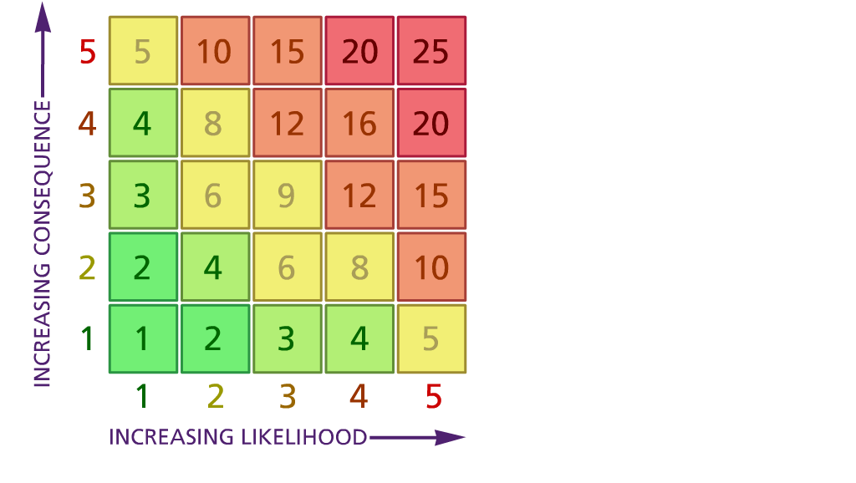

(1) List hazards something with the potential to cause harm here
(2) List groups of people who are especially at risk from the significant hazards which you have identified
- List existing controls here or note where the information may be found. Then try to quantify the level of risk the likelihood of harm arising that remains when the existing controls are in place based on the number of persons affected, how often they are exposed to the hazard and the severity of any consequence. Use this column to list the controls that you might take and develop all or some of that list into a workable action plan. Have regard for the level of risk, the cost of any action and the benefit you expect to gain. Agree the action plan with your team leader and make a note of it overleaf. If it is agreed that no further action is to be taken this too should be noted.
Likelihood: Consequence

5 – Very likely 5 – Catastrophic

4 – Likely 4 – Major
3 – Fairly likely 3 – Moderate

2 – Unlikely 2 – Minor

1 – Very unlikely 1 – Insignificant

 | 5. Action plan | Responsible | Completed
1
2
3
4
5

