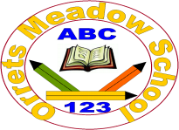

These are the members of our Governing Body

Name | Type of Governor | Specialist Governor
Mr I Patten - Chair | Co-opted Governor | Literacy & Attendance
Mrs C Cooper – Vice Chair | Co-opted Governor | Safeguarding, LAC, H&S & Numeracy
Mrs C McGowan | LA Governor
Mrs L Paul | Co-opted Governor
Mr M Ferris | Staff Governor
Mrs C Griffiths | Parent Governor | SMSC
Ms B Owen | Co-opted Governor
Mr K Jones | Parent Governor

All Governors can be contacted via the Clerk to Governors, Mrs J Santangeli at Orrets Meadow School.
No Governor is related to any member of staff.
Currently no Governor is on another schools Governing Body

