Governor Report- Summer 2023
Music
Charlotte O’Brien
Achievements
At the beginning of the year all children took part in a Musical Monday Body Percussion afternoon. Each class listened to a song, created body percussion rhythms and patterns and performed their creations for their class. The children had the opportunity to work through the four strands of musical learning on a short project.
All teachers, supported by TAs, continue to contribute video evidence of their children’s achievements in music to demonstrate progression across the music curriculum. We are building up a video collection that demonstrates the progress children make in Music at Orrets Meadow.
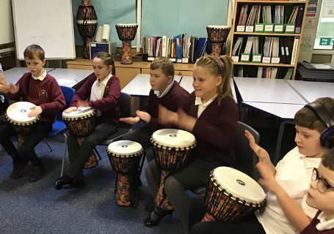
In the Autumn Term I created ‘Music Progression at Orrets Meadow’ drawing together, the Dimensions Curriculum, Edsential Music Progression of Skills and Development Matters into a single document. This new document will ensure that teachers can back track objectives to adapt their planning and meet the needs of their class as well as assess the children progress more accurately.
During the Spring Term Tigers and Foxes enjoyed the First Access Drumming Project. Through our links with Edsential Music Hub we received 10 weeks tuition from Sharon Thomas a Music Specialist, who led African Drumming with the classes. They celebrated their work with a Drumming Showcase for the parents and the school. The project proved a hit with the children’s and was mentioned frequently in the pupil surveys.
In the Summer Term I had the opportunity to work with the School Council. We explored the music we love then the children completed a gap task to find out music loved by their class. We then created a ‘Top Ten School Play List’ for the hall which can be used at Friday Lunchtime and in Friday Celebration Assembly and enjoyed by the school.
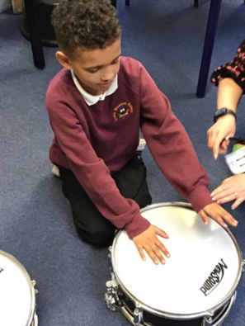
During June Year 5 children attended the KS1 Concert at the Liverpool Philharmonic Hall to enhance their curriculum. The children loved listening to a live orchestra and singing a shared song with a large group of people.
In the wider curriculum the children enjoyed listening to Jewish Songs and singing with Eric Cohen who visited school during Religion Week to share his faith with the children and brought his guitar. In the summer term, a group of children attended the ‘Around the World Wirral Schools Dance Festival’ at the Floral Pavilion to perform a choreographed dance for a large audience of their peers, family and friends.
In Cultural Week children explored Music from different cultures and eras using resources from Classroom200. In PSHE Week children all had the opportunity to explore Music and Mindfulness and make links between their emotions and music using BBC Mood boosters amongst other resources.
Over the year children have accessed a wide range of songs and music from across the world via the Dimensions curriculum. Book scrutiny and lesson observations show progress across the school that meets the objectives of the National Curriculum.

CPD
- Musical Monday Briefing 21/9/22
Prior to the Musical Monday afternoon on 2/10/22, staff took part in training to develop knowledge and ideas bout Body Percussion and musical vocabulary. They performed body percussion for ‘Happy’ by Pharrel Williams and considered the breaking down the afternoon for their class to create a body percussion performance of a chosen class song.
2. Edsential Music Hub- Music Leads Update 24/11/22
I attended the Music Subject Leaders Music Hub Meeting in November. It was a valuable chance to speak to other Music Leads and make contact with Music Leaders in other Special Schools in the area. We were given updates on music developments over the last year, spent time looking at ‘The Power of Music to Change Lives’ (June2022) and discuss its implications for school. It was reassuring to speak to others schools and develop a clearer understanding of how our music offer compares to other schools.
- Gabby Crolla- Preparing for Ofsted 2/11/22
With the assistance of Gabby Crolla we took a deep dive into our subjects and discussed the Intent, Implementation and Impact of our Curriculums on the children’s progression of skills and knowledge in our subject.
- Music Update Staff Meeting 8/2/23
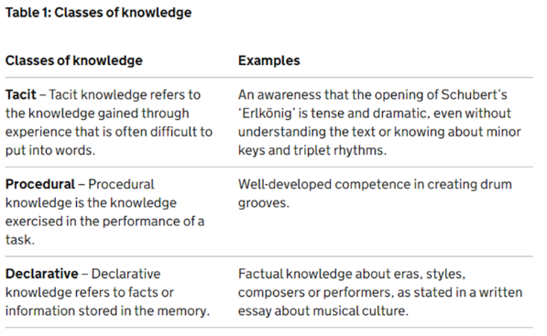
In Spring Term I led an update about Music at Orrets Meadow. Staff considered the value of Music in the curriculum, looked at current research in musical teaching and how it should inform their teaching and current Ofsted advice to SEND practitioners.
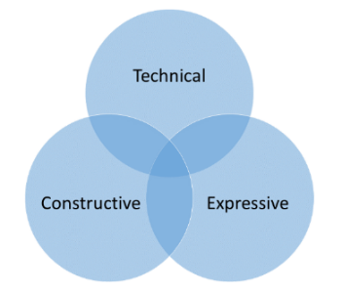

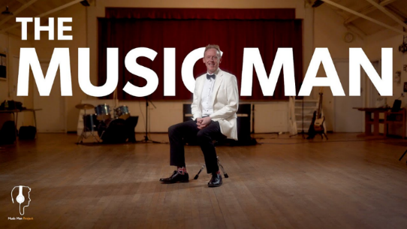
The staff all had the chance to review The Sound of Intent and The Music Man resources free to use online.
- Music Mark- Ofsted Update on Music in Schools 24/3/23
Via Zoom I attended an Ofsted update about music in school.
- Music Progression at Orrets Meadow
All teachers have participated and reviewed the new document ‘Music Progression at Orrets Meadow’ created to support teachers back-tracking and adjusting their planning and teaching to meet the needs of the children.
- Music Mark- Aurora Orchestra- The Magical Toy Box 24/4/23
Via Zoom I attended an introduction to the Aurora Orchestra and what they have to enhance our curriculum.

Quality of teaching and learning
To monitor the quality of teaching and learning in Music, a Music Leader’s file is kept updated. All the relevant policies and documents are kept in one central place. The Dimensions Curriculum has been reviewed to ensure the objectives from the national curriculum are met. An audit of musical instruments available for composition and performance in school is shared with all staff. The music policy has been updated to include suggestions from the Model Music Curriculum.
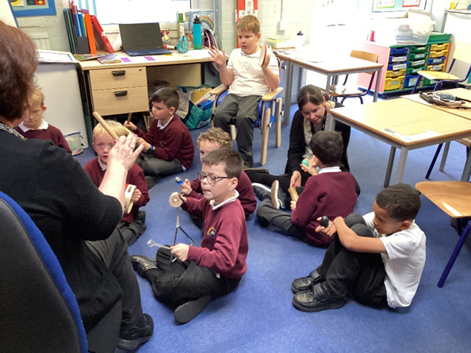
This year’s Children’s Music Survey showed that Music is a popular subject across school with 82% of children saying they like Music a lot. The Teachers Surveys showed that they are all confident in teaching music in their classrooms and enjoy delivering the wide variety of music genres and eras. The Teachers have requested we buy in Charanga to support music teaching and learning and have find more musicians to visit school.
During the Musical Monday afternoon in the Autumn Term, I was able to conduct a Learning Walk to observe music being taught through out school. It was delightful to see the range activities going on adapted to the ages and stages of the classes. Progression of skill was clearly evident in the activities being accessed and achievements made by the children in these sessions.
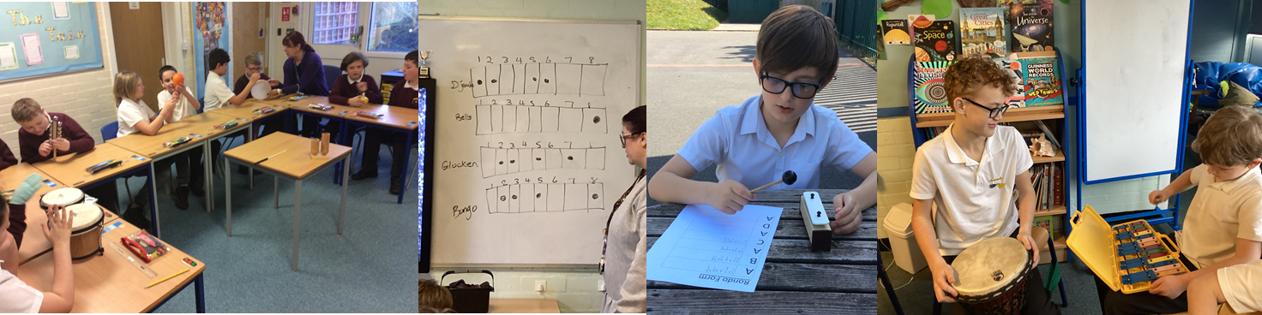
Strengths
- Robust curriculum that meets all the demands of the National Curriculum and beyond.
- Confident, enthusiastic teachers who adapt the curriculum to meet the needs of their pupils.
- Wide range of multisensory resources to support skill development across the school.
Ways forward
- Investigate Charanga to supplement teaching and learning in Music.
- Investigate Music Therapy to enhance our Music Provision.
- Explore the possibility of visiting musicians.

Targets 2023-2024
- Organise a ‘Musical Monday’ afternoon. (Autumn 2023)
- Explore purchasing Charanga to support teaching and learning (Autumn 2023)
- Increase and update Instrument Inventory (September 2023)
- Investigate how Music Therapy could support our curriculum (Autumn 2023)
- Develop Pre-Curriculum Steps for Music based on Sounds of Intent (Autumn 2023)
- Liaise with ST at Edsential to organise ‘First Access Drumming Project’ (Spring 2024)
- Staff Meeting- Using Charanga to enhance Teaching and Learning in Music (Spring 2023)
- Continue to support Music for Mindfulness and Music from different cultures. (Spring and Summer 2024)
- Update the Music Offer (Summer 2024)
- Update the Music Listening spine (Summer 2024)

