Governors Report – Summer 2022
Computing
Matthew Ferris-Rice
Achievements
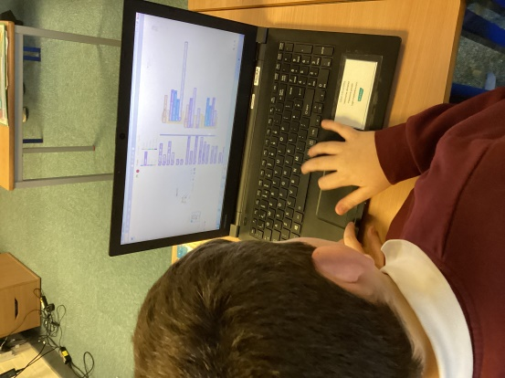
During this academic year computing has continued to be taught both in discrete computing lessons alongside computing foci within dimensions topics. Throughout the year pupils have benefitted from the improvement in online communication worldwide over the previous years, this has allowed pupils to talk to guests from various places around the world. I have worked closely with staff this year in order to offer support with software that is unfamiliar and especially to collect evidence of their incredible computing lessons for our class scrapbooks. There have been some extremely creative scrapbooks, which show consistent evidence and a range of tasks, but most importantly a high level of enjoyment and engagement from pupils throughout the year.

CPD
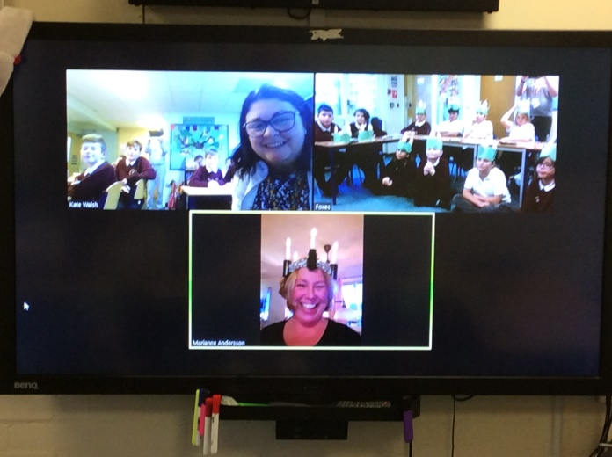
Throughout this academic year I have again taken part in the School Improvement Liverpool Primary Computing subject leader meetings each term. These courses continue to be delivered online, which has led to a wider range of subject leaders regionally being able to join. These have continued to be extremely informative and a further added advantage of online delivery is that there are guest speakers from other schools as well as leading companies within the field. These have been invaluable at signposting resources and sharing good practice.
As part of my ongoing efforts to provide support and offer CPD to staff at Orrets Meadow I led a staff meeting in January focusing on unplugged activities. This was to introduce staff to developing pupils as computational thinkers with tasks away from devices. This in turn will help pupils to have a deeper understanding and problem solving skills within debugging. Whilst completing a book scrutiny of class scrapbooks I was encouraged to see a vast display of unplugged activities being used to introduce pupils to new concepts. I have continued to provide support to all members of staff in order to develop each person as a competent and confident user of technology.
Quality of teaching learning
As the computing subject leader, I have completed a range of activities to oversee computing this year. During the autumn term, I conducted a pupil survey in order ascertain pupils enjoyment of computing as a subject, what they had learnt previously that had helped them within their computing lessons and how aware they were of ways that they could stay safe whilst online. The results of this were very encouraging as 80% of the pupils asked enjoyed every computing lesson. Most pupils were able to identify a trusted adult they could speak to if they felt unsafe online. During this first term I also worked closely with staff in order to share good practice with respects to class scrapbooks and collecting evidence. I also lead an e-safety coffee morning in order to further engage and support parents with their children’s experiences and development with technology.
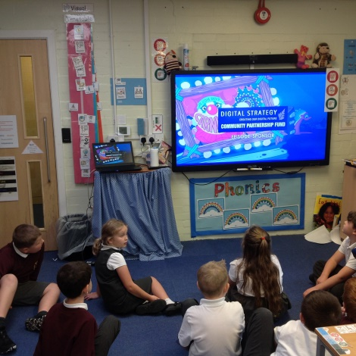
In the spring term, I again asked pupils for their opinions on computing during our second block of discrete computing lessons. During this pupil survey 90% of those asked expressed that they enjoyed all of their computing lessons. Pupils were a lot more engaged within discussions on this occasion and were able to discuss what they had been learning, what they enjoyed and specific programmes they had been using within their learning. An extremely positive within computing was more pupils, especially those in some of the older classes, are starting to ask for peer support in order to solve problems they face within computing. I also completed a staff survey in order to ensure that staff felt confident progressing pupils throughout computing. This also gave staff a chance to express any support they felt they needed in relation to a range of software.
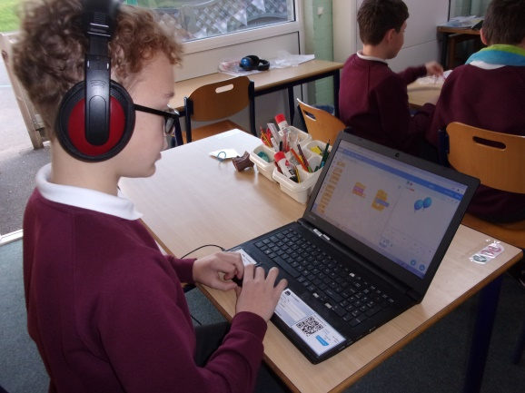
In the summer term, I had the opportunity to be more present within computing lessons and I carried out a learning walk of computing lessons, both within discrete lessons and dimensions lessons. This was a very positive experience as it highlighted the range of needs throughout the school and how well staff cater to these, whilst still providing a level of challenge. I was also fortunate to observe a full lesson, which again highlighted pupils enjoyment of computing, unplugged activities and a good range of tasks to support and challenge. After the completion of our final block of discrete computing lessons I completed a book scrutiny of class scrapbooks and found that they were highly engaging and showed a wide array of creative tasks in order to engage pupils within computing. Unfortunately due to ongoing restrictions we have not been able to visit the apple store this year for their educational visits, however we are looking forward to these restarting next year.

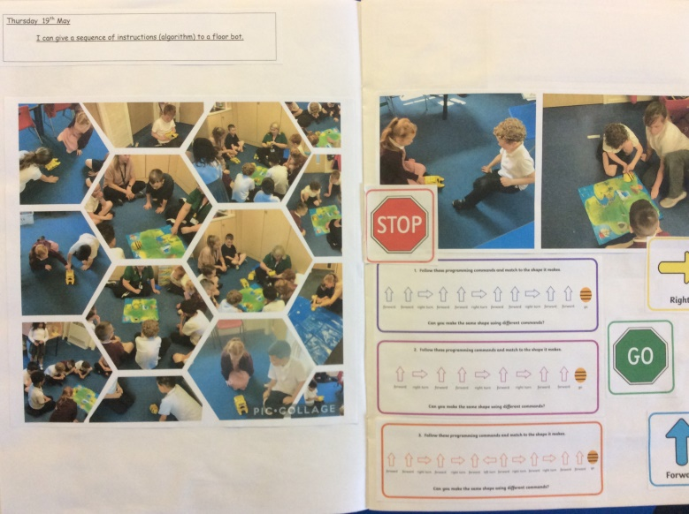
Strengths
Computing has continued to be a well-loved and subject this year and pupils have remained highly engaged. A key underpinning of this is the staffs’ willingness to engage with new ideas and expertly implement these within their lessons. It has been brilliant to see from the book scrutinies and learning walks that I have conducted how computing is delivered across the school, especially how unplugged activities and computational thinking is being made accessible to all kids. Having discrete teaching of computing throughout the year has been extremely beneficial for pupils; they are not only exciting, engaging and allow children to build on their abilities as end users, but they enable pupils to focus on developing their basic digital literacy skills. The teaching of computing is extremely varied at Orrets Meadow as the teachers are extremely adept at differentiating all lessons in order to meet the range of abilities within their class as well as look for opportunities to engage in cross curricular learning and enhance pupils’ capital culture through the median of technology.

Ways forward
Focus | Action Required | Intended Completion
Review the basic skills certificate system. | - Review the basic skills targets to ensure that e-safety is prominent within all levels.  - Update certificates in order to match basic skills targets. | Autumn 1 2022
Develop a more consistent process to capture this data. | - Collect and analyse basic skills certificate data on a termly basis.  - Give staff intended dates for data collection. | September 2022  December 2022  March 2023  July 2023
Research and develop further opportunities for formative assessment. | - Explore barefoot computing and purple mash as options for formative assessment.  - Engage with other computing subject leaders to better understand current practices at a regional and national level. | Ongoing throughout the year
Educational visits to the apple store. | - Monitor when the apple store is resuming their educational visits programme and organise class visits. | Ongoing throughout the year

