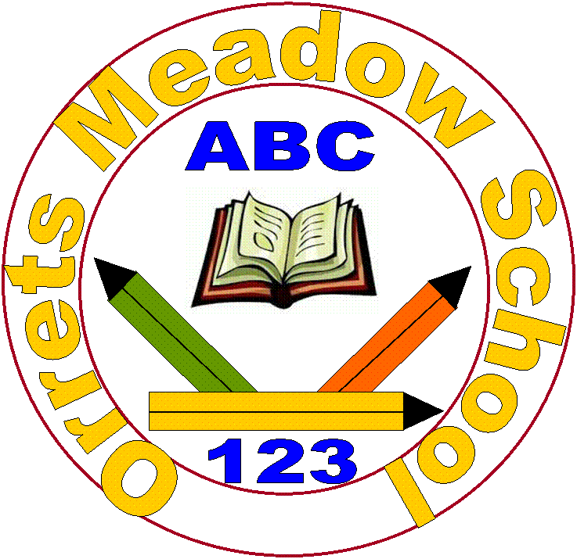
Orrets Meadow School
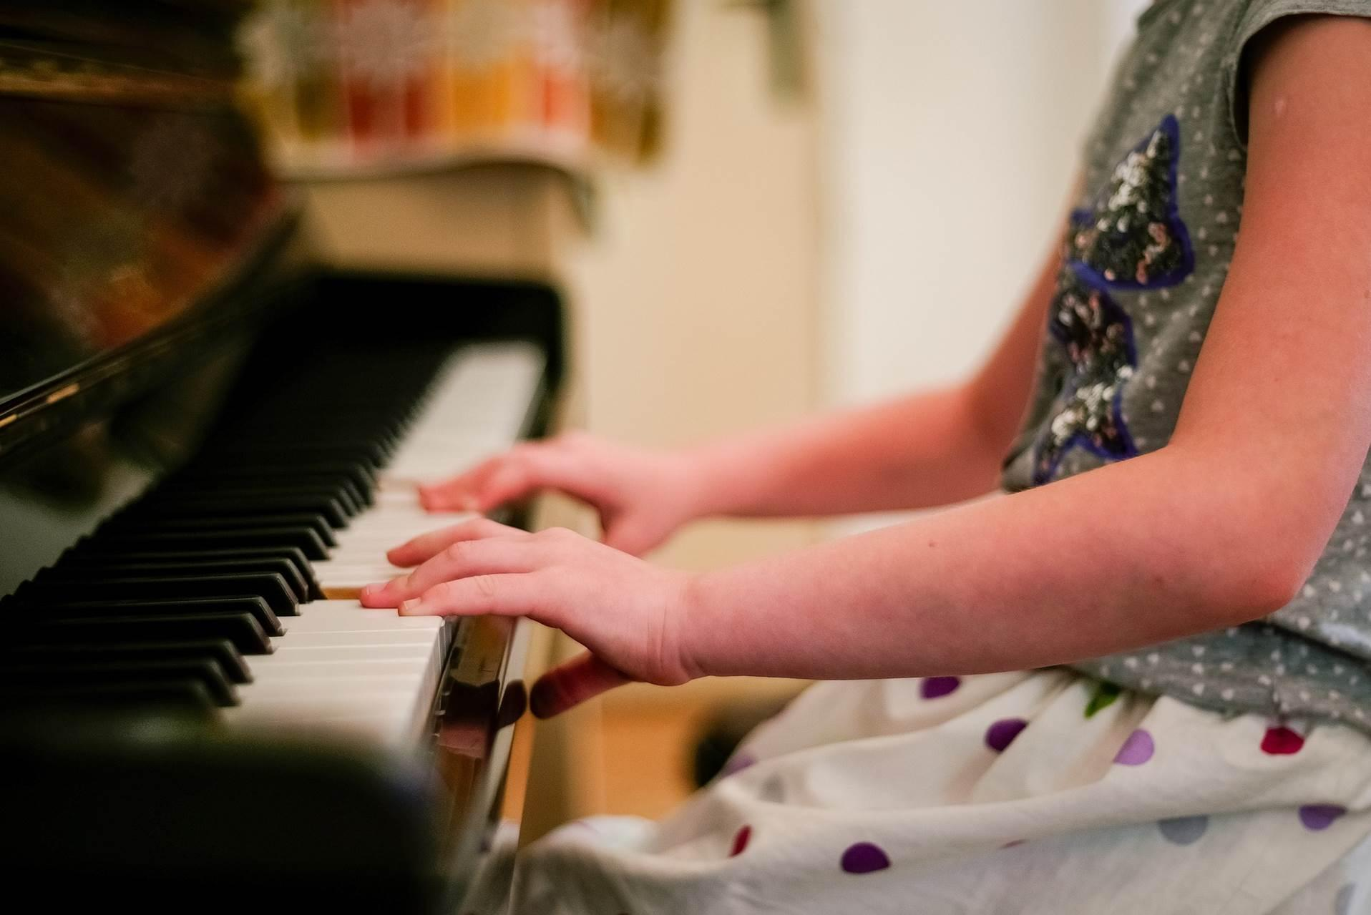
Music Policy

“To raise the aspirations of every child and give them confidence to fulfil their potential through positive experiences”

Orrets Meadow Curriculum Aims and Values

Aims
To ensure all our children are at the centre of a broad, varied and interesting learning experience that is enjoyable and relevant for the future. Our creative, multisensory curriculum will create a sense of awe and wonder and help to inspire a lifelong love of learning. The holistic nature of our practice will promote positive mental health and well-being and will enhance our children’s life skills, social skills and cultural awareness.

Values
Our curriculum will promote a range of values including:
- Respect
- Empathy
- Responsibility
- Equality
- Independence
- Happiness
- Resilience
- Gratitude
- Honesty
- Friendship
Intent
National Curriculum - Music
Purpose of study
Music is a powerful, unique form of communication that can change the way pupils feel, think and act. It transcends different cultures, abilities and generations – stimulating responses on both emotional and intellectual levels. A high-quality music education should engage and inspire pupils to develop a love of music and their talent as musicians, and so increase their self-confidence, creativity and sense of achievement. As pupils progress, they should develop a critical engagement with music, allowing them to compose, and to listen with discrimination to the best in the musical canon.
Aims
The national curriculum for music aims to ensure that all pupils:
♣ Perform, listen to, review and evaluate music across a range of historical periods, genres, styles and traditions, including the works of the great composers and musicians
♣ Learn to sing and to use their voices, to create and compose music on their own and with others, have the opportunity to learn a musical instrument, use technology appropriately and have the opportunity to progress to the next level of musical excellence
♣ Understand and explore how music is created, produced and communicated, including through the inter-related dimensions: pitch, duration, dynamics, tempo, timbre, texture, structure and appropriate musical notations.
In addition, the Model Music Curriculum (MMC) sets out sequences of learning in the following key areas which, when taken together, all contribute towards the steadily increasing development of musicianship:
- Singing
- Listening
- Composing
- Performing/Instrumental Performance
Within each of these areas are some suggested repertoire choices to support teachers in delivering the curriculum and, in the appendices, suggested approaches to demonstrate the way in which musical listening, meaning, performance and composition are linked.
Orrets Meadow’s Curriculum
We teach a Global Curriculum called 'Learning means the World' (LMTW)for all our afternoon subjects. This curriculum is innovative, forward-thinking and highly relevant to our pupils' needs and thoroughly engages them as they tackle challenging and inspiring topics and issues.
LMTW curriculum has been written with world issues in mind and is centred on 4Cs:-
- Communication
- Conflict
- Conservation
- Culture
Why did we choose 'Learning Means the World'?
As a school which is majority white British, we want our pupils to fully embrace cultural diversity, learning about, experiencing and celebrating a range of different cultural and faith heritages.
We believe that communication is key to accessing learning and securing pupils’ future success. As many of our pupils have Speech Language Communication Needs it is essential that opportunities are given to develop language for learning across the curriculum. With one of its 4 foci being on communication, this curriculum provides lots of opportunities for pupils to develop expressing themselves in discussion, debate and presentation, as well as enabling them to collaborate and exchange ideas.
We feel our pupils, as the future generation, need a greater awareness and appreciation of local, national and global conservation issues and initiatives. The need to learn that they have an important role to play in sustainability. This curriculum gives pupils opportunities to grow and develop spiritually, emotionally, physically and socially in the natural world around them. Our commitment to nurturing positive attitudes and values and developing life and social skills is promoted throughout the Learning Means The World (LMTW) curriculum.
It is theme based and broken down into the following phases:
- Explorers (Foundation level)
- Pathfinders (KS1 level)
- Adventurers (Lower KS2 level)
We have the freedom to teach the National Curriculum in line with our pupils' specific needs and believe that our whole curriculum meets the values and aims which our stakeholders requested at the start of the consultation.
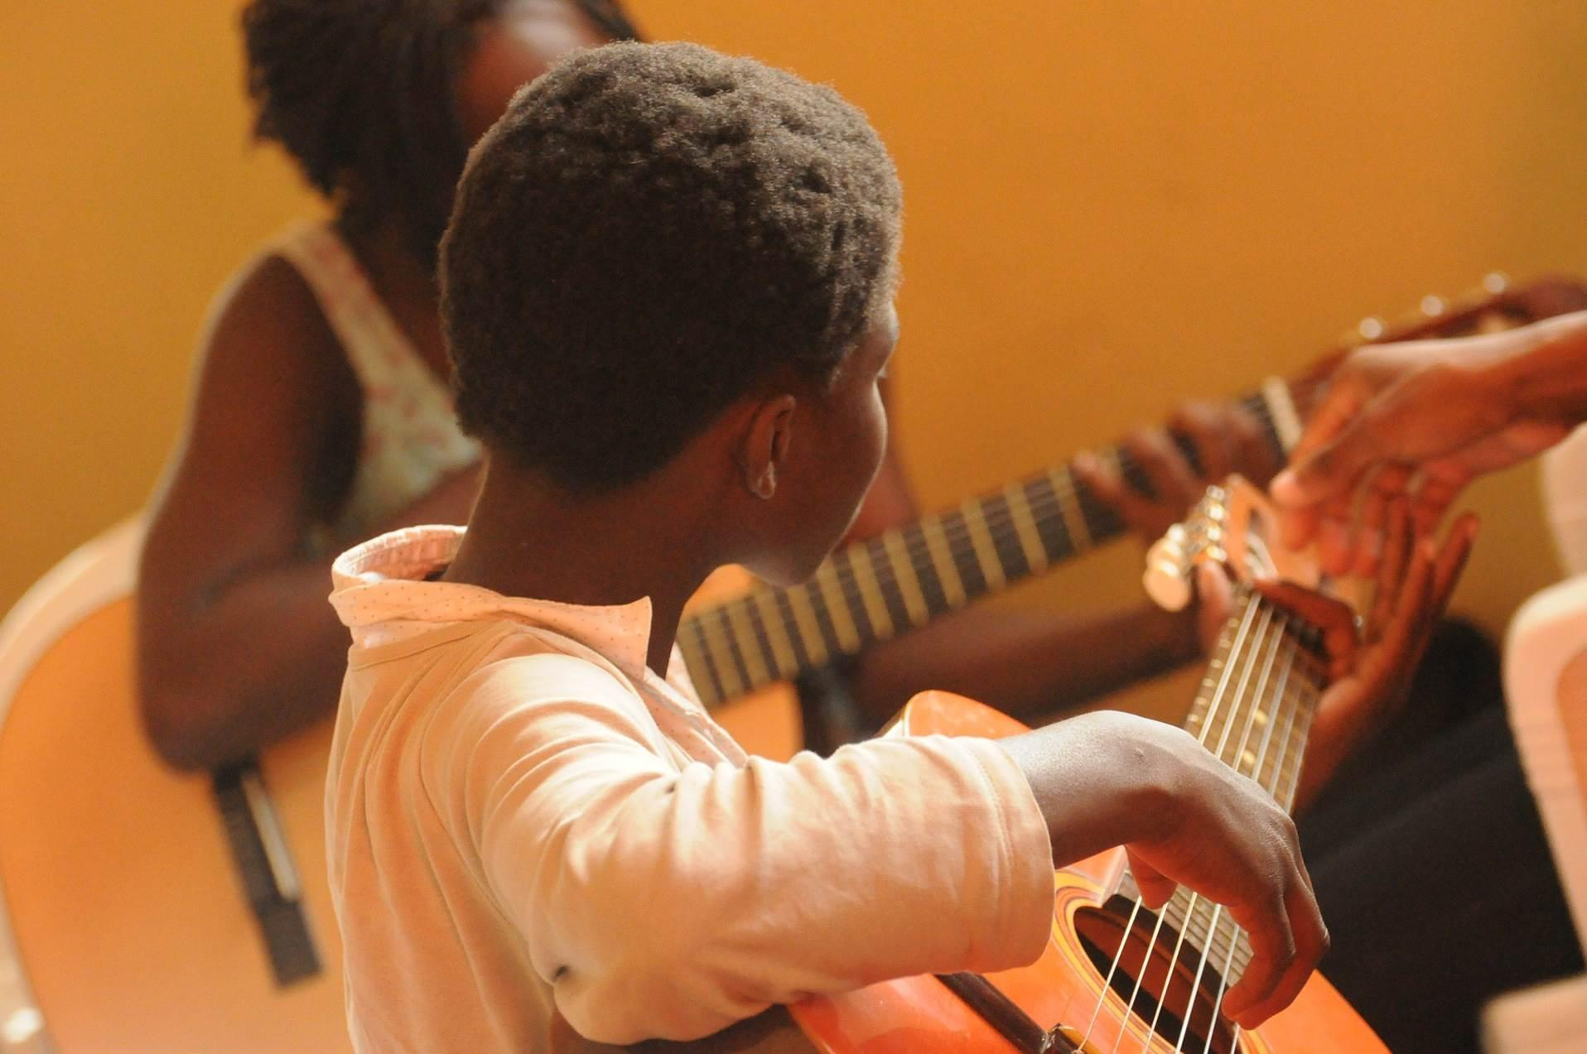

Music increases pupils’ confidence through self-expression and performance, as well as providing a sense of achievement.

Why is Music important?
Through music, we are provided with a powerful universal language which helps promote unity, enables us to process and express our emotions and fuels our imagination.
Music is important in developing individual discipline, focus and memory.

Whether we are singing, playing, or listening, we develop our aural discrimination through music, which is an important part of communication and literacy.
As a universal language,
music enables children to
break down barriers and
enables communication.

Music helps pupils to appreciate and understand a wide range of traditions and cultures.

Implementation
When is Music taught?
Music is taught through thematic units. The attached overview maps out which thematic units feature this subject and the Long-Term Plan clearly shows the progression of skills across the school.
In addition to the Dimensions Curriculum, we will also be launching ‘Musical Monday’ as a blocked afternoon to explore a musical theme using the four strands of music mentioned in the MMC.
Our music provision is further enhanced by musicians visiting the school and a yearly trip out to the Liverpool Philharmonic to be a part of the School Concerts.
How is Music taught?
Music is taught through a combination of subject knowledge and composing, performing, listening and appraising skills. Learning takes place both inside and outside the classroom.
Access to the curriculum
We aim to make an enjoyable learning experience and encourage all children to participate in a wide range of musical activities. Adaptions are frequently made to accommodate the challenging sensory needs of many of our pupils. Specialist items such as noise cancelling headphones and low resonance instruments such as Boom whackers make composition and performance a much less noisy affair for those that prefer it that way.
What do we learn about in Music?
We learn about the following:-
- Notation
- Graphic scores
- Signs and symbols
- Soundscapes
- Sound effects
- Singing
- Sea shanties
- Folk songs
- National anthems
- Slave songs
- Battle chants
- War songs
- Cyclic patterns
- Instrument families
- Evolution of instruments
- African music, including drumming
- Celtic music
- Hannukah music
- Jingles
- Film music
- Musicals
- Inuit throat singing

Who do we learn about in Music?
We learn about a range of famous composers from history, such as J.S. Bach, Ludwig Van Beethoven and Rimsky-Korsakov.
We also learn about more contemporary composers, such as Andrew Lloyd-Webber.

Music allows pupils to
express their feelings and
ideas through
composition and
performance.

Music Topic Overview

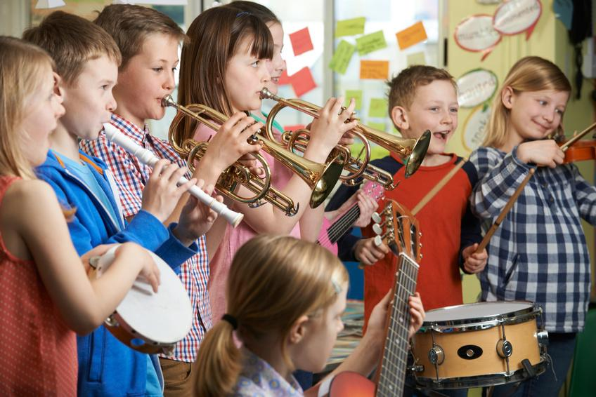
“When words fail, music speaks” Beethoven
Beehoven

Music knowledge builder across the school

Pre-Curriculum Music
Step 3 and 4  (Three and Four Year Olds) | Communication and Language | • Sing a large repertoire of songs.
 | Physical Development | • Use large-muscle movements to wave flags and streamers, paint and make marks.
 | Expressive Arts and Design | • Listen with increased attention to sounds.  • Respond to what they have heard, expressing their thoughts and feelings.  • Remember and sing entire songs.  • Sing the pitch of a tone sung by another person (‘pitch match’).  • Sing the melodic shape (moving melody, such as up and down, down and up) of familiar songs.  • Create their own songs, or improvise a song around one they know.  • Play instruments with increasing control to express their feelings and ideas
Step 5 and 6 (Reception) | Communication and Language | • Listen carefully to rhymes and songs, paying attention to how they sound.  • Learn rhymes, poems and songs
 | Physical Development | • Combine different movements with ease and fluency
 | Expressive Arts and Design | • Explore, use and refine a variety of artistic effects to express their ideas and feelings.  • Return to and build on their previous learning, refining ideas and developing their ability to represent them.  • Create collaboratively, sharing ideas, resources and skills.  • Listen attentively, move to and talk about music, expressing their feelings and responses.  • Sing in a group or on their own, increasingly matching the pitch and following the melody.  • Explore and engage in music making and dance, performing solo or in groups.
Step 7 (ELG) | Expressive Arts and Design  Being Imaginative and Expressive | • Sing a range of well-known nursery rhymes and songs.  • Perform songs, rhymes, poems and stories with others, and (when appropriate) try to move in time with music.

Long Term Plan – Progression of skills

Impact

How do we assess and monitor Music

Music enables children to develop an understanding of culture and history, both in relation to children individually, as well as ethnicities from across the world. Children are able to enjoy music in as many ways as they choose – either as listener, creator or performer. Children have the opportunity to discuss and share their own thoughts, opinions and ideas, acknowledging and respecting that these may vary and that this is positive. They can dissect music and comprehend its parts.

We use Trackzone to measure impact which is an online tracking programme that enables teachers to easily record, monitor and update their assessments in real-time. It makes data analysis at pupil, class and subject level possible, helps identify gaps in learning and any areas for development.

Using a simple grading system of 1-5 (U = Unassessed), teachers are able to make a judgement on each pupil’s progress, taking into account the overall evidence gathered through observation, conversation and examination, using their own professional judgement. Awarding a '4' would indicate a pupil is working at age-related expectation, '5' would be linked to mastery or exceeding expectation and ‘1-3’ would be grades indicative of partial knowledge / achievement.

As many of our pupils have short term memory difficulties, they find retaining knowledge especially difficult, so we use Kahoot quizzes throughout the units to support them remember ‘Sticky Knowledge’. These quizzes make learning fun, engaging and impactful. Teachers can use the readymade quizzes created by Dimensions for each unit or they can create their own to introduce the topic, review and reinforce knowledge and use the information gained to help them identify which objectives have been achieved in Trackzone.

Each child’s average grade (1-5) is collected twice a year for SLT, subject leaders and teachers to gain valuable knowledge on how the child, class and school are working in each subject.

SLT, teachers and subject leaders use assessment for learning to inform planning, teaching and learning and CPD opportunities.

SLT and subject leaders are continuously monitoring their subject to ensure it meets the needs of our pupils. They monitor using a variety of activities, including:

- Learning walks
- Book scrutiny
- Lesson observations
- Pupil survey and discussions
- Staff survey and discussions

We are excited to teach our Learning Means the World curriculum and know it will positively impact on our pupils’ academic and whole well-being.

