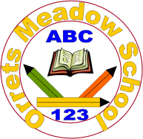
Governors Report – Summer 2022
English
Matthew Ferris-Rice
Achievements
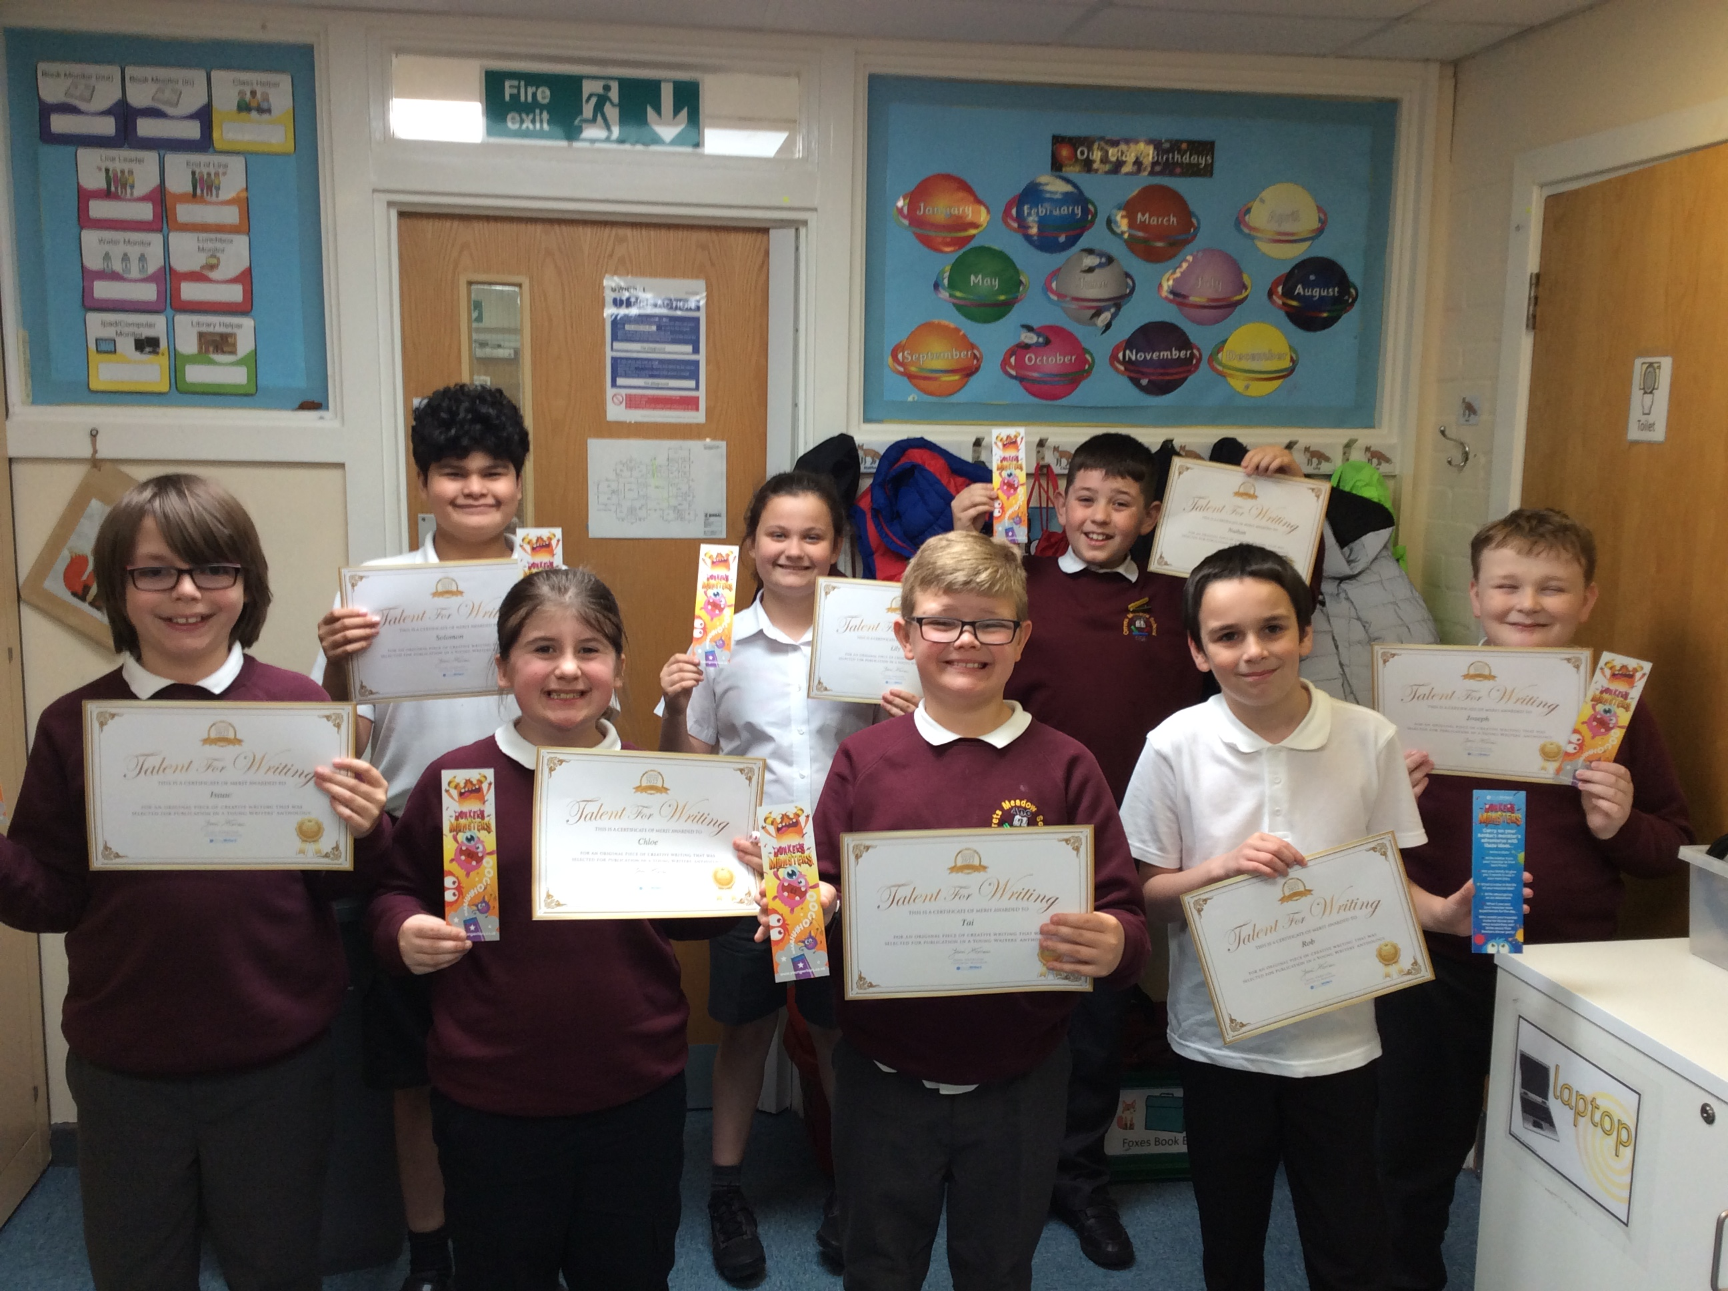Throughout this academic year I have continued to monitor and improve reading for pleasure and the pupils’ exposure to the reading and writing journey at all ages and stages across the school. I have led multiple opportunities in order to develop staff confidence and ability across the English curriculum. Following national guidance on reviews of synthetic phonics programmes (SSP) a main focus of this year has been on updating and developing our Orrets SSP in order to meet these guidelines. There have been some real strengths and highlights throughout the year, most recently a number of our pupils being selected for publication through the young writers’ mini saga competition and both the Owls and Fox classes receiving letters from Clarence House, in response to their letters about the rainforest.
As always through teacher assessments as well as our summative assessment we have been able to capture the continual and accelerated progress of our pupils in both reading and spelling.
CPD
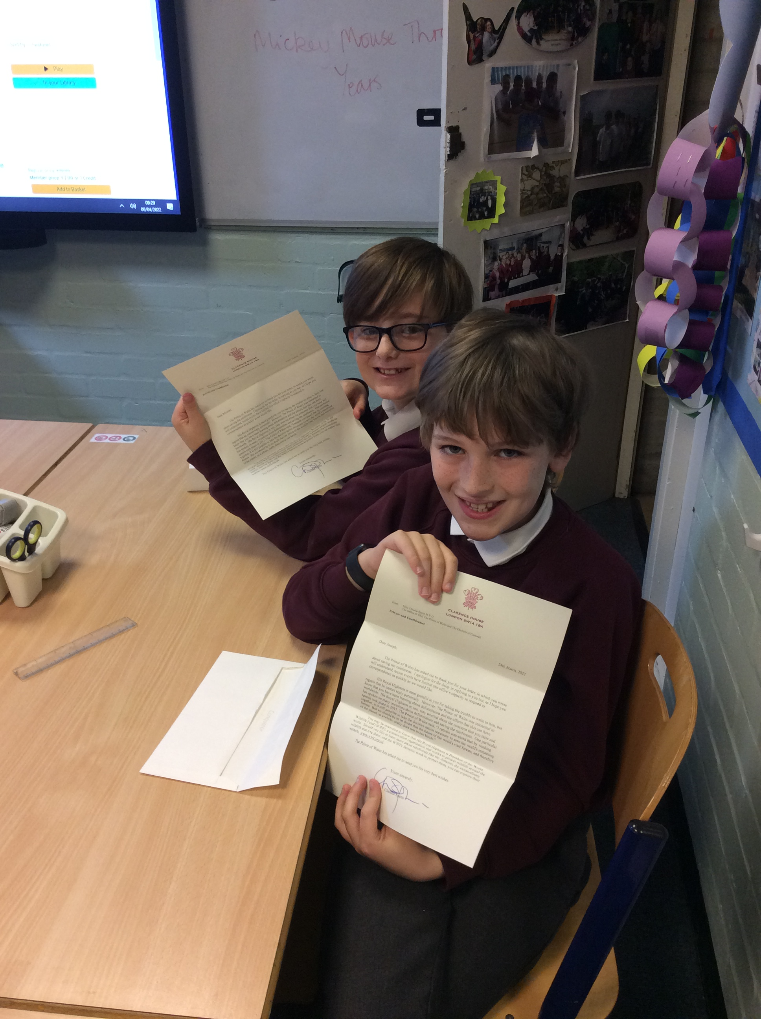This year I have continued to attend English subject leader updates and English moderation cluster meetings through Sarah Squared. The update meetings have been an invaluable source of updating on national changes to the English curriculum and discussing how these can be best implemented within our school. It has provided networking opportunities with other subject leaders in order to share outstanding practice, which again has been used to the benefit of our pupils. During the moderation sessions this year we have focused on the development of the various strands of writing and what these may look like for our pupils. Once this document is finalised it can be shared with staff in order to show progression through these strands.
With a strong focus on further developing the phonetic knowledge of all staff, amongst the other areas of English, I have led several staff meetings this year focusing on phonics, writing and reading. During the first year I arranged for Sarah Tennant (from Sarah Squared) to lead an inset day on phonics focusing mainly on the pure sounds for phonemes as well as developing segmenting and blending skills. These were followed up by another inset day for TAs on specific training for our Orrets programme and several staff meetings with teachers focusing on phonics.
Also during the autumn term, I led a staff meeting focusing on the reading and writing journey throughout the school and how this could be enhanced at all stages. This again was followed up later in the year by English moderation focusing on writing across a range of genres.

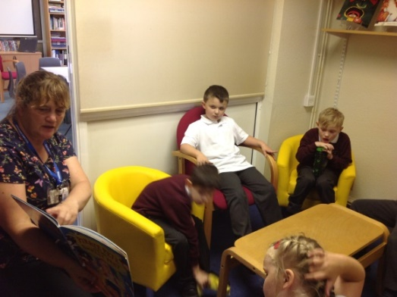
Reading for Pleasure at Orrets Meadow
Library:
Reading for pleasure has continued to grow at Orrets this year. The library has remained popular and is regularly attended by pupils, at least once a week. This is evident in the increased book talk around the school, which highlights pupils’ enjoyment of a range of books and willingness to recommend books to each other. Thanks to the continuing support of friends of Orrets, through the Amazon wish list, we have been able to keep our book stock fresh and exciting for pupils.
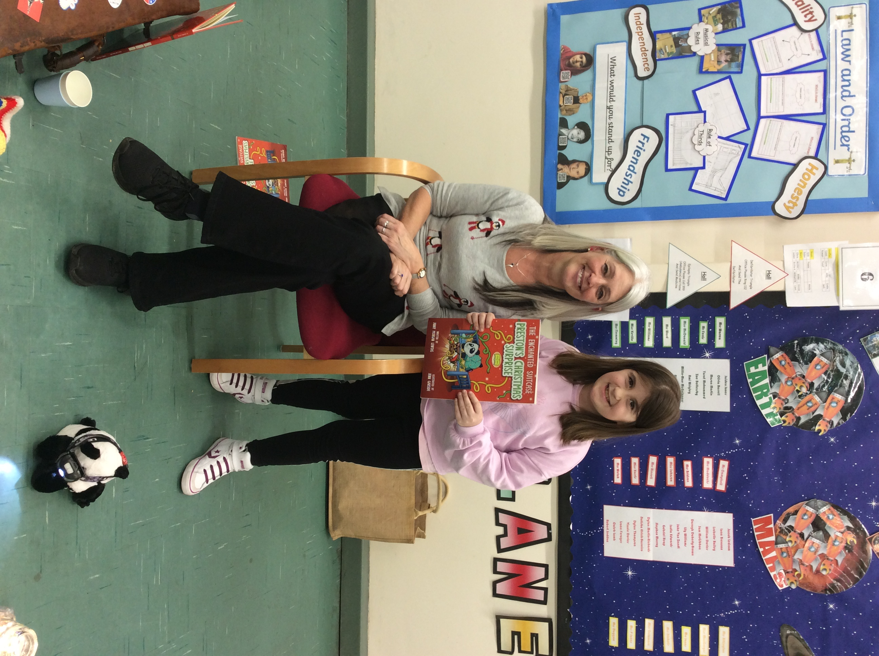Focusing on Authors:
In December we were very lucky to be visited by the author Jinny Morgan Lewtas, who was featured in the Wirral globe. She attended school to read her book Preston’s Christmas Surprise. She held two sessions which were highly engaging and multisensory, which were extremely well received by all pupils. This lead to a real buzz around the school and excitement for reading.
During the year several classes have taken advantage of the increasing number of virtual author visits that have been streamed live straight into the classroom. This has allowed pupils to engage with a diverse range of authors from all over the world. We focused on female authors from around the world during world book day in order to engage pupils in a more diverse range of authors and learn about varying lifestyles globally. There are already many plans for next year to continue to expose pupils to a range of authors.

Quality of teaching learning
As the English lead this year I have again had the opportunity to carry out a range of tasks that have given me greater insight into the workings of our school and allowed me to monitor systems already in place. Following on from the implementation of the reading system last year I have continued to monitor pupils progress through the book bands and after each testing period I have looked for correlations between reading ages, provided from testing and the book bands that the pupil is reading at. These have also been compared to the bug club online book bands that the pupils are reading within. This has shown that books are appropriately paced and targeted both physically and virtually across the school. As well as reading data I continued to use the reading and writing trackers in order monitor national curriculum assessments throughout the year.
Through book scrutinies and learning walks I have been able to observe the outstanding progress that pupils have been making throughout the school. There has been a focus on observing phonics for consistency throughout the year. Alongside these tasks I also ensured that all of the policies for English were updated in order to show current practice.

Phonics:
As previously mentioned phonics has been a main focus throughout this year and I have completed numerous tasks in order to ensure that our programme meets national requirements. These tasks have included:
- Whole school external phonics training (September inset day)
- Developing the teaching progression for phonics by cross referencing
    - Our current programme (updated 2017)
    - The reading framework (July 2021)
    - National Curriculum
    - Several validated phonics schemes
- Teacher consultation staff meeting (10.11.21)
- Developing flash cards unique to our programme, along with context words.
- Further updating after the release of the Reading Framework (January 2022)
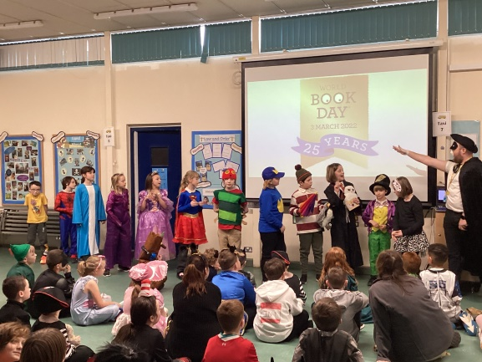
- Developing word banks for each sound, consisting of only sounds that had been taught until that point.
- Consulting governors on the new phonics programme.
- Appointing and meeting with the phonics governor (Beth Hulmes)
- Developing the updated assessment system.
- Embedding common exception words.
- Verifying that the programme would meet criteria stipulated by the government.
- TA phonics inset day
- Staff meetings focusing on phonics.
- Whole school phonics observations and learning walks.
Our phonics scheme is now a robust scheme with embedded CPD that gives advice on phonemes, morphology, etymology and even oral positioning for certain sounds.
Strengths
Throughout moderation this year, staff have continued to display their own mastery of delivering English by continuing to show a range of creative and inclusive practice in order to make sure that all pupils are engaged and have high levels of enjoyment of all of the strands of English. All staff must be commended on their willingness and ability to adapt to new procedures put in place, especially linked to phonics. Through their dedication and devotion within the subject pupils show increased confidence and reading for pleasure is thriving within the school.
Ways forward
Further develop opportunities for pupils to enhance their comprehension.
(See school development plan 22/23 for further details)

