 | RA 029B Contingency Plan Step 4 Road Map 19th July 2021 v1 | RISK ASSESSMENT  RECORDING FORM

Location or School  Address: Orrets Meadow School | Date assessment  Undertaken 12th July | Assessment undertaken.  by : Jeanne Fairbrother AND C Duncan
Activity or  situation Contingency Plan Step 4 Road Map 19th July 2021 | Review  date: ongoing review | Signature: C Duncan

Background information

Contingency Plan School opening - Road Map Step 4 19th July 2021

The DfE guidance explains the actions school leaders should take to reduce the risk of transmission of coronavirus (COVID-19) in their school. It includes advice from Department of Health and Social Care (DHSC) and Public Health England (PHE).

All education and childcare settings should have outbreak management plans (sometimes called contingency plans) outlining how they would operate if any of the measures described in the document below were recommended for their setting or area. This includes how they would ensure every child, pupil or student receives the quantity and quality of education and care to which they are normally entitled.

The measures below may be advised:
- for an individual setting or a small cluster of settings only, by directors of public health as part of their responsibilities in outbreak management (in most cases a ‘cluster’ will be no more than 3 or 4 settings linked in the same outbreak), or
- for settings across areas that have been offered an enhanced response package, where settings and directors of public health decide it is appropriate.

Guidance Contingency framework: education and childcare settings
https://www.gov.uk/government/publications/coronavirus-covid-19-local-restrictions-in-education-and-childcare-settings/contingency-framework-education-and-childcare-settings

This risk assessment applies to:
- primary schools
- secondary schools (including sixth forms)
- special schools, special post-16 providers and alternative provision
- 16 to 19 academies
- infant, junior, middle, upper schools

Guidance
This risk assessment has regard to all relevant guidance and legislation including, but not limited to, the following:
- actions for early years and childcare providers during the COVID-19 outbreak
- actions for schools during the COVID-19 outbreak
- actions for FE colleges and providers during the COVID-19 outbreak
- providing apprenticeships during the COVID-19 outbreak
- protective measures for holiday and after-school clubs, and other out-of-school settings during the COVID-19 outbreak
- guidance for special schools and other specialist settings: COVID 19
- guidance for higher education providers: COVID 19
- guidance for children’s social care services
- holiday activities and food programme guidance for local authorities
- summer schools programme guidance

Legislation and guidance
Health and Safety at Work Act etc. 1974
Management of H&S at Work Regulations 1999
Workplace (Health, Safety and Welfare) Regulations 1992
DfE Actions for schools plus associated COVID 19 Guidance
Public Health England Guidance

1) Hazard / Activity | 2) Who can be harmed and how? | 3) What controls exist to reduce the risk?  Have you followed the hierarchy of controls (eliminate, substitute etc)? | Risk Score  Consequence  X Likelihood | 4) Any further action.  This should be included in the action plan below (5)
Schools failing to Collaborate with local authorities leading to localised outbreak of Covid cases | Staff, pupils, visitors, contractors increased risk of transmission of COVID 19 | - Local authorities, directors of public health (DsPH) and PHE health protection teams (HPTs) are responsible for managing localised outbreaks.  - School liaises and responds to guidance from DPH& local PH Teams | 3X2=6
Failure to assess the risks of Covid to the school community leading to localised outbreak of Covid cases | Staff, pupils, visitors, contractors increased risk of transmission of COVID 19 | - School has assessed the reasonably foreseeable risks of transmission of COVID 19.  - The risk assessment is regularly reviewed as circumstances in school and the public health advice changes.  - School monitors whether the controls in place are effective and working as intended. | 3X2=6
Site failing to have outbreak management plans - stepping measures up and down to respond to Covid numbers locally | Staff, pupils, visitors, contractors increased risk of transmission of COVID 19 | - School has a risk assessment for following the new guidance from July 19th, and this contingency plan risk assessment – for reverting to control measures in place prior to Step 4 if required to by Public Health.  - School has outbreak management plans outlining how we would operate if there were an outbreak in school or local area.  - School will call the DfE helpline on 0800 046 8687 and selecting option 1 for advice on the action to take in response to a positive case who will escalate the issue to the local health protection team where necessary and advise if any additional action is required, such as implementing elements of the outbreak management plan.  - School will consult local Public Health Teams to contain any outbreak by following local health protection team advice below:  - School’s local PH Helpline phone number to contact  - Wirral schools contact Wirral LA covid helpline 0151 666 3600 email: covidschoolsupport@wirral.gov.uk  - School will follow measures recommended by the Local Authority, Director of Public Health and local PHE health protection teams (HPTs) as part of our outbreak management responsibilities.  - All schools - From the date that school officially closes for summer, all MDS submissions will stop. From that point, Public Health at the Local Authority will be told of any outbreaks via NHS T&T. | 3X2=6
Site not prepared to re-introduce Shielding - CEV staff & pupils, pregnant staff leading to wider infection. | Staff, pupils, visitors, contractors increased risk of transmission of COVID 19 | - Shielding is currently paused it can only be reintroduced by national government in the event of a major outbreak that poses a significant risk to individuals on the shielded patient list (SPL),  - School/college’s outbreak management plan covers this possibility.  - All identified CEV & pregnant staff have individual risk assessments detailing the measures the setting has put in place to reduce risks to these staff, including how these protective measures have been reviewed as part of an updated workplace risk assessment.  - Setting to insert what actions it will take to reintroduce shielding if required.  See clinically extremely vulnerable people. | 3X2=6
Site failing to plan Residential educational visits with Covid precautions leading to wider infection. | Staff, pupils, visitors, contractors increased risk of transmission of COVID 19 | - All visits are risk assessed and include current local restrictions.  - School will consider carefully if the educational visit is still appropriate and safe.  - Only pupils who are attending the setting will go on an educational visit. | 3X2=6
Site failing to plan Open days with Covid precautions leading to wider infection. | Staff, pupils, visitors, contractors increased risk of transmission of COVID 19 | - All such events are risk assessed and include current local restrictions.  - School will consider carefully if the event is still appropriate and safe.  - If it cannot happen in person zoom meetings will be held and there is a virtual tour on the school website. | 3X2=6
Site failing to plan transition or taster days with Covid precautions leading to wider infection. | Staff, pupils, visitors, contractors increased risk of transmission of COVID 19 | - All such events are risk assessed and include current local restrictions.  - School will consider carefully if the event is still appropriate and safe.  - Visits will be arranged for v small groups of children and one parent to visit the school after 4pm when there are less people onsite. | 3X2=6
Site failing to plan Parental attendance in settings with Covid precautions leading to wider infection. | Staff, pupils, visitors, contractors increased risk of transmission of COVID 19 | - School will take into account current local restrictions and risk assess all visitors to the premises.  - School will consider carefully if such visits are still appropriate and safe.  - Zoom meetings will take place if parents cannot attend in person. | 3X2=6
Site failing to plan Performances in settings with Covid precautions leading to wider infection. | Staff, pupils, visitors, contractors increased risk of transmission of COVID 19 | - All such events are risk assessed and include current local restrictions.  - School will consider carefully if the event is still appropriate and safe.  - The performance will be videoed and shared with parents in the event of it being cancelled. | 3X2=6
Site failing to plan Attendance restrictions with Covid precautions leading to wider infection. | Staff, pupils, visitors, contractors increased risk of transmission of COVID 19 | Primary schools  - If some attendance restrictions are needed, all vulnerable children, children of critical workers, children in reception, year 1 and year 2 should still be allowed to attend.  - If attendance is restricted further, vulnerable children and children of critical workers should still be allowed to attend.  Special schools  - If attendance restrictions are needed DfE’s attendance expectations in special schools will remain in line with the equivalent age groups in mainstream schools. | 3X2=6

Risk Rating | Action Required
20 - 25 | Unacceptable – stop activity and make immediate improvements
10 - 16 | Urgent action – take immediate action and stop activity, if necessary, maintain existing controls vigorously
5 - 9 | Action – Improve within specific timescales
3 - 4 | Monitor – but look to improve at review or if there is a significant change
1 - 2 | Acceptable – no further action but ensure controls are maintained & reviewed
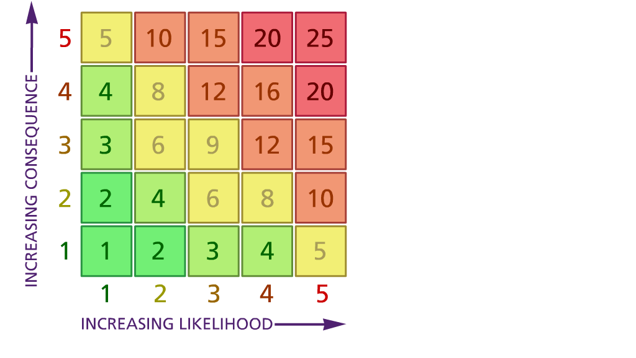

Likelihood: Consequence:

(1) List hazards something with the potential to cause harm here
(2) List groups of people who are especially at risk from the significant hazards which you have identified
- List existing controls here or note where the information may be found. Then try to quantify the level of risk the likelihood of harm arising that remains when the existing controls are in place based on the number of persons affected, how often they are exposed to the hazard and the severity of any consequence. Use this column to list the controls that you might take and develop all or some of that list into a workable action plan. Have regard for the level of risk, the cost of any action and the benefit you expect to gain. Agree the action plan with your team leader and make a note of it overleaf. If it is agreed that no further action is to be taken this too should be noted.
5 – Very likely 5 – Catastrophic

4 – Likely 4 – Major
3 – Fairly likely 3 – Moderate

2 – Unlikely 2 – Minor

1 – Very unlikely 1 – Insignificant

 | 5. Action plan | Responsible | Completed
1
2
 | Action plan agreed by C Duncan 12/7/2021

