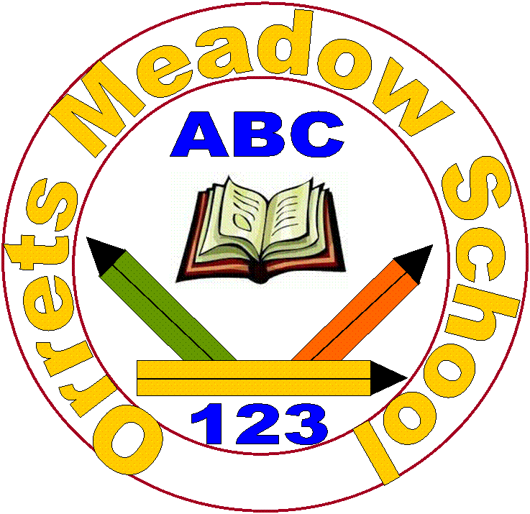
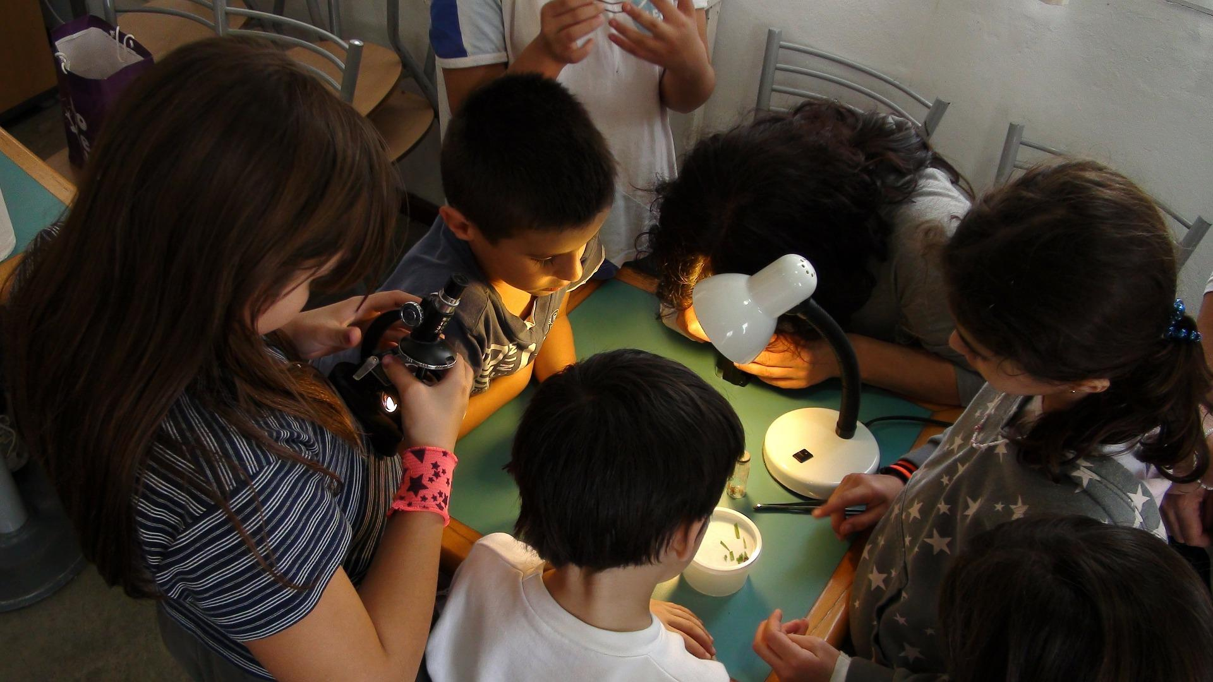
Orrets Meadow School

Science Policy

“To raise the aspirations of every child and give them confidence to fulfil their potential through positive experiences”

Orrets Meadow Curriculum Aims and Values
Aims
To ensure all our children are at the centre of a broad, varied and interesting learning experience that is enjoyable and relevant for the future. Our creative, multisensory curriculum will create a sense of awe and wonder and help to inspire a lifelong love of learning. The holistic nature of our practice will promote positive mental health and well-being and will enhance our children’s life skills, social skills and cultural awareness.
Values
Our curriculum will promote a range of values including:
- Respect
- Empathy
- Responsibility
- Equality
- Independence
- Happiness
- Resilience
- Gratitude
- Honesty
- Friendship
Intent
National Curriculum - Science
Purpose of study
A high-quality science education provides the foundations for understanding the world through the specific disciplines of biology, chemistry and physics. Science has changed our lives and is vital to the world’s future prosperity, and all pupils should be taught essential aspects of the knowledge, methods, processes and uses of science. Through building up a body of key foundational knowledge and concepts, pupils should be encouraged to recognise the power of rational explanation and develop a sense of excitement and curiosity about natural phenomena. They should be encouraged to understand how science can be used to explain what is occurring, predict how things will behave, and analyse causes.
Aims
The national curriculum for science aims to ensure that all pupils:
- develop scientific knowledge and conceptual understanding through the specific disciplines of biology, chemistry and physics
- develop understanding of the nature, processes and methods of science through different types of science enquiries that help them to answer scientific questions about the world around them
- are equipped with the scientific knowledge required to understand the uses and implications of science, today and for the future.
Orrets Meadow’s Curriculum
We teach a Global Curriculum called 'Learning means the World' (LMTW) for all our afternoon subjects. This curriculum is innovative, forward-thinking and highly relevant to our pupils' needs and thoroughly engages them as they tackle challenging and inspiring topics and issues.
LMTW curriculum has been written with world issues in mind and is centred on 4Cs:-
- Communication
- Conflict
- Conservation
- Culture
Why did we choose 'Learning Means the World'?
As a school which is majority white British, we want our pupils to fully embrace cultural diversity, learning about, experiencing and celebrating a range of different cultural and faith heritages.
We believe that communication is key to accessing learning and securing pupils’ future success. As many of our pupils have Speech Language Communication Needs it is essential that opportunities are given to develop language for learning across the curriculum. With one of its 4 foci being on communication, this curriculum provides lots of opportunities for pupils to develop expressing themselves in discussion, debate and presentation, as well as enabling them to collaborate and exchange ideas.
We feel our pupils, as the future generation, need a greater awareness and appreciation of local, national and global conservation issues and initiatives. The need to learn that they have an important role to play in sustainability. This curriculum gives pupils opportunities to grow and develop spiritually, emotionally, physically and socially in the natural world around them. Our commitment to nurturing positive attitudes and values and developing life and social skills is promoted throughout the Learning Means The World (LMTW) curriculum.
It is theme based and broken down into the following phases:
- Explorers (Foundation level)
- Pathfinders (KS1 level)
- Adventurers (Lower KS2 level)
We have the freedom to teach the National Curriculum in line with our pupils' specific needs and believe that our whole curriculum meets the values and aims which our stakeholders requested at the start of the consultation.

SMSC
An important aspect of our curriculum at Orrets Meadow is the incorporation of all things SMSC. All staff in all subjects take any and every opportunity to humanise and contextualise aspects and issues of social, moral and other intrinsic events or concepts, be they past, present or potentially pending. We see the promotion of discussion and debate as a healthy part of life in school.

Why is Science important?
Science is an important and valued subject because it is highly relevant; an integral part of daily life, from cooking and checking the weather, to recycling and nature walks.
Through science, our lives are changed for the better. We believe all pupils should be taught about the role that science plays in positive advancements, as well as scientific knowledge, methods and processes.

Advances in science are continuing to transform our world at lightning speed and we need to do our best to prepare our pupils for a future we can only imagine.
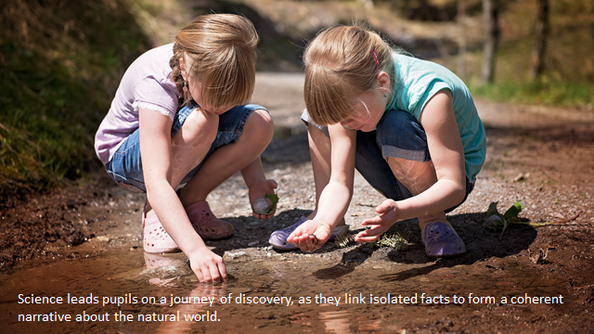

Implementation
When is Science taught?
Science is taught discretely as a theme week each half term. The children will focus on one national curriculum subject area each half term such as ‘Everyday materials’. Alongside this, Science is also taught through thematic units. The attached overview maps out which thematic units feature this subject and the Long-Term Plan clearly shows the objectives taught.

How is Science taught?
Science is taught as a full theme week each half term through working scientifically (involving practical investigation, observation and application skills, enquiry and research) alongside specific taught subject knowledge. Learning takes place both inside and outside the classroom.
Access to the curriculum
We aim to make an enjoyable learning experience and encourage children to participate in a variety of scientific activities. However due to the challenging nature of some of our pupils additional needs, including sensory overload from the ASD, participation in a whole class science investigation lesson might not be appropriate provision. In such cases an alternative activity will be organised.
What do we learn about in Science?
We learn about the following:-
- Plants
- Animals, including humans
- Living things & habitats
- Evolution & inheritance
- Rocks
- Everyday materials
- Properties & changes of materials
- States of matter
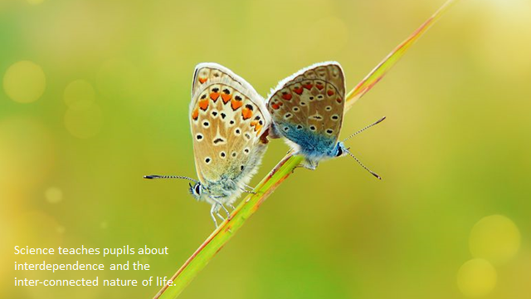
- Light and heat
- Sound
- Forces & magnets
- Seasonal changes
- Earth & space
- Electricity
- Movement

Who do we learn about in Science?
We learn about a range of famous Scientists from history and present day. Some of the famous scientists we learn about are Sir David Attenborough, Albert Einstein and Chris Packham, Charles Darwin ad Thomas Young.

Science Topic Overview

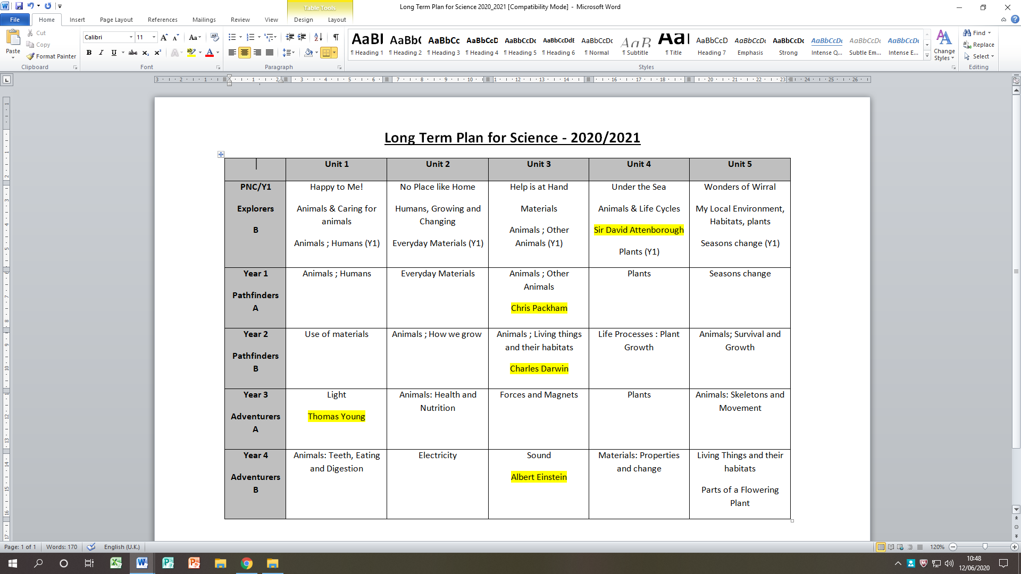
- Discrete lessons

- Dimension lessons

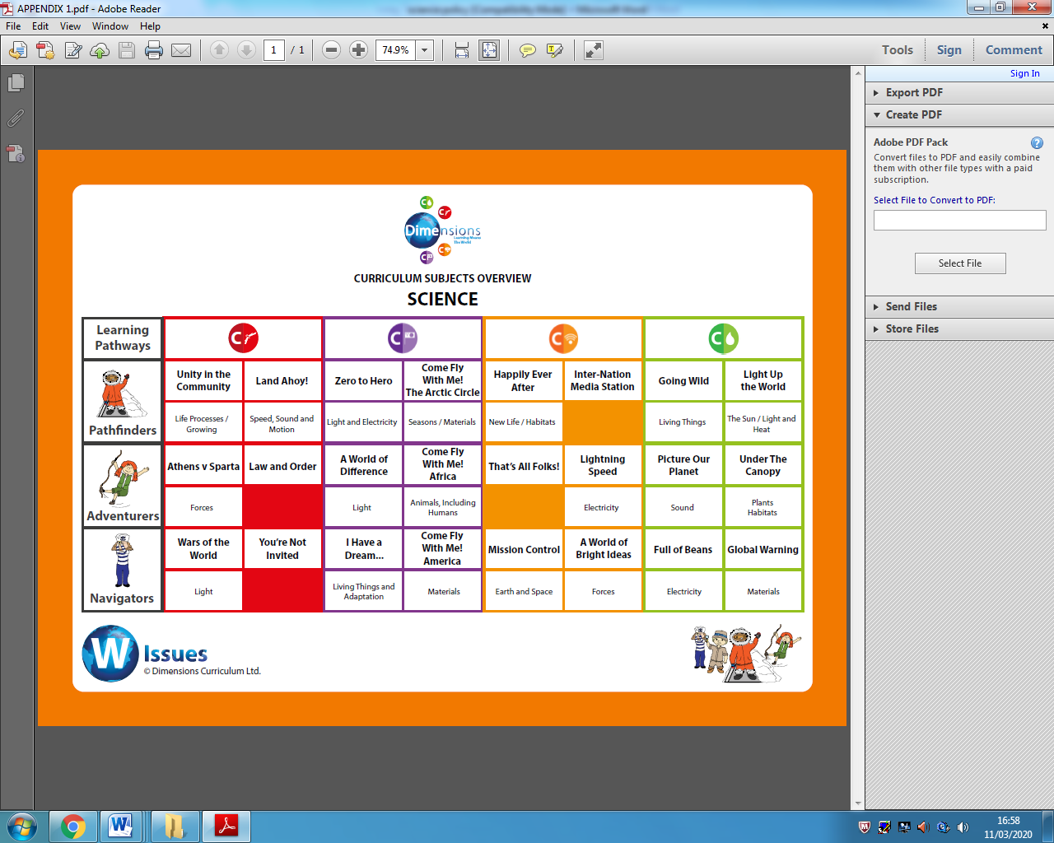

Science National Curriculum knowledge builder across the school- Dimensions

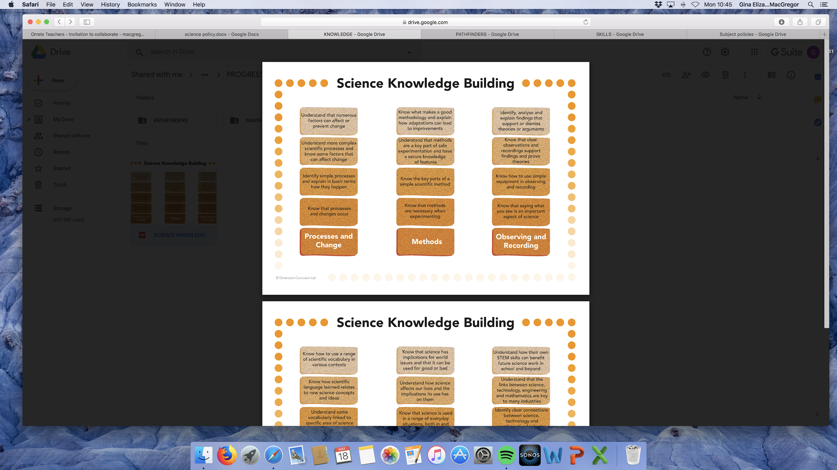

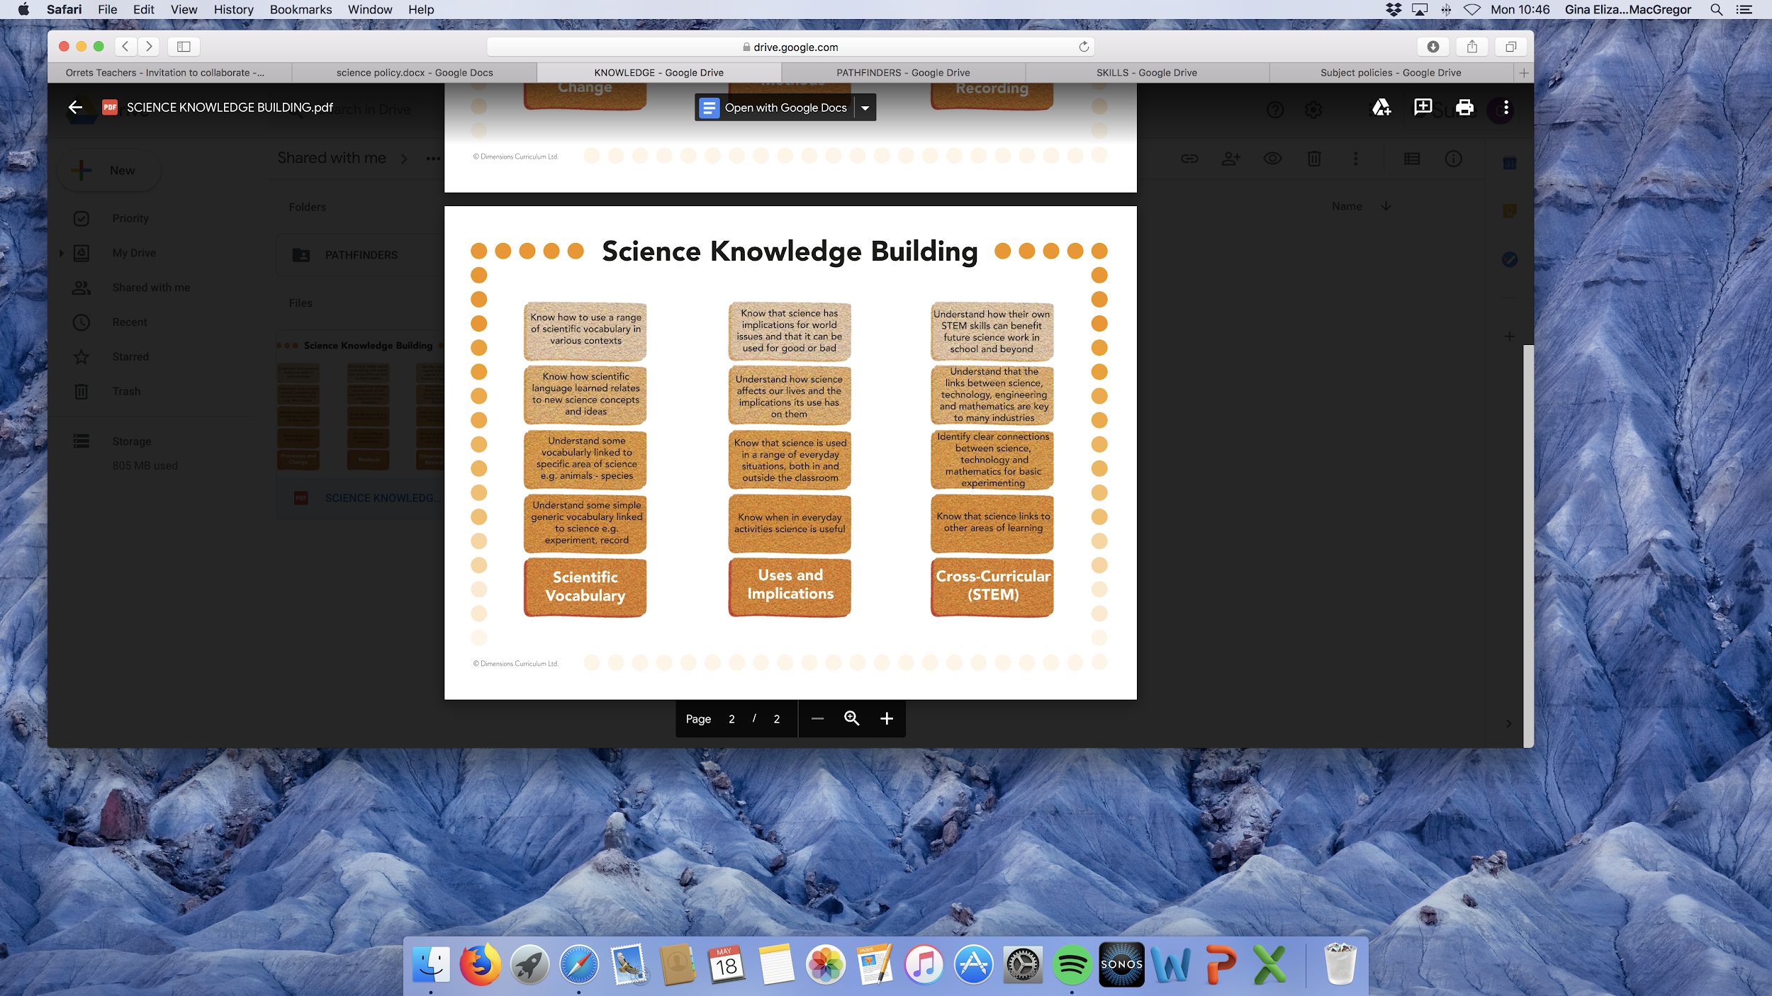

Long Term Plan - NC coverage and how it is taught as objectives in LMTW
Example from Pathfinders

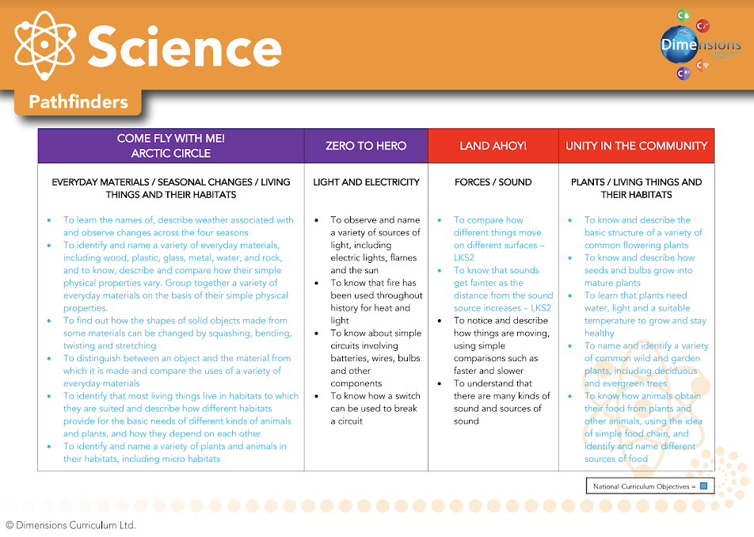

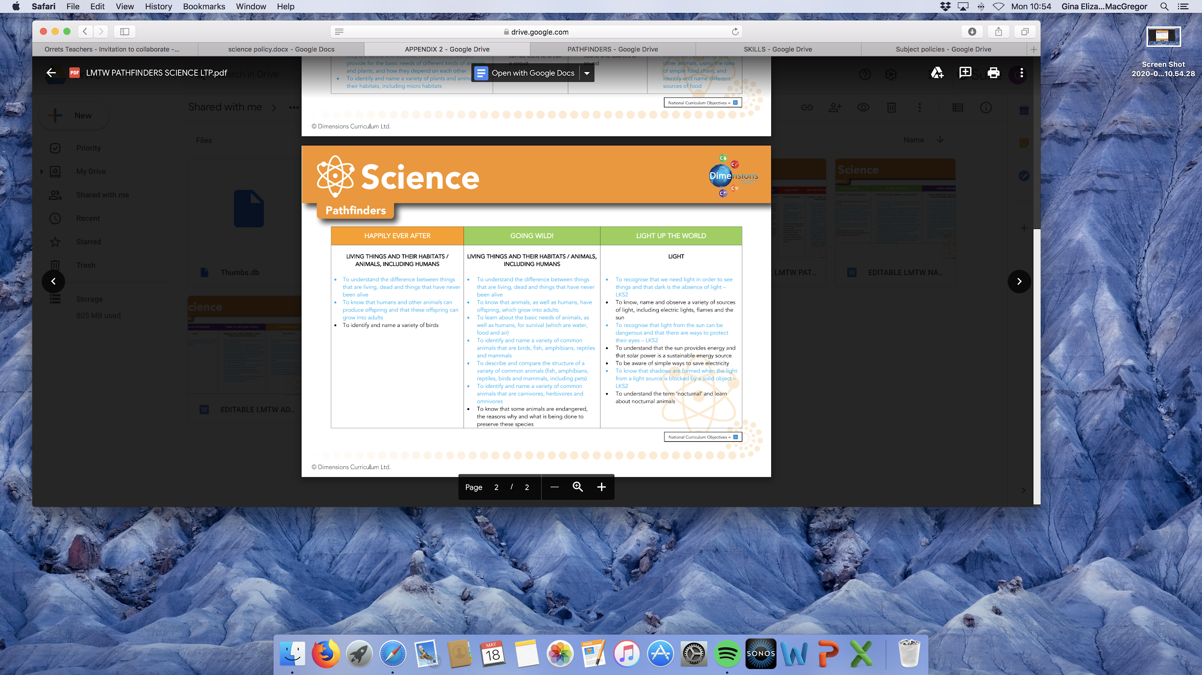

Long Term Plan - NC coverage and how it is taught as objectives
Example from discrete lessons
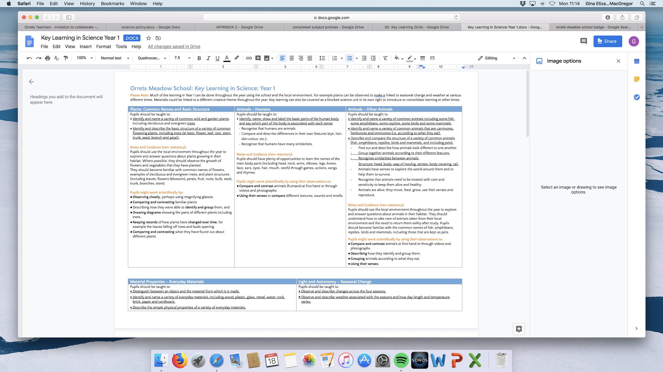

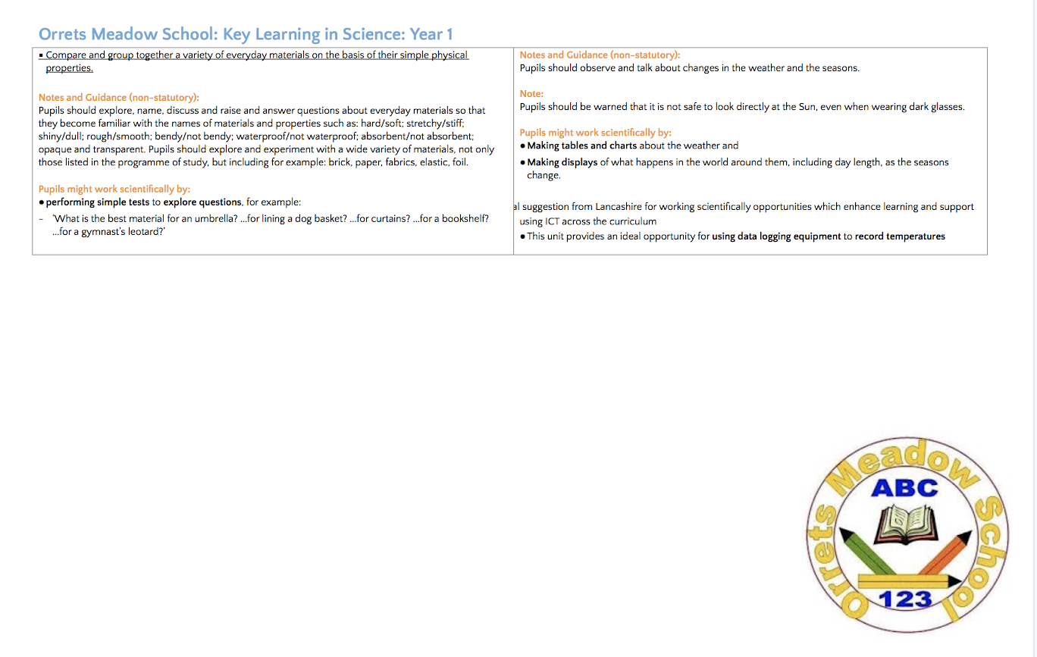

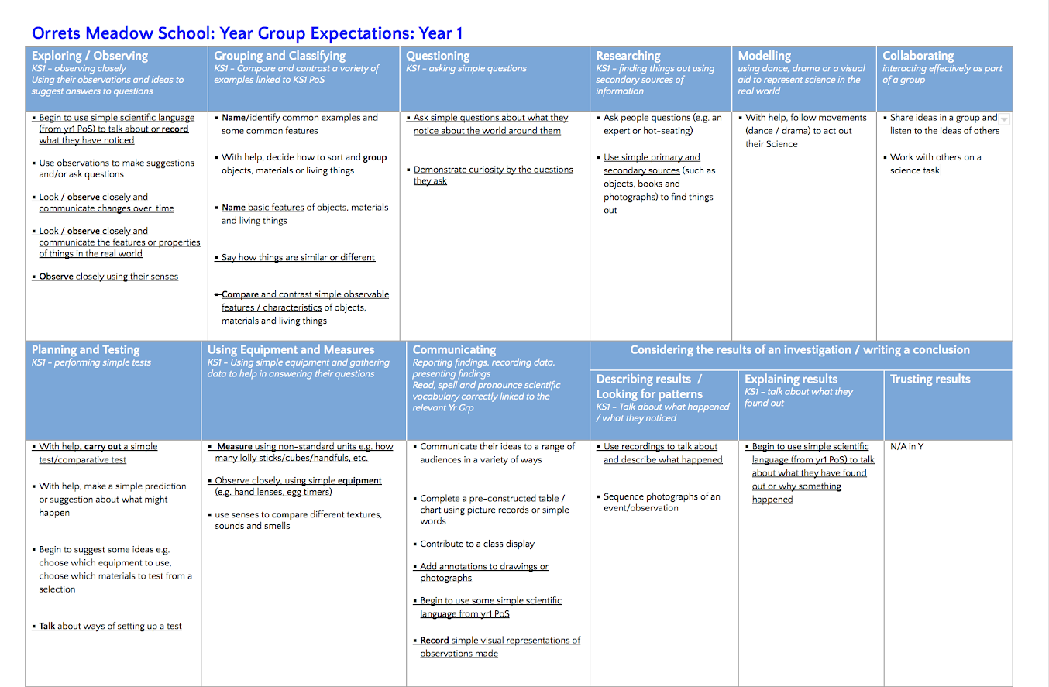

Long Term Plan – Progression of ‘Thinking Scientifically’ skills

- Dimensions
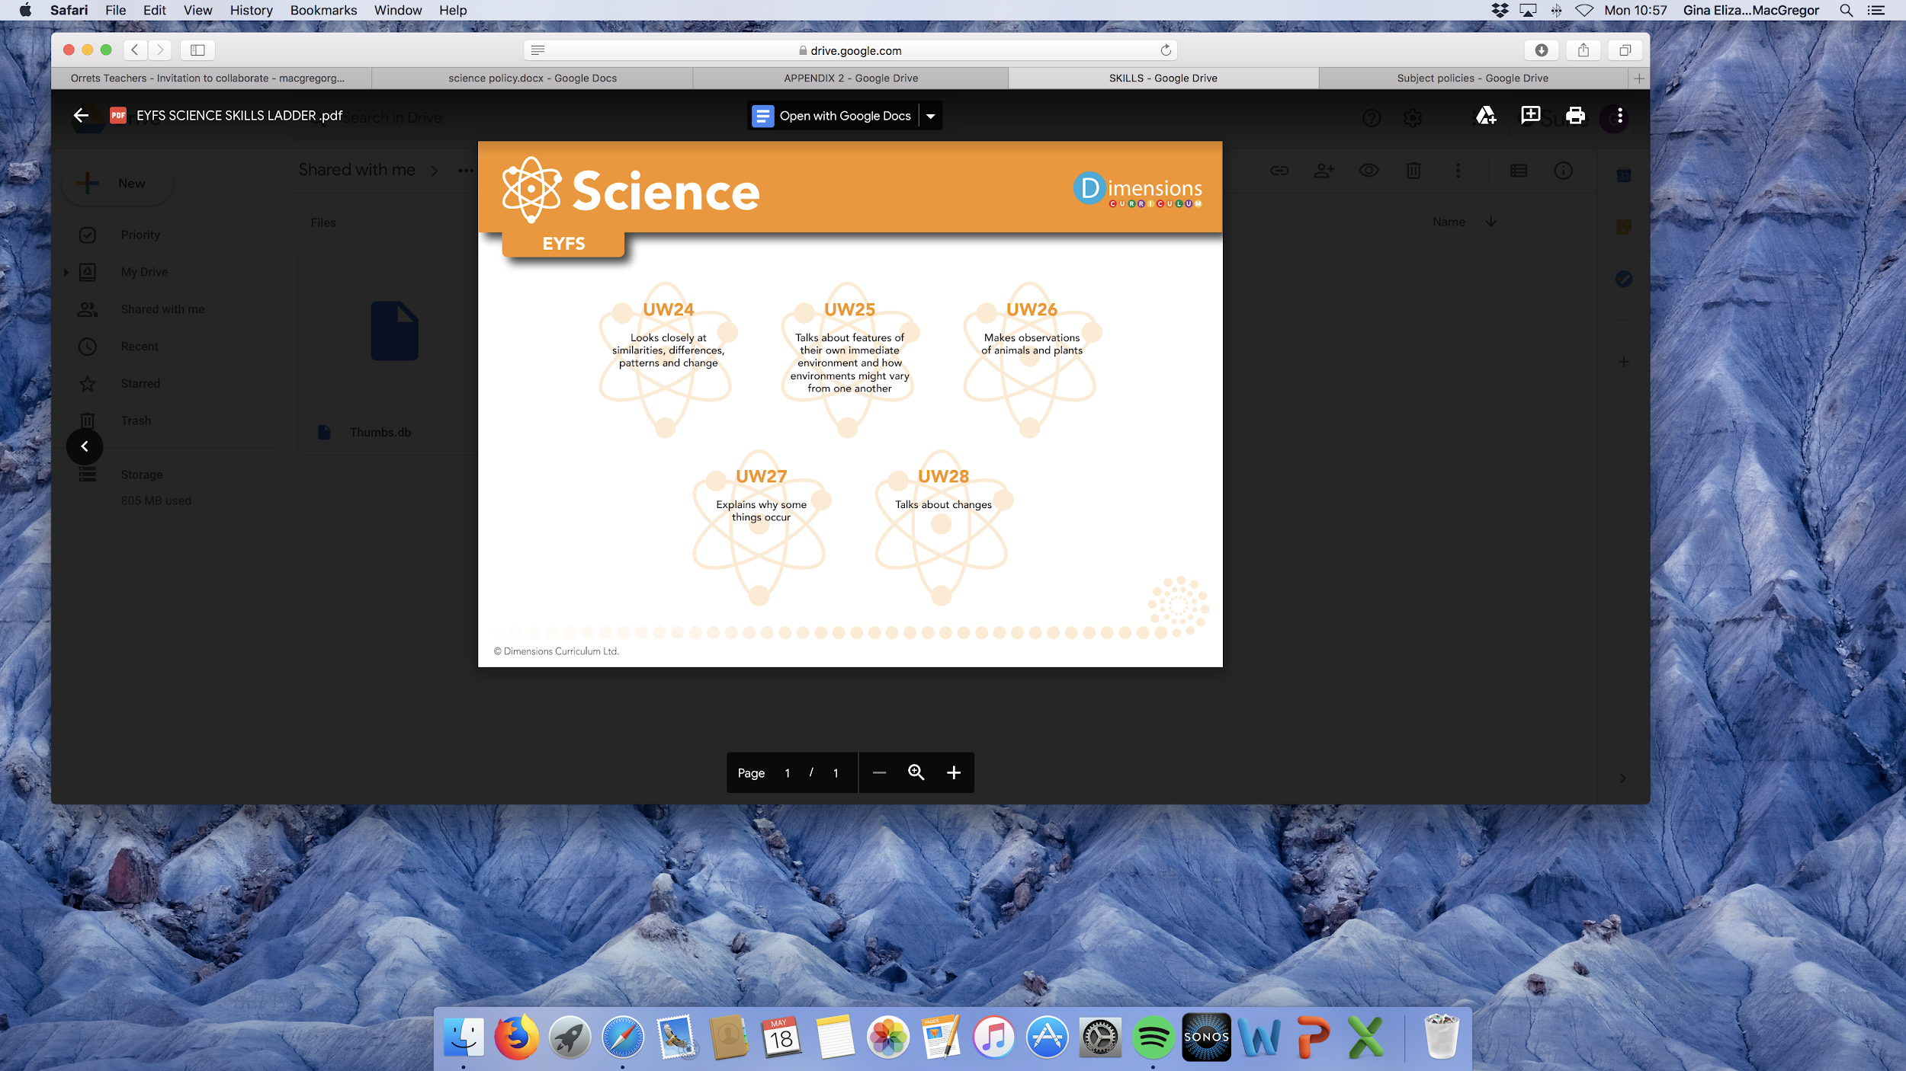

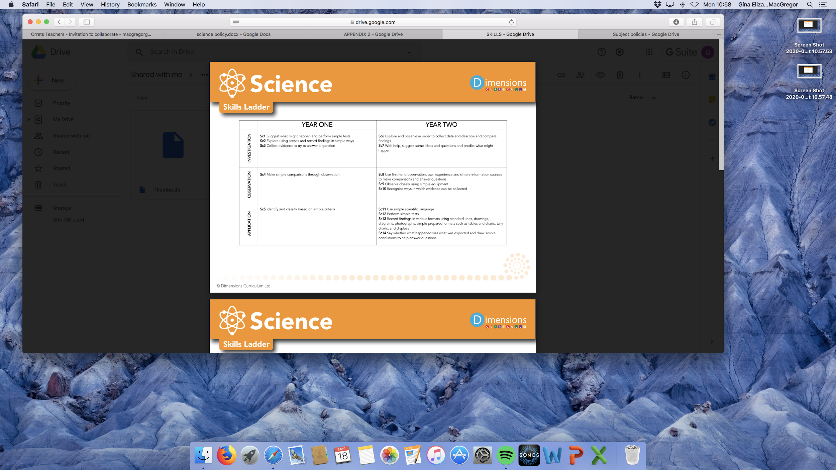

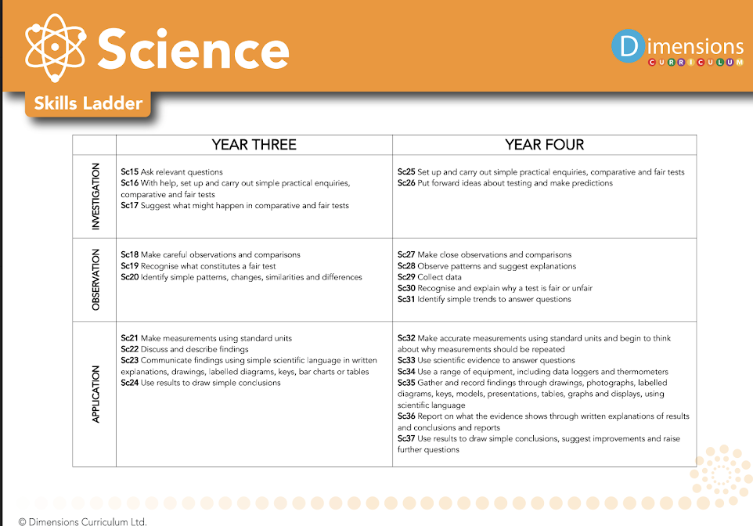

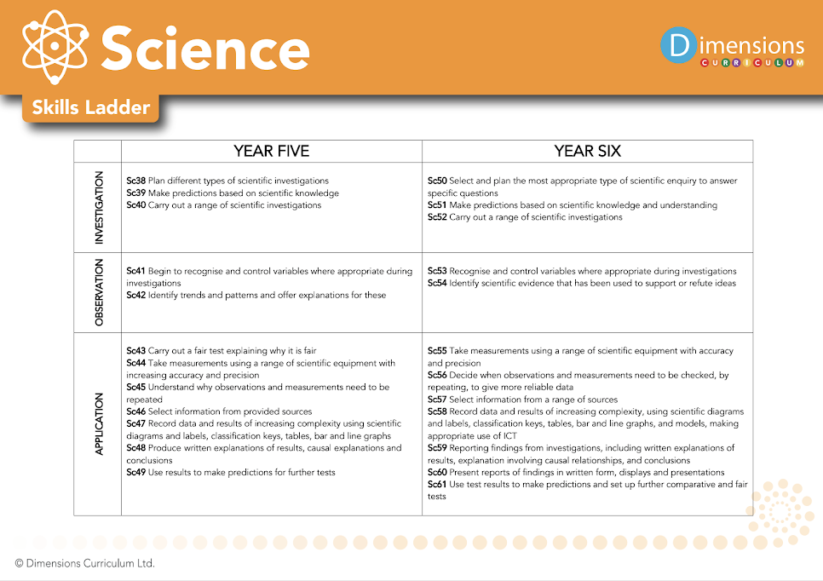

- Discrete teaching

Science Progression of skills | Pre-National Curriculum | Year 1 | Year 2 | Year 3 | Year 4 | Upper KS2 (year 5/6)
Plan | ➢ choose the resources they need for their chosen activities and say when they do or don’t need help | ➢ answer simple questions and begin to recognise that they can be answered in different ways | ➢ ask simple questions and recognising that they can be answered in different ways | ➢ with some guidance, begin to ask relevant questions such as ‘What if we changed…?’ and using different types of scientific enquiries to answer them  ➢ with support, set up simple practical enquiries, comparative tests and explore how to make it a fair test | ➢ ask / raise / choose their own relevant questions and using different types of scientific enquiries to answer them  ➢ set up and organise their own simple practical enquiries, comparative and fair tests | ➢ plan different types of scientific enquiries to answer questions, including recognising and controlling variables where necessary
Do | ➢know about similarities and differences in relation to places, objects, materials and living things  ➢make observations of animals and plants  ➢explore a variety of materials, tools and techniques, experimenting with colour, design, texture, form and function.  ➢select and use technology for particular purposes | ➢ look closely and measure using simple equipment such as sand timers  ➢ with support, perform simple tests  ➢  with support identify and classify by grouping and sorting | ➢ observe closely and measure using non-standard and standard units  ➢ perform simple tests  ➢ identify and classify | ➢ make systematic and careful observations and take accurate measurements using standard units and begin to use some equipment | ➢ make systematic and careful observations and, where appropriate, take accurate measurements using standard units, use a range of equipment, including thermometers and data loggers | ➢ take measurements, using a range of scientific equipment, with increasing accuracy and precision, taking repeat readings when appropriate
Record | ➢represent their own ideas, thoughts and feelings through design and technology, art, music, dance, role play and stories | ➢ with support, gather and record simple data to help in answering questions such as annotating pictures, sequencing pictures and communicating answers to an adult | ➢ gather and record simple data with some accuracy e.g. a bar chart or annotated drawings to help in answering questions | ➢ gather, record, classify and present data in a variety of ways to help in answering questions such as simple tables, bar charts and pictures given to the  ➢ with support, record findings using simple scientific language, drawings, labelled diagrams, keys, bar charts, and tables | ➢ begin to independently gather, record, classify and present data in a variety of ways to help in answering questions  ➢ where appropriate, students to choose the best way to record findings using simple scientific language, drawings, labelled diagrams, keys, bar charts, and tables | ➢ record data and results of increasing complexity using scientific diagrams and labels, classification keys, tables, scatter graphs, bar and line graphs
Review | ➢talk about the features of their own immediate environment and how environments might vary from one another  ➢explain why some things occur and talk about changes | ➢ use their observations and ideas to suggest / share answers to given questions using some scientific vocabulary | ➢ use their observations and ideas to suggest answers to questions using scientific vocabulary and some reasoning e.g. ‘I think that ___ happened because ___.’ | ➢ with support or scaffolding, report on findings from enquiries, including oral and written explanations, displays or presentations of results and conclusions  ➢ with support or scaffolding, use results to draw simple conclusions, make predictions for new values, suggest improvements and raise further questions  ➢ with help, identify differences, similarities or changes related to simple scientific ideas and processes  ➢ write a simple explanation of why something has happened using straightforward scientific evidence to answer questions or to support their findings. | ➢ report on findings from enquiries, including oral and written explanations, displays or presentations of results and conclusions  ➢ use results to draw simple conclusions, make predictions for new values, suggest improvements and raise further questions  ➢ identify differences, similarities or changes related to simple scientific ideas and processes  ➢ use straightforward scientific evidence to answer questions or to support their findings | ➢ use test results to make predictions to set up further comparative and fair tests  ➢ report and present findings from enquiries, including conclusions, causal relationships and explanations of and degree of trust in results, in oral and written forms such as displays and other presentations  ➢ identify scientific evidence that has been used to support or refute ideas or arguments

Impact

How do we assess and monitor Science?

In order to assess our Science which is embedded into the Dimensions curriculum, we use Trackzone which is an online tracking programme which enables teachers to easily record, monitor and update their assessments in real-time. It makes data analysis at pupil, class and subject level possible, helps identify gaps in learning and any areas for development.

Using a simple grading system of 1-5 (U = Unassessed), teachers are able to make a judgement on each pupil’s progress, taking into account the overall evidence gathered through observation, conversation and examination, using their own professional judgement. Awarding a '4' would indicate a pupil is working at age-related expectation, '5' would be linked to mastery or exceeding expectation and ‘1-3’ would be grades indicative of partial knowledge / achievement.

As many of our pupils have short term memory difficulties, they find retaining knowledge especially difficult, so we use Kahoot quizzes throughout the units to support them remember ‘Sticky Knowledge’. These quizzes make learning fun, engaging and impactful. Teachers can use the readymade quizzes created by Dimensions for each unit or they can create their own to introduce the topic, review and reinforce knowledge and use the information gained to help them identify which objectives have been achieved in Trackzone.

Each child’s average grade (1-5) is collected twice a year for SLT, subject leaders and teachers to gain valuable knowledge on how the child, class and school are working in each subject.

We are excited to teach our Learning Means the World curriculum and know it will positively impact on our pupils’ academic and whole well-being.

How do we monitor and assess discrete Science Lessons?

In order to assess our discrete science lessons, teachers use the Orrets Meadow foundation skills assessment APP tool. Each year group expectations are on a one page profile with their specific curriculum targets for ‘thinking scientifically’ set out; teachers then highlight the targets, as and when the children meet them. If one third of the objectives are highlighted, they are ‘Beginning’ to work at age-related expectation, if two thirds of the objectives are highlighted, they are ‘Developing’ skills to work at age-related expectation and if all targets are highlighted then they are ‘Secure’ in working at age-related expectation. Due to the nature of our children, we track the ‘Thinking Scientifically’ skills of the subject as our students are working below their age related expectation. The data is collected three times a year and given as a score such as 3D, meaning the child is working at year 3 level and ‘Developing’ age related expectation.

SLT, teachers and subject leaders use assessment for learning to inform planning, teaching and learning and CPD opportunities.

SLT and subject leaders are continuously monitoring their subject to ensure it meets the needs of our pupils. They monitor using a variety of activities, including:

- Learning walks
- Book scrutiny
- Lesson observations
- Pupil survey and discussions
- Staff survey and discussions

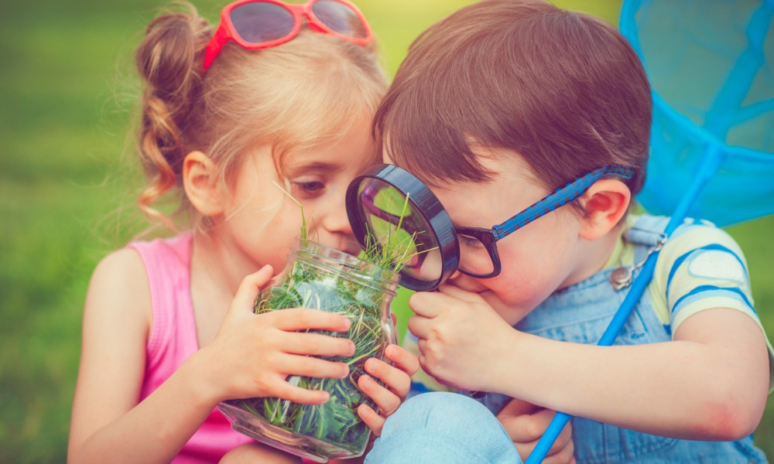

[Type a quote from the document or the summary of an interesting point. You can position the text box anywhere in the document. Use the Drawing Tools tab to change the formatting of the pull quote text box.]

Science encourages pupils to ask ‘how’ and ‘why’ questions, with the aim of finding out the answers.

