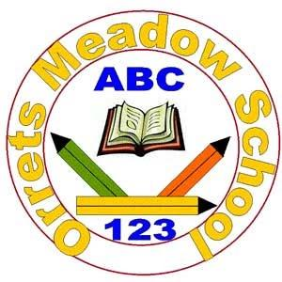

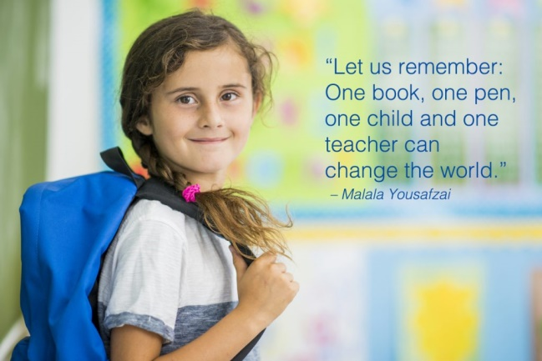**Orrets Meadow School**

**English Policy**

**“To raise the aspirations of every child and give them confidence to fulfil their potential through positive experiences”**

**Orrets Meadow Curriculum Aims and Values**

**Aims**

To ensure all our children are at the centre of a broad, varied and interesting learning experience that is enjoyable and relevant for the future. Our creative, multisensory curriculum will create a sense of awe and wonder and help to inspire a lifelong love of learning. The holistic nature of our practice will promote positive mental health and well-being and will enhance our children’s life skills, social skills and cultural awareness.

**Values**

Our curriculum will promote a range of values including:

* Respect
* Empathy
* Responsibility
* Equality
* Independence
* Happiness
* Resilience
* Gratitude
* Honesty
* 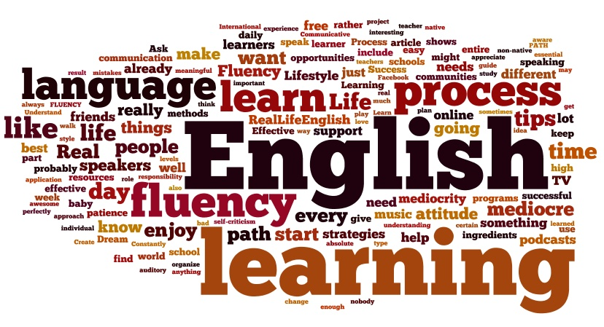Friendship

**Intent**

**National Curriculum – English   
  
Purpose of Study**

English has a pre-eminent place in education and in society. A high-quality education in English will teach pupils to speak and write fluently so that they can communicate their ideas and emotions to others, and through their reading and listening, others can communicate with them. Through reading in particular, pupils have a chance to develop culturally, emotionally, intellectually, socially and spiritually. Literature, especially, plays a key role in such development. Reading also enables pupils both to acquire knowledge and to build on what they already know. All the skills of language are essential to participating fully as a member of society; pupils who do not learn to speak, read and write fluently and confidently are effectively disenfranchised.

**Aims of the Orrets English Curriculum**

Through the teaching of English at Orrets Meadow we aim to help pupils to achieve a range of skills that will become transferable in order to help them to succeed. The aims for are English curriculum are for pupils to;

* Listen attentively, paying attention to detail, to process the information and retain aurally as much detail as they are able.
* Speak confidently with intonation, clear diction, accurate grammar and style with regard for their listener.
* Read fluently with good comprehension, which is reflected in appropriate expression and intonation, from a wide variety of text, at their own level, for pleasure, relaxation, and investigation.
* Develop their cognitive skills, imagination and personal expression through a range of writing tasks using clear, concise language with accurate punctuation and grammar, in a style appropriate for the purposes.
* Make progress along the continuum to become a competent speller.
* Use neat legible cursive handwriting.
* Make fair critical responses about their own language work, that of their peers and that of a variety of authors and poets.

**English Curriculum at Orrets Meadow**

The English curriculum at Orrets Meadow has been integrated with our Global Curriculum called ‘Learning Means the World’. This allows pupils to acquire secure knowledge of topics through their afternoon curriculum that can then be used and applied throughout English lessons. Our curriculum promotes a mastery of English by following ‘The Reading and Writing Journey’ as well as providing purpose for writing during themed weeks throughout the year, such as report writing linked to science investigations.

Pupils at Orrets Meadow also develop their phonetic awareness, spelling and reading skills through a multi-sensory daily programme of study following the Orrets Meadow Core Curriculum.

**Why Is English Important?**

English is both a subject in its own right and the medium for teaching; for pupils, understanding the language provides access to the whole curriculum. Fluency in the English language is an essential foundation for success in all subjects. English is an essential subject that allows pupils to engage with the world around them. Through English lessons pupils will learn;

* 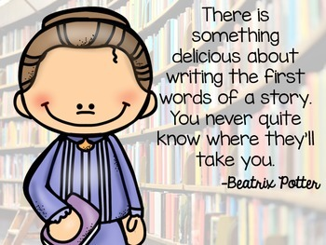Spoken Language
* Writing Composition
* Writing Transcription
* Word Reading
* Reading Comprehension
* Handwriting
* Vocabulary, Grammar and Punctuation

All of these elements of English allow pupils to process and determine meaning from both spoken and written English. It enables pupils to be able to express their own needs in an articulate manner as well as providing transferable skills that can be used later in life in real life contexts.

**Implementation**

**When is English Taught?**

Children at Orrets Meadow spend an extended time allocation on English. In our younger classes this is a 45 minute phonics session and a 45 minute English lesson daily. As pupils become more proficient with their phonetic knowledge they will partake in a 30 minute phonic and spelling session and an hour long English lesson daily. This ensures that each child can have a daily spelling lesson, read with an adult, as well as experience high quality English teaching in classes or group sessions.

**What do we learn about in English?**

We learn about a range of text genres and styles, as well as writing for different purposes. We learn about;

* Spoken Language
* Writing Composition
* Writing Transcription
* Word Reading
* Reading Comprehension
* Handwriting
* Vocabulary, Grammar and Punctuation

Each section of English has a progression of skills which teachers expertly use in order to cater to the learning needs of pupils within their classes. These progressions of skills can be found in the appendices of this document along with the long term plans for English.

**Daily Core Curriculum**

In order to meet the needs of our pupils, we continue to follow a highly structured cumulative phonic and key word programme for reading and spelling as our ‘Core Curriculum’. This programme originally followed Hickey Multisensory Language Course (2000), but has been adapted and developed for group and class work. Teachers use their expertise, to plan and deliver multisensory experiences with great scope for overlearning, based on rigorous assessment and tailored to the needs of the child or group. This programme is regularly reviewed and updated in order to ensure that it meets with national requirements. Our phonics programme is split into 10 individual levels. As the levels progress pupils are taught both phonemes alongside morphology.

Each grapheme, suffix and prefix have their own unique context word attached to it and these are presented using flash cards. These cards are used daily in order to recap prior learning and is beneficial as repetition is key to securing this phonetic knowledge with our pupils, who often struggle with short term and working memory.

Daily activities include:

* Alphabet- ordering and sequencing letters and words
* Auditory Discrimination/Phonemic Awareness
* Memory- auditory and visual
* Revision of key words and known phonics for reading and spelling using flashcards
* New Learning of key words and phonics for reading and spelling
* Daily reading, with a Teacher or Teaching Assistant
* PROBE (Precise Recording of Objective Based Education)
* Homework linked to phonics or keywords
* Dictionary and thesaurus activities

This structure allows children to develop the transferable basic skills necessary to access the wider curriculum. In small achievable steps, they experience success and build confidence.

**English Mastery at Orrets Meadow**

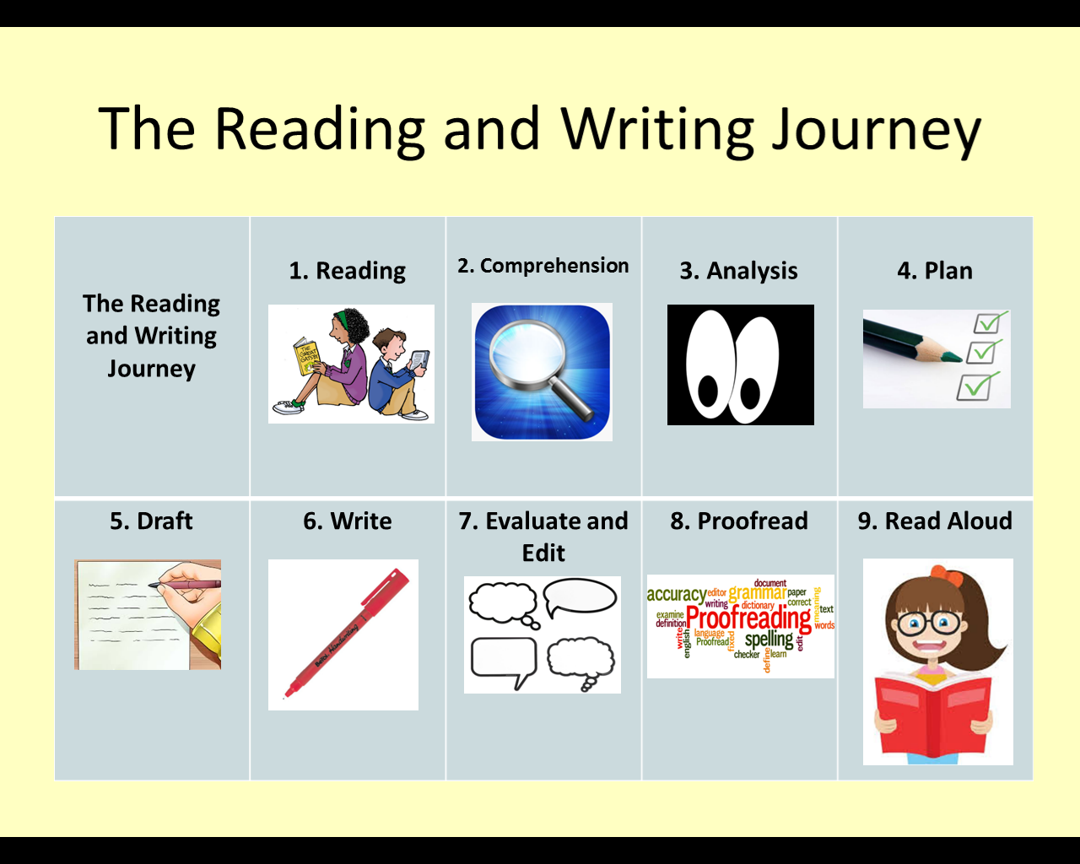‘The Reading and Writing Journey’ illustrated below is the key feature of the Mastery curriculum at Orrets Meadow.

By ensuring each of these elements are taught explicitly children will master the skills needed to become confident readers and writers. Following our new English long term plan (Appendix 1-6), which is linked to our Global Curriculum allows pupil to have a greater comprehension of topics. This allows pupils to focus on the individual writing styles and skills to be used in the area of English they are currently studying.

**How is English Taught?**

English is taught through a combination of subject knowledge, comprhension of differnet genres of wiritng and the development of specific skills along a continuum. Teachers use their expertise in order to deploy a range of teaching and learning strategies that best meet the needs of the pupils within their classrooms. These teaching and learning strategies include;

* Multisensory activities
* Visual, auditory and kinaesthetic
* Overlearning
* 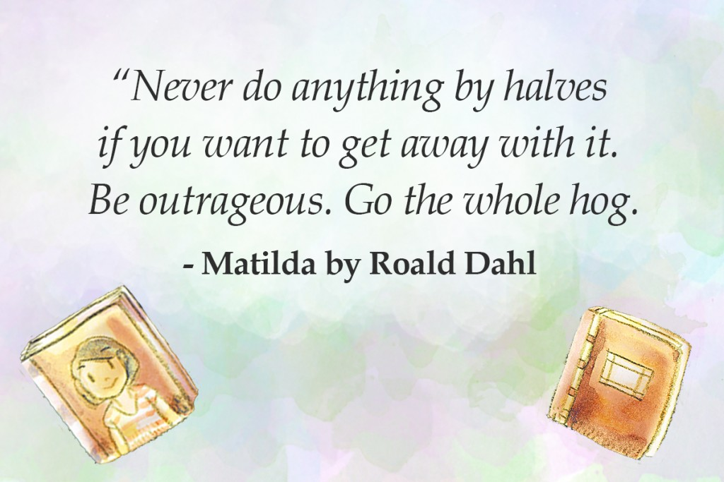Structured and scafolded practical and written activities
* Drama activities for character exploration
* One to one proof reading and editting prior to final drafts of pieces of work.
* Guided reading and writing
* Modelling
* Sight reading
* Probes
* One to one reading
* Small group work and strategic deployment of teaching assistants
* Opportunities to incorporate technology.

**Orrets Meadow Literacy Spine**

Throughout the school pupils are exposed to range of appropriate books covering a range of topics. The Orrets Meadow Literacy Spine (Appendix 7) shows a list of recommended books that are used to broaden pupils’ knowledge of different stories with significant social, moral and cultural impact, which foster an enjoyment of reading and learning. The Literature spine is composed of two elements for each year group; Curriculum Texts and Class Reading. Texts under ‘Curriculum Texts’ are a mixture books that have been recommended through our Global curriculum and other stories that the school team have found to link closely with the areas covered.

Class readers are books not linked to the curriculum that teachers can share with their classes in order to promote a lifelong love of reading and reading for pleasure. These texts have been informed by Pie Corbett as well as recommended texts from the teaching staff. Books selected by teaching staff are books that teachers know are appropriately pitched for our pupils as well as being stories that staff love and are enthusaistic to share.

**Specific Additional Curriculum Needs**

A Speech Therapist assesses and provides group and individual programmes for children with Speech Language and communication needs. These programmes are delivered in Additional Needs Group sessions by a group of three Specialist Teaching Assistants.

**Computer Literacy**

The use of computers permeates all areas of modern life, it is essential we equip our pupils with skills for computer literacy so they are able to fully participate in an ever changing world.

The use of technology is embedded in teaching and learning practices across the English Curriculum. Orrets Meadow is fortunate to have a great variety of laptops, PCs and iPads available for children and teachers to access in order to support the development of skills such as spoken language, composition and writing for different purposes. Some of the software used include;

* Clicker 6 – This features predictive text to enable pupils to explore a wider range of vocabulary that can be used. It also has the capability to read text back to pupils, which helps to develop their proof reading and editing skills.
* Clicker Sentences – This enables pupils to develop their sentence composition by ordering words into the correct order. This can be used at different levels to incorporate a progression of punctuation and range of sentence structures. This application also reads back sentences for pupils to listen for corrections.
* Purple Mash – Purple mash has a range of elements that can help pupils with organisational, layout features and writing for a range of purposes.
* Bug Club - The school has invested in an ICT based programme called Bug Club, which allows pupils to access a range of fiction and non-fiction books at their levels from home. This programme not only helps with word reading, but also comprehension through targeted questioning.

**SMSC in English**

The English curriculum at Orrets Meadow provides many opportunities for pupils to reflect on Spiritual, Moral, Social and Cultural factors. During English lessons pupils can explore the lives of others from history and around the world through stories. Pupils are exposed to each of these elements in a range of ways including the following;

|  |  |  |  |
| --- | --- | --- | --- |
| **Spiritual** | **Moral** | **Social** | **Cultural** |
| Imagery | Right and wrong | Instructional writing | Stories from other cultures |
| Sharing Ideas | Conscience Alley | Role Play | Famous author studies |
| Text and Poetry | Persuasive Writing | Talking Partners | Researching other countries |
| Curiosity | Debating | Working in Pairs | Fact Sheets |
| Imaginative writing | Relationships | Peer Writing of stories | Travel agents and brochures |
| Greek Myths | Fables | Acting | Chinese New Year |
| Legends | Fairy tales | Researching | Kensuke’s Kingdom |

**Home-School partnership**

Although much has been said in the media regarding homework for Primary age children, we have found that the support of our parents is invaluable in children making progress. Fostering a close link with home encourages active generalisation of the new skills and is another opportunity to reinforce new learning.   
Homework is set Monday to Friday, which the exception of big events or specific holidays.

Children are set:

1. Reading
2. PROBE
3. Spelling, writing or maths task.

Home work should not take longer than 10-15 minutes to complete.

**Impact**

**How do we assess and monitor English?**

**Assessment Activities**Throughout the year the impact of the teaching English is closely monitored and assessed using a range of strategies to acquire both staff and pupils views on their success in English. These include

* Learning walks by the English Lead.
* A Learning walk with the English Lead and the Head of Governors
* Book Scrutiny
* Lesson Observations carried out by the Head teacher and the English Lead.
* Pupils’ surveys and discussions.
* Staff surveys and discussions

**Assessment for learning**

**Assessment Cycle**

The Core curriculum is assessed each term, which provides teachers with the detail needed to plan their programmes and identifies children in need of additional provision and support. During this cycle pupils are tested on their phonetic knowledge with respect to spelling and reading (both in context and isolation). This informs staff of the gaps in pupils learning so that each of these strands can be catered to at the pupils’ level.

**Assessing Pupils Progress(APP)**

Children will be assessed using APP sheets devised from the objectives given in the English programme of study. Assessments will indicate whether a child attains ‘Beginning’, ‘Developing’ or ‘Secure’ against the objectives being studied. Children will be awarded appropriate ‘Steps’ (1-6) when working towards the curriculum and levels A1-C6 when working within the curriculum.

**Tracking and reporting**

**Termly Data Report**

At the end of each term, parents are supplied with an update on their child’s progress, in the form of a Data Report. This shows progress through the year and against curriculum objectives.

**Pupil Progress Meeting**

Pupil Progress Meetings are held each term to identify children not making expected progress. Additional support and group interventions are put into place to promote progress.

**End of year report**

All children receive an end of year report summarising and highlighting the progress they have made in the English curriculum**.**

**Standard Attainment test (SATs)**

Children who are working on the KS2 curriculum will sit the SAT test each May. For some children taking the SATs would have a negative impact on mental health. In such instances careful consideration is made as to which assessments they will take. Individuals unable to access the SATs are awarded a teacher assessment, based on their class work.

**Pupil Self-Assessment**

Children make a summative assess their own progress over an English lesson, by marking their work with a green, orange or red circle. Green meaning the child is secure in their progress and red meaning they are in need of more reinforcement. Additionally children are encouraged to make on going running assessment at appropriate times during the lesson, with coloured circle or traffic lights on their desks

When the children are sufficiently skilled and mature, they will be encouraged to make peer assessment and set targets for their peers.

**Marking & Feedback (Academic Guidance)**

The Academic Guidance Policy sets out the philosophy, standards and marking codes to be used by teachers. Whenever possible, feedback is given orally at the earliest opportunity. A marking code is displayed at the front of each book.

Additionally teachers mark work with a star (green highlighter) and a target (pink highlighter), indicating the next steps a child needs to take to make progress.

**English Policy Appendices**

**Long term plans for English:**

1. **Pre National Curriculum (Cycle A)**
2. **Pre National Curriculum (Cycle B)**
3. **Pathfinders Cycle A (Year 1)**
4. **Pathfinders Cycle B (Year 2)**
5. **Adventurers Cycle A (Year 3)**
6. **Adventurers Cycle B (Year 4)**

**Other Appendices**

1. **Literacy Spine**
2. **Progression of Grammar**
3. **Progression of Reading**
4. **Progression of Writing**

|  |  |  |  |  |  |  |  |  |  |  |  |  |
| --- | --- | --- | --- | --- | --- | --- | --- | --- | --- | --- | --- | --- |
| **Fiction** | | **Happy to be me!**  **(3 wks)**  **Communication** | **Jurassic Park**  Appendix 1: Pre-National Curriculum Cycle A Long Term Plan  **Understanding of the World**  **(5 Weeks)** | | **Ticket to Ride**  **Understanding of the World**  **(4 wks)** | **‘Help is at Hand’**  **Who helps us**  **(4 weeks)**  **Conflict** | | **‘Under the Sea’**  **Friendship and Truth**  **(6 weeks)**  **Culture** | | **‘What on Earth..’ Respect for our World**  **(3 weeks)**  **Conservation** | | **‘Pirates and Mermaids’**  **New Brighton**  **(4 weeks)**  **Wonders of Wirral** |
| **Whole Class shared Text - Novel** | | | | | | | | | | | | |
| **Week 1** | | **Funny Bones**  Repetitive Language  Writing fact files | **Dinosaurs and Captain Flinn**  Reading cave –read simple words and sentences. | | **The Train Ride**  Design a ticket  Talk about a train experience | **Farmer Duck**  Making sentences  Writing Captions | | **Barry the Fish with Fingers**  Rhyming words  Labelling the fish | | **I am Josephine**  Name living things  Read aloud simple sentences  To write I am sentences | | **Pirates Love Underpants**  Describes main story settings,  events and principal characters. |
| **Week 2** | | **All Ears, All Eyes**  Non-fiction books  Sound walk  **Ears, Eyes and Toes**  ‘All about me’ books  Senses and food | **Non-fiction Dinosuar**  Talk about what they have read.  Match words to cave paintings. | | **Magic Train Ride/Mr Grumpy’s Car**  Alphabetical order animal pictures  Write about and draw magic train | **Can’t you Sleep Little Bear**  Non-fiction books  Recount | | **The Rainbow Fish**  Telling stories with puppets  The shiny scale | | **Pretty by Canizales**  Write a letter  Show understanding of what they have read | | **Pete the Cat and the Treasure Map**  Design treasure maps  Design and label a sea monster |
| **Week 3** | | **Goldilocks**  Family stories  Making books | **Dinosaur Rhyme**  Read dinosaur feet words  Rhymes | | **Ferry, boat, plane.**  Fiction and Non-fiction book corner  Write sentences about ferry, boat or a plane | **Chinese New Year/**  **Police Ambulance and Nurses**  Reading signs Writing captions | | **Sharks, Whales and Dolphins**  Matching sentences to pictures  Writing descriptions | | **Smartest Giant in Town**  Create clothing catalogue  To vocabulary | | **The Singing Mermaid**  Rhyming words  Follow instructions to make mermaid biscuits |
| **Week 4** | |  | **Shape Dinosaur**  **Labels, captions writing own book**  Create own dinosaur  Scrambled sentences for reading | | **Hot air balloon**  Rhyme words with up.  Use hot air balloon writing frame. | **Doctors and Nurses**  Labelling body parts  Get well cards | | **Nugget and Fang**  Rearranging letters  Shark food | | **Old Things**  Rhyming words  Write initial sound  Answer questions | | **Brochures and Posters**  Design posters/brochures to promote New Brighton. |
| **Week 5** | |  | **Dodo ice age**  Draw Dodo and write fascinating facts.  Read about extinct animals. | |  |  | | **Crazy Crustaceans**  Find the rhyme  Guess the crustacean | |  | |
| **Week 6** | |  |  | |  |  | | **The Lonely Lobster**  Rhyming strings  Adventure writing | |  | |
| **WHOLE SCHOOL THEMED WEEK** | |  |  | |  | **Christmas Around the World**  **Russia**  Sequencing  Retelling the Christmas story.  Role Play parts of the Christmas story. | | **Religion Week**  **Hinduism**  Labelling and writing captions.  Sequencing the stories | | **Language and Cultural Week**  Learn and write simple facts.  Promoting speaking and listening of another language | |  |
| **SCIENCE WEEK** | **Animals; Humans**  Labelling/  Caption writing | | | **David Attenborough**  **Animals; Other Animals**  Instructions | | | **Every day Materials**  Labelling/Caption writing | | **Plants**  Non Fiction information | | **Seasonal Change**  Instructions | |
| **Grammar – Word, Sentence, Text, Punctuation and Handwriting** | | | | | | | | | | | | |

Appendix 2: Pre-National Curriculum Cycle B Long Term Plan

|  |  |  |  |  |  |  |  |  |  |  |  |  |  |  |  |  |  |  |  |  |  |  |
| --- | --- | --- | --- | --- | --- | --- | --- | --- | --- | --- | --- | --- | --- | --- | --- | --- | --- | --- | --- | --- | --- | --- |
| **Fiction** | **Dimensions Theme 1**  **Tell Us a Story!** | | | **Dimensions Theme 2**  **Blast Off** | | | | **Dimensions Theme 3**  **Tell Us a Story!** | | | | **Dimensions Theme 4**  **Come Fly With Me!** | | | **Dimensions Theme 5**  **No Place Like Home** | | | | **Dimensions Theme 6**  **Over the Rainbow** | | **Wonders of Wirral Theme 7**  **Swamps and Ice creams Parkgate**  **Fantasy (4 wks)** | |
|  | | **Whole Class shared Text – Novel** | | | | | | | | | | | | | | | | | | | | |
| **Week 1** | **Non Fiction Toy book**  Toy Alphabet Writing Stories. | | **Zoom Rocket Zoom – Margaret Mays**  Rhyming words  Rocket adventure | | | **Jack and the Bean Stalk**  Comparing Versions of Stories Writing a Letter to the Giant. | | | | | **‘A Kids Guide to China’**  Fact Books Chinese Letter Writing. | | | **Peace at Last**  Re-telling stories  Describing rooms | | | | **Colour information**  Make a rainbow book  Red/match colours to names | | **Shrek**  Describes main story settings,  events and principal characters. | | |
| **Week 2** | **Where’s My teddy**  **Jez Alborough**  Listening to Stories Describing Teddy | | **Non Fiction Planet Book**  Planet shaped writing template  Labels  Matching planets to names | | | **The Gingerbread Man**  Comparing Stories ‘Lost’ Posters | | | | | **Story of Chinese New Year Animals**  Writing Letters to China | | | **The Three Little Pigs**  Comparing stories  The Fourth Little Pig-writing | | | | **Brown Bear, Brown Bear**  Match captions  Draw/paint animals and write this is a…..  sentences | | **Should I Share My ice cream**  Recipes  Ice cream Sundae design  Invitation | | |
| **Week 3** | **The Rhyming Rabbit – Julia Donaldson**  Rhyming Words Describing Movements | | **Alien Books**  **Alien’s love underpants**  **Welcome to Alien School Zum-Zee**  Letter to aliens  Short alien sentences | | | **Snow White**  Comparing Stories Invent a New Dwarf | | | | | **All About Indian by Shalu Sharma**  Indian Fact Books Making a Holiday Brochure | | | **The Three Little Pigs**  Matching words to pictures | | | | **Kipper’s Snowy Day**  **Sun and Moon Lindsey Yankey**  Label clothes for different weathers  Write about snow/sun | | **Superworm**  Letter to one of the characters. | | |
| **Week 4** | **Toy Story**  Reading Key Words Writing Stories | | **Star in a Jar**  Talk about where you would take the star  Story map  Labels  Captions | | | **Cinderella x 1**  Flashcards Writing Wishes | | | | | **Diwali Holidays Around the World by Lisa J Amstutz**  Diwali Fact Books Story Maps | | | **Perfect Pet**  Similar Stories  Rory the Tiger | | | | **Wizard of Oz**  Where would you go writing frame  Retell sory | | **Poems about senses**  Explore the senses through poetry. | | |
| **Week 5** | **Whatever Next!**  **Non Fiction Space.**  Words in the Stars Space Ranger Descriptions | |  | | | **Cinderella x 2**  Flashcards Writing Wishes | | | | | **Non Fiction Information on Russia.**  Russian Alphabet Writing Captions | | |  | | | |  | |
| **Week 6** |  | |  | | | **Learning to Listen**  Re-telling Stories What Happens Next? | | | | |  | | |  | | | |  | |
| **WHOLE SCHOOL THEMED WEEK** |  | | | | **Christmas Around the World**  Sequencing  Retelling the Christmas story.  Role Play parts of the Christmas story. | |  | | **Religion Week**  **Hinduism**  Labelling and writing captions.  Sequencing the story of Rama and Sita. | | | |  | | | | **Language and Cultural Week**  Learn and write simple facts.  Promoting speaking and listening of another language | | |  | | |
| **SCIENCE WEEK** | **Animals; Humans**  Labelling/  Caption writing | | | | | | **David Attenborough**  **Animals; Other Animals**  Instructions | | | **Every day Materials**  Labelling/Caption writing | | | | | | **Plants**  Non Fiction information | | | | **Seasonal Change**  Instructions | | |
|  | | | | |  | | **Grammar – Word, Sentence, Text, Punctuation and Handwriting** | | | | | | | | | | | | | | |

Appendix 3: Pathfinders Cycle A (Year 1) Long Term Plan

|  |  |  |  |
| --- | --- | --- | --- |
| **Unit** | **Fiction** | **Non-Fiction** | **Poetry** |
| ‘Happily Ever After’  Fairy Tales  All About Me  (6 Wks) | **Traditional Stories and Fairy Tales** (4wks)  **Texts:** The Ugly Duckling, Little Red Riding Hood, Cinderella, The Three Little Pigs  **Outcome:** Retell stories, sequence events, write descriptions, write own versions of story, repetitive phrases. | **Letter** (1wks)  **Texts**: Invitations postcards  **Outcome:** Write a postcard and letter to a character. | **Songs and repetitive poems:** (1wk)  **Outcome:** Join in with repeated phrases and patterns. |
| Science Week (1wk) |  | **Instruction Writing:** (1wk)  **Outcome:** Write up Science experiment |  |
| ‘Going Wild’  All about Animals  (6 wks) | **Author Study** (3 wks)  **Texts:** Little Beauty – Anthony Browne  Gorilla – Anthony Browne  The Zoo – Anthony Browne  **Outcome:** Retell stories orally using narrative language. Make predictions about events in a story. Write a retelling of a story. | **Explanations:** (2wks)  **Texts:** Where the Wild Things Are – M Sendak  **Outcome:** Features, discuss presentation, purpose and audience. Produce clear diagrams/charts to show process. Create glossary of words for living things. | **Poems about nature:** (1wk)  **Outcome**: Write and perform own nature poem. |
| Science Week (1wk) |  | **Explanation Texts:** (1wk)  **Outcome:** Write an explanation of a process linked to everyday materials. |  |
| Christmas around the World  (1wk) | **Here Comes Christmas** (1wk) **Texts:** Variety of versions of the Christmas Story.  **Outcome:** Children know that Advent is preparation time for the Christian festival of Christmas.  Recount, retell and re-act the Christmas story in the correct sequence. |  |  |
| **‘Come Fly With Me!’**  **Arctic Circle**  **(6 wks)** | **Stories from other cultures** (3wks)  **Texts:** The Polar Bear Son – Inuit Tale – L Dabcovich An Eskimo Tale - Chunks of light  **Outcome:** Retell story, character, settings, create class storybook. | **Instructions:** (2wks)  **Texts:** Image of Inuit snow goggles to prevent snow blindness.  **Outcome:** Follow instruction, sequence; write instructions on how to make something for a friend. | **Humorous Poems and riddles:** (1wk)  **Outcome:** Create a riddle and express poems like and dislike. |
| Religion Week (1wk) |  | **Report Writing:** (1wk)  **Outcome:** Write a non-chronological report on an element of Islam. |  |
| Science Week (1wk) |  | **Explanation Texts:** (1wk)  **Outcome:** Write an explanation of a process linked to plants. |  |
| Language and Culture Week (1wk) |  | **Non Chronological Report:** (1wk)  **Outcome:** Write a simple non- fiction report on an aspect of their country. |  |
| Science Week (1wk) |  | **Instruction Writing:** (1wk)  **Outcome:** Write up Science experiment. |  |
| ‘Unity in the Community’  Where I Belong  (6 wks) | **Stories with predictable/ Patterned language. Fantasy Stories:** (4wks)  **Texts:** We’re going on a bear hunt – M Rosen, Not now Bernard – D McKee, Man on Moon – S Bartram, The Garden – D Sheldon  **Outcome:** Create a story with predictable language linked to a theme.  Write a story in a fantasy neighbourhood. | **Persuasion**: (1wks)  **Outcome:** Create an advert persuading people to visit your fantasy neighbourhood. | **Rhyme and Pattern:** (1wk)  **Outcome**: Recite a familiar poem off by heart. |
| Science Week (1wk) |  | **Information Texts:** (1wk)  **Outcome:** Write labels and sentences on Chris Packham. (animals) |  |
| West Kirby & Hilbre Island  (4 wks) | **Stories with a moral:**(2wks)  **Texts:** Dogger – Shirley Hughes  **Outcome:** Discuss giving up things for others and the ups and downs of the characters. Feelings and emotions. Write a thank you letter to Bella from Dave. | **Recount:** (2wks)  **Outcome:** Write a simple, person recount based on their visit to West Kirby. |  |

Appendix 4: Pathfinders Cycle B (Year 2) Long Term Plan

|  |  |  |  |
| --- | --- | --- | --- |
| **Unit** | **Fiction** | **Non-Fiction** | **Poetry** |
| ‘Land Ahoy!’  Pirates  (6 wks) | **Stories with familiar settings:** (3wks)  **Texts:** Stories set at sea or the seaside.  **Outcome:** Re-enact stories, retell stories, sequence pictures, scenes and sentences. Describe a pirate. Write a diary entry for a pirate captain. | **Recount/ Dictionary:** (2wks)  **Outcome:** Write a recount on a pirate party day. Make a dictionary of pirate words and write them in alphabetical order. | **Songs and repetitive poems:** (1wk)  **Outcome**: Identify repeated patterns in poem. Read and write own list poems. |
| Science Week (1wk) |  | **Instruction Writing:** (1wk)  **Outcome:** Write up Science experiment. |  |
| ‘Light up the World’  The Sun – light & Heat  (6 wks) | **Author Study** (3 wks)  **Texts:** The Owl is afraid of the Dark – J Tomlinson  **Outcome:** Discuss author style, character descriptions, hot seating. Write a dialogue between characters. Plan and write a story using a character from a book and take them on a different adventure. | **Recount:** (2wks)  **Outcome:** Share and write about family news. Sequence events and use time connectives to write a personal recount. | **Poetry Appreciation:** (1wk)  **Outcome**: Talk about favourite words and phrases in poems. Make a response to a poem. Recite a familiar poem by heart with intonation. |
| Science Week (1wk) |  | **Explanation Texts:** (1wk)  **Outcome:** Write an explanation of a process linked to animals and how we grow. |  |
| Christmas around the World  (1wk) | **Festivals of Light** (1wk) **Texts:** Variety of versions of the Christmas Story.  **Outcome:** Recall and retell the story of Hanukkah and offer simple explanations why the Menorah is important to Jews. |  |  |
| **‘Zero to Hero’**  **Inspirational figures, past and present**  **(6 wks)** | **Adventure Stories** (3wks)  **Texts:** Traction Man is Here – M Grey  Dino Danger – M Keene  **Outcome:** Discuss sequence of events in books and how they relate to each other. Write own adventure story with a beginning, middle and ending. | **Information Texts:** (2wks)  **Texts:** Range of non- fiction books on famous people. Diary entries/ famous diary writers. Blogs  **Outcome:** Hot seat and interview famous people. Choose a famous person and write factual sentences on them. Use secondary sources to create pages for a non- fiction book called “Zero to Hero.” Pupils to create own personal diary. Write own blog entry. | **Riddles:** (1wk)  **Outcome:** Write riddles in the first or third person. Write a rhyming class riddle about a famous person. |
| Religion Week (1wk) |  | **Report Writing:** (1wk)  **Outcome:** Write a non-chronological report on an element of Buddhism. |  |
| Science Week (1wk) |  | **Information Texts:** (1wk)  **Outcome:** Research and produce a fact sheet on Charles Darwin. (Living things and habitats) |  |
| Language and Culture Week (1wk) |  | **Non-Chronological Report:** (1wk)  **Outcome:** Write a simple non- fiction report on an aspect of their country. |  |
| Science Week (1wk) |  | **Instruction Writing:** (1wk)  **Outcome:** Write up Science experiment/Instructions for helping plants to grow. |  |
| ‘Inter-Nation Media Station’  Media Broadcasting  (6 Wks) | **Narrative Writing** (3wks)  **Film Clips:** Meet Top Dollar, Nan on the phone and Radio interviews  **Outcome:** Use adjectives to describe Top Dollar. Write story about Norman and nan’s big day out. Write and read out ‘Thank you’ speech for Top Dollar. Prepare an interview script with questions and answers for Top Dollar. | **Persuasion/ Fact and Opinion:** (2wks)  **Outcome:** Is watching too much TV good for you? Discuss and debate.  Create a poster persuading people either way.  Create fact and opinion sentences about Top Dollar. | **Calligrams:** (1wk)  **Outcome:** Write and present creatively single word calligrams. Write and present as a poster own shape poems. |
| Science Week (1wk) |  | **Explanation Texts:** (1wk)  **Outcome:** Write an explanation of a process linked to Animals survival and growth |  |
| Hoylake & Moreton  (4 wks) | **Traditional Tales - Fables:** (2wks)  **Texts:** Collection of simple fables  **Outcome:** Children to write a short fable with a moral behind it. | **Recount:** (1wk)  **Outcome:** Write a simple, 1st person recount based on their visit to Hoylake. | **Traditional Poems:** (1wk)  **Outcomes**: Read, write and perform free verse. |

|  |  |  |  |
| --- | --- | --- | --- |
| **Unit** | **Fiction**  Appendix 5: Adventurers Cycle A (Year 3) Long Term Plan | **Non-Fiction** | **Poetry** |
| ‘Athens V Sparta’  Conflict in Ancient Greece  (6 Wks) | **Traditional Tales – Myths and Legends** (3wks)  **Texts:** Greek Myths – Marcia Williams  The Orchard Book of Greek Myths – G McCaughrean  Romulus and Remus  **Outcome:** Write a Greek myth | **Recount - Newspapers/ Magazines (2wks)**  **Outcome:** Write a newspaper article recounting a Greek event. | **Creating Images**: (1wk)  **Outcome:** Write poems using adjectives and perform. |
| Science Week (1wk) |  | **Information Texts:** (1wk)  **Outcome:** Research and produce a fact sheet on Thomas Young (light) |  |
| World of Difference  Religious Festivals  (6 wks) | **Adventure Stories** (3wks)  **Texts:** Firework Maker’s Daughter – Phillip Pullman  **Outcome:** Write an adventure story | **Information texts:** (2wks)  **Outcome:** Research and produce information sheets on different religions. | **Narrative Poetry:** (1wk)  **Outcome:** Read and retell stories from narrative poems |
| Science Week (1wk) |  | **Instruction writing:** (1wk)  **Outcome:** Write up science experiment. |  |
| Christmas around the World (1wk) | **Care and Concern** (1wk) **Texts:** Variety of versions of the Christmas Story.  **Outcome:** Learn the Innkeeper’s story.  How do charities show care at Christmas? |  |  |
| ‘‘Picture our Planet’  Photo Stories  (6 wks) | **Folklore**  **(2 wks)**  **Texts:** Nessie – the Loch Ness Monster –R Brassey, Loch Ness Monster – J Carney  **Outcome:** Make a judgement using evidence on whether the folklore story is true or not. | **Persuasion:** (3wks)  **Outcome:** Write a persuasive letter to parents asking them to move to Scotland, Brazil or Fiji. | Poems from around the World:(1wk)  **Outcome**: Read, compare and perform poetry from different countries. |
| Religion Week (1wk) |  | **Report Writing:** (1wk)  **Outcome:** Write a non-chronological report on an element of Sikhism. |  |
| Science Week (1wk) |  | **Instruction writing:** (1wk)  **Outcome:** Write up science experiment. |  |
| Language and Culture Week (1wk) | **Plays/ Stories from different countries:** (1wk)  **Texts:** Play scripts, Story from country  **Outcome:** Write a simple play based on the story from a different country. |  |  |
| Science Week (1wk) |  | **Explanation Texts:** (1wk)  **Outcome:** Write an explanation of a process linked to plants. |  |
| ‘Lightning Speed’  The World Wide Web  (6 wks) | **Mystery Stories:** (3wks)  **Texts:** The Chronicles of Harris Burdick – Chris Van Allsburg  **Outcome:** Write a short mystery story based on the ‘Evil Genius’ character for the DT project | **Formal & Informal Writing**: (2wks)  **Outcome:** Write a formal invitation to launch of new technology.  Write letter to a friend about new technology they have been bought. | **Limericks**: (1wk)  **Outcome**: Read poems aloud and write simple pattern poems. |
| Science Week (1wk) |  | **Explanation Texts:** (1wk)  **Outcome:** Write an explanation of a process linked torocks. |  |
| Birkenhead Park & Docks  (4 wks) | **Plays:** (2wks)  **Texts:** Familiar story Play scripts  **Outcome:** Write a play based on a familiar story. Infer character’s thoughts, feelings and motives based on their actions. | **Persuasion:** (1wks)  **Outcome:** Create a leaflet to persuade people to visit your place. | **Performance Poems:** (1wks)  **Outcome:** Perform poems showing understanding through intonation, tone, volume and actions. |

Appendix 6: Adventurers Cycle B (Year 4) Long Term Plan

|  |  |  |  |
| --- | --- | --- | --- |
| **Unit** | **Fiction** | **Non-Fiction** | **Poetry** |
| ‘Law and Order’ Rules and Rights (6wks) | **Traditional Tales** - Alternative Fairy Tales (writing and performing a play) (4wks)  **Texts:** ‘Hansel and Gretel,’ Little Red Riding Hood/Rapunzel’ (B Woollvin), ‘Cinderfella’ (M Doyle & M Hunt), Play Scripts  **Outcome:** Write a traditional tale from a key character perspective.  - Predict what might happen from details read.  -Write and perform a play based on a traditional tale. | **Letters/ Points of view:** (1wk)  **Texts:** Letters written for different purposes, e.g. postcards, historical letters, etc.  **Outcome:** Consider points of view for and against community issue e.g. dog fouling on pavements. Write a letter to a local councillor putting their view point forward. | **Creating Images**: (1wk)  ‘If I were King’ (AA Milne)  **Outcome:** Explore use of similes and imagery language and write own verse about being King/Queen using poetic features studied. |
| Science Week (1wk) |  | **Instruction Writing:** (1wk)  **Outcome:** Write up science experiment. |  |
| ‘Under the Canopy’ Rainforests (6wks) | **Adventure Stories** (3wks)  **Texts:** ‘The Great Kapok Tree’ (L Cherry)  **Outcome:** Role play animal conversations/hot seating. Use drama to act out the story and perform. Rewrite the final part of the story with a different ending. | **Persuasion:** (2wks)  **Texts:** ‘The Great Kapok Tree’ (L Cherry), ‘Hymn to the Rainforest’ video clip, ‘Vanishing Rainforest (R. Platt)  **Outcome:** Persuade the logger not to cut down the tree – debate, drama and write a persuasive letter. | **Express Emotions**: (1wk)  **Outcome**: Write and perform poetry expressing emotion about the rainforest being cut down. |
| Science Week (1wk) |  | **Explanation Texts:** (1wk)  **Outcome:** Write an explanation of a process linked to electricity. |  |
| Christmas around the World (1wk) | **Christmas Story** (1wk) **Texts:** Variety of versions of the Christmas Story.  **Outcome:** Retell the Christmas Story. |  |  |
| ‘Come fly with me!’ (6wks) | **Traditional Stories:** (3wks)  **Texts:** ‘Tales from Africa’ (K Arnott)  **Outcome:** Compare different versions of the same story. Dramatise a scene/explore motive, feelings and plot. Create own African short story. | **Reports:** (2wks)  **Texts:** The Lion King film  **Outcome:** Identify organisational feature. Write a report in the form of an informational leaflet on some aspects of African culture, wildlife and landscape. | **Choral and Performance:** (1wk)  Poems by Niyi Osundare  **Outcome:** Features of performance poetry. Write and perform own poems including alliteration, rhyming sentences, onomatopoeia. |
| Religion Week (1wk) |  | **Report Writing:** (1wk)  **Outcome:** Write a non-chronological report on an element of Judaism. |  |
| Science Week (1wk) |  | **Information Texts:** (1wk)  **Outcome:** Research and produce a fact sheet on Albert Einstein (sound). |  |
| Language and Culture Week (1wk) | **Traditional Tales** - Fables (1wk)  **Texts:** Collection of short fable stories.  **Outcome:** Using features identified, write own short fable conveying a moral. |  |  |
| Science Week (1wk) |  | **Explanation Texts:** (1wk)  **Outcome:** Write an explanation of a process linked to materials. |  |
| ‘That’s All Folks!’ Film & Animation (6wks) | **Stories Set in Imaginary Worlds:** (3wks)  **Texts:** Comic cartoons, picture book, fantasy stories.  **Outcome:** Compare settings, how author creates mood and atmosphere in settings. Write an imaginary world story, relating to animated character who is out of place there. Use photography to enhance the writing. | **Play scripts**: (2wks)  **Texts:** Cartoon Scripts  **Outcome:** Write own script for a dialogue between two animated characters. Perform the scripts. | **Narrative**: (1wk)  **Outcome**: Discuss words and phrases the writer uses to engage and impact the reader. Read and respond to narrative poems. |
| Science Week (1wk) |  | **Instruction writing:** (1wk)  **Outcome:** Write up science experiment. |  |
| Port Sunlight (4wks) | **Diaries:** (2wks)  **Texts:** The Suitcase Kid (J. Wilson), Diary extracts.  **Outcome:** Write sections of the suitcase kid in the form of a diary. | **Autobiography and Biography:** (2wks)  **Texts:** Extracts from autobiography and biography.  **Outcome:** Write their autobiography. |  |

Appendix 7: Orrets Meadow Literacy Spine

Explorers (Cycle A)

|  |  |
| --- | --- |
| **Curriculum Texts** | **Class Readers** |
| Funny Bones (Allan Ahleberg) | Where’s Spot? (Eric Hill) |
| Peace at Last (Jill Murphy) | Dear Zoo (Rod Campbell) |
| Farmer Duck (Martin Waddell) | You Choose (Pippa Goodhart & Nick Sharratt) |
| Barry the Fish with Fingers (Sue Hendra) | Brown Bear, Brown Bear, What Do You See? (Bill Martin Jnr. & Eric Carle) |
| Pirates Love Underpants (Claire Freedman & Ben Cort) | Jasper’s Beanstalk (Nick Butterworth & Mick Inkpen) |
| All Ears, All Eyes (Richard Jackson) | The Very Hungry Caterpillar (Eric Carle) |
| The Three Little Pigs | Hairy Maclary from Donaldson’s Diary (Lynley Dodd) |
| Can’t you Sleep Little Bear? (Martin Waddell) | Each Peach Pear Plum (A & J Ahlberg) |
| The Rainbow Fish (Marcus Pfister) | Hug (Jez Alborough) |
| Pete the Cat and the Treasure Map (James Dean) | The Train Ride (June Grebbin) |
| Ears, Eyes and Toes | Come on, Daisy! (Jane Simmons) |
| The Singing Mermaid (Julia Donaldson) |  |
| The Colour of Us (Karen Katz) |  |
| Perfect Pet (Margie Palatini) |  |
| Nugget and Fang (Tammi Sauer) |  |
| Goldilocks |  |
| We’re Going on a Bear Hunt (Michael Rosen) |  |
| I Forgot |  |
| Commotion in the Ocean (Giles Andreae) |  |
| How to Babysit a Grandma (Jean Reagan) |  |
| All Join In (Quentin Blake) |  |
| The Lonely Lobster (Beth Costanzo) |  |
| Dodo Ice Age |  |
| Mr Gumpy’s Motor Car (John Burningham) |  |
| The Train Ride (June Grebbin) |  |
| Captain Flinn and the Pirate Dinosaurs (Giles Andreae) |  |

Explorers (Cycle B)

|  |  |
| --- | --- |
| **Curriculum Texts** | **Class Readers** |
| Jack and the Beanstalk – Twinkl | Owl Babies (Martin Waddell) |
| I am Josephine and I am a living thing (Jan Thornhill and Jacqui Lee) | The Gruffalo (Julia Donaldson) |
| The Gingerbread Man - Twinkl | Handa’s Surprise (Eileen Browne) |
| Where’s my Teddy? (Jez Alborough) | Mr Gumpy’s Outing (John Burningham) |
| Pretty (Canizales) | Rosie’s Walk (Pat Hutchins) |
| Should I Share my Ice-cream? (Mo Willems) | Six Dinner Sid (Inga Moore) |
| Snow White – Twinkl | Mrs Armitage on Wheels (Quentin Blake) |
| The Rhyming Rabbit (Julia Donaldson) | On the Way Home (Jill Murphy) |
| The Smartest Giant in Town (Julia Donaldson) | Goodnight Moon (Margaret Wise Brown) |
| All About India (Shalu Sharma) | Shhh! (Sally Grindley) |
| Superworm (Julia Donaldson) |  |
| Cinderella - Twinkl |  |
| Mr Small (Roger Hargreaves) |  |
| Diwali Holidays Around the World (Lisa J Amstutz) |  |
| Old Bear (Jane Hissey) |  |
| The New Baby (Anna Civardi) |  |
| How the Camel got his Hump (Rudyard Kipling) |  |
| Whatever Next (Jill Murphy) |  |
| Zoom Rocket Zoom (Margaret Mays) |  |
| Alien’s Love Underpants (Claire Freedman) |  |
| Welcome to Alien School (Caryl Hart) |  |
| Star in the Jar (SamHay) |  |
| Kipper’s Snowy Day (Mick Inkpen) |  |
| Sun and Moon (Lindsey Yankey) |  |
| The Wizard of Oz (Joshua George) |  |

Pathfinders (Cycle A)

|  |  |
| --- | --- |
| **Curriculum Texts** | **Class Readers** |
| The Ugly Duckling (Lynne Bradbury)/ Twinkl | The Elephant and the Bad Boy (Elfrida Vipont & Raymond Briggs) |
| Little Red Riding Hood - Twinkl | Avocado Baby (John Burningham) |
| Cinderella - Twinkl | The Tiger Who Came to Tea (Judith Kerr) |
| The Three Little Pigs - Twinkl | Lost and Found (Oliver Jeffers) |
| Where the Wild Things Are (Maurice Sendak) | Knuffle Bunny (Mo Willems) |
| The Polar Bear Son – An Inuit Tale (Lydia Dabcovich) | Beegu (Alexis Deacon) |
| We’re Going on a Bear Hunt (Michael Rosen) | Cops and Robbers (A & J Ahlberg) |
| Not Now Bernard (David McKee) | Elmer (David Mckee) |
| Man on the Moon (Simon Bartram) | The Twits (Roald Dahl) |
| The Garden (Dyan Sheldon) | The Water Horse (Dick-King Smith) |
| Dogger (Shirley Hughes) | Blob (David Walliams) |
| The Zoo (Anthony Browne) |  |
| Little Beauty (Anthony Browne) |  |
|  |  |

Pathfinders (Cycle B)

|  |  |
| --- | --- |
| **Curriculum Texts** | **Class Readers** |
| The Owl Who Was Afraid of the Dark (Jill Tomlinson) | Meerkat Mail (Emily Gravett) |
| Traction Man is Here (Mini Grey) | Amazing Grace (Mary Hoffman) |
| Dino Danger (Mortimer Keene) | Pumpkin Soup (Helen Cooper) |
| The Lighthouse Keeper’s Lunch (Ronda and David Armitage) | Who’s Afraid of the Big Bad Book? (Lauren Child) |
| The Runaway Iceberg (Twinkl) | Dr Xargle’s Book of Earthlets (Tony Ross) |
| The Snail and the Whale (Julia Donaldson) | Tuesday (David Wiesner) |
| The Secret of Spiggy Holes (Enid Blyton) | The Flower (John Light) |
| Jake’s First Day - Twinkl | Gorilla (Anthony Browne) |
|  | Emily Brown and The Thing (Cressida Crowell) |
|  | Frog and Toad Together (Arnold Lobel) |
|  | The Giraffe, the Pelly and Me (Roald Dahl) |
|  | Fantastic Mr Fox (Roald Dahl) |
|  | The Hodgeheg (Dick King-Smith) |
|  | Flat Stanley (Jeff Brown) |
|  | Willa and old Miss Annie (Berlie Doherty) |
|  |  |

Adventurers (Cycle A)

|  |  |
| --- | --- |
| **Curriculum Texts** | **Class Readers** |
| Greek Myths (Marcia Williams) | The Iron Man (Ted Hughes) |
| The Orchard Book of Greek Myths (Geraldine McCaughrean) | Cat Tales: Ice Cat (Linda Newberry) |
| Nessie, the Loch Ness Monster (Richard Brassey) | The Sheep-pig (Dick King-Smith) |
| Loch Ness Monster (James Carney) | The Abominables (Eva Ibbotson) |
| Firework Maker’s Daughter (Phillip Pullman) | The Battle of Bubble and Squeak (Philippa Pearce) |
| The Chronicles of Harris Burdick (Chris Van Allsburg) | The Diary of a Killer Cat (Anne Fine) |
|  | How to Train your Dragon (Cressida Cowell) |
|  | Charlie and the Chocolate Factory (Roald Dahl) |
|  | The Secret Seven (Enid Blyton) |
|  | The Invisible (Tom Percival) |
|  | The Lost Homework (Richard O’Neill) |

Adventurers (Cycle B)

|  |  |
| --- | --- |
| **Curriculum Texts** | **Class Readers** |
| Hansel and Gretel (Anthony Browne) | Bill’s New Frock (Anne Fine) |
| Little Red Riding Hood/Rapunzel (Bethan Woollvin) | Charlotte’s Web (EB White) |
| Cinderfella (Malachy Doyle and Matt Hunt) | Why the Whales Came (Michael Morpurgo) |
| The Great Kapok Tree (Lynne Cherry) | The Snow Walker’s Son (Catherine Fisher) |
| The Vanishing Rainforest (Richard Platt) | Perry Angel’s Suitcase (Glenda Millard) |
| Tales From Africa (Kathleen Arnott) | Voices in the Park (Anthony Browne) |
| African Tales: A Barefoot Collection (Gcina Mhlophe) | The Forgettery (Rachel Ip) |
| Journey to Jo’burg (Beverly Naidoo) | Kensuke’s Kingdom (Michael Morpurgo) |
| The Suitcase Kid (Jaqueline Wilson) | Gangsta Granny (David Walliams) |
| The Lion, The Witch and The Wardrobe (C.S. Lewis) | The Enchanted Wood (Enid Blyton) |
| The Secret World of Polly Flint (Helen Cresswell) | The Famous Five (Enid Blyton) |
| Anna and the Land of Clocks | It’s a No-Money Day (Kate Milner) |
| Leon and the Place Between (Grahame Baker-Smith) |  |

Appendix 8: Progression in Grammar

|  |  |
| --- | --- |
| **Pre NC** | **Sentence**   * Combining words to make labels, captions, lists, phrases and short sentences. * Joining words using and joining words and clauses using ‘and’   **Text**   * Sequence spoken sentences to form short narrative orally. * Help retell stories orally by * Using repeated story language * Using time adverbials eg. First, then, next, suddenly   **Punctuation**   * Letter formation * Separation of words with spaces * Personal pronoun I * Capital letters * Full stops * Capital letters for names |
| **Y1** | **Sentence Structure**   * How words can combine to make sentences * Joining words and joining sentences using and   **Text Structure**   * Sequencing sentences to form short narratives   **Punctuation**   * Separation of words with spaces * Introduction of capital letters, full stops, question marks and exclamation marks to demarcate sentences. * Capital letters for names and the personal pronoun I |
| **Y2** | **Sentence Structure**   * Subordination (using when, if, that, because) and co-ordination (using or, and, or but). * Expanded noun phrases for description and specification * How the grammatical patterns in a sentence indicate its function as a statement, question, exclamation or command.   **Text Structure**   * Correct choice and consistent use of present tense and past tense throughout writing. * Use of the progressive form of verbs in the present and past tense to mark actions in progress   **Punctuation**   * Use of capital letters, full stops, question marks and exclamation marks to demarcate sentences. * Commas to separate items in a list. * Apostrophes to mark where letters are missing in spelling and to mark singular possession in nouns. |
| **Y3** | **Sentence Structure**   * Expressing time, place and course using conjunction, adverbs or prepositions   **Text Structure**   * Introduction to paragraphs as a way to group related material * Headings and sub-headings to aid presentations * Use of the present perfect form of verbs instead of the simple past   **Punctuation**   * Introduction to inverted commas to punctuation direct speech |
| **Y4** | **Sentence Structure**   * Noun phases expanded by the addition of modifying adjectives, nouns and preposition phrases (e.g. the teacher expanded to: the strict maths teacher with curly hair). * Fronted adverbials (e.g. Later that day, I heard bad news).   **Text Structure**   * Use paragraphs to organise ideas around a theme. * Appropriate choice of pronoun and noun within and across sentences to aid cohesion and avoid repetition.   **Punctuation**   * Use of inverted commas and other punctuation to indicate direct speech. * Apostrophes to mark plural possession. * Use of commas after fronted adverbials. |

Appendix 9: Progression of Reading

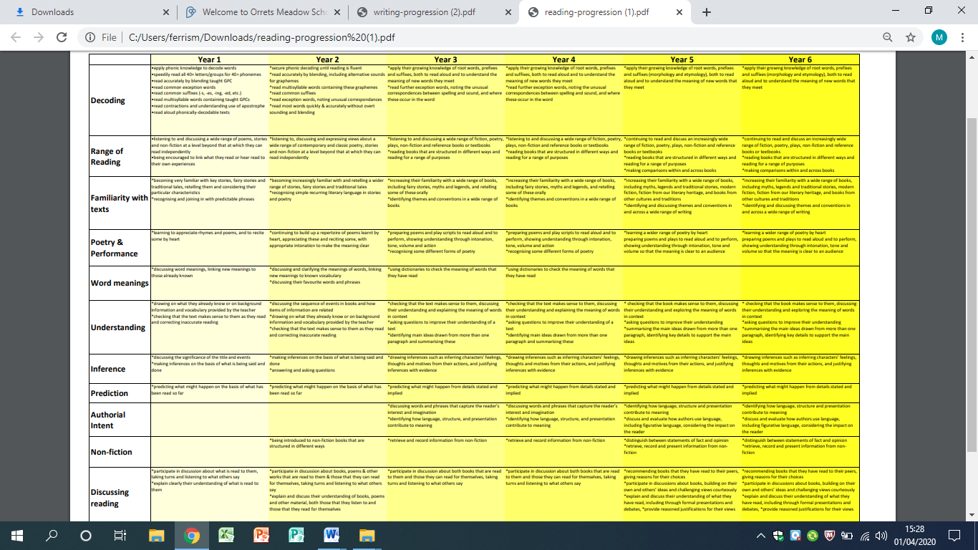

**Appendix 10: Progression of Writing**

