 | RA 029A School Opening Step 4 Road Map 19th July 2021 v1 | RISK ASSESSMENT  RECORDING FORM

Location or School - Orrets Meadow School  Address: | Date assessment  Undertaken 19/07/21 | Assessment undertaken  by : Jeanne Fairbrother AND CD
Activity or situation :  School Opening Step 4 Road Map 19th July 2021 | Review  date : ongoing review | Signature: C J Duncan

Background information
School Opening Step 4 Road Map 19th July 2021
The DfE guidance explains the actions school leaders should take to reduce the risk of transmission of coronavirus (COVID-19) in their school. It includes advice from Department of Health and Social Care (DHSC) and Public Health England (PHE).

This risk assessment applies to :
• primary schools
• secondary schools (including sixth forms)
• special schools, special post-16 providers and alternative provision
• 16 to 19 academies
• infant, junior, middle, upper schools

Please note that this risk assessment has been created in line with the current government guidance. It contains sample control measures that fit with the system of controls contained in Government guidance. One size does not fit all, and schools should make this model risk assessment their own and reflect any local guidance.

Guidance
This risk assessment has regard to all relevant guidance and legislation including, but not limited to, the following:
- The Health Protection (Notification) Regulations 2010
- The Reporting of Injuries, Diseases and Dangerous Occurrences Regulations (RIDDOR) 2013
- Public Health England (PHE) (2017) ‘Health protection in schools and other childcare facilities’
- NEW DfE (2021) ‘Schools COVID-19 operational guidance’ July 2021
- UPDATED DfE (2021) ‘Actions for early years and childcare settings during the coronavirus (COVID-19) outbreak’
- DfE (2021) ‘Face coverings in education’
- UPDATED ‘Actions for out of school settings’ July 2021

Legislation and guidance
Health and Safety At Work Act etc. 1974
Management of H&S at Work Regulations 1999
Workplace (Health, Safety and Welfare) Regulations 1992
DfE Actions for schools plus associated COVID 19 Guidance
Public Health England Guidance

1) Hazard / Activity | 2) Who can be harmed and how? | 3) What controls exist to reduce the risk?  Have you followed the hierarchy of controls (eliminate, substitute etc) | Risk Score  Consequence  X Likelihood | 4) Any further action;  This should be included in the action plan below (5)
Failure to assess the risks of COVID 19 transmission in school. | Staff, pupils, visitors, contractors increased risk of transmission of COVID 19 | - School has assessed the reasonably foreseeable risks of transmission of COVID 19  - The risk assessment is regularly reviewed as circumstances in school and the public health advice changes.  - School monitors whether the controls in place are effective and working as intended. | 3X2=6
Failing to have adequate outbreak management plans to allow for stepping measures up and down. | Staff, pupils, visitors, contractors increased risk of transmission of COVID 19 | - School has this risk assessment for following the new guidance from July 19th and a contingency plan risk assessment - for reverting to control measures in place prior to Step 4 if required to by Public Health.  - School has outbreak management plans outlining how to operate if there were an outbreak in school or local area.  - School will call the DfE helpline on 0800 046 8687 and select option 1 for advice on the action to take in response to a positive case who will escalate the issue to the local health protection team where necessary and advise if any additional action is required, such as implementing elements of the outbreak management plan.  - School will consult local Public Health Teams to contain any outbreak by following local health protection team advice below:  - local PH Helpline phone number to contact  - Wirral schools contact Wirral LA covid helpline 0151 666 3600 email: covidschoolsupport@wirral.gov.uk  - School will follow measures recommended by the Local Authority, Director of Public Health and local PHE health protection teams (HPTs) as part of our outbreak management responsibilities.  - From the date that school officially closes for summer, all MDS submissions will stop. From that point, Public Health and the Local Authority will be informed of any outbreaks via NHS T&T. | 3X2=6
Failing to manage mixing and ‘bubbles’ after 19th July. | Staff, pupils, visitors, contractors increased risk of transmission of COVID 19 | - School will continue with the current measures until the end of the summer term, 20th July, following measures in our RA 029 Step 3 COVID Road Map v9.3  - School has outbreak management plans in place to reintroduce bubbles temporarily if it becomes necessary due to local outbreaks or increases in cases at the instruction of PHE Teams.  - School has planned carefully following the latest DfE/PHE guidance and will follow all measures at a steady pace.  - Assemblies can be reintroduced again, but school will re-introduce this gradually. In September Assemblies will take place in the hall with doors and computer windows.  - Staggered starts, lunch and breaks to limit numbers do not need to take place.  - Staff do not need to work with only one group/bubble.  - Staff meetings in a larger, well ventilated space in the hall.  - Staffrooms – staff will have the choice to use the staffroom or the classroom for their breaks – masks are a personal choice and the door and windows can be opened to improve ventilation.  - Meetings, including with parents, teams, Zoom etc. may continue depending on the local situation and how the member of staff leading the meeting feels.  - Teaching or holding meetings in well-ventilated areas wherever possible, such as outdoors or indoors with windows open.  - Staff wearing a face covering when coming into contact with people in enclosed and crowded spaces will be their choice and will be respected. | 3X2=6
School failing to manage tracing close contacts and isolation after the 19th July. | Staff, pupils, visitors, contractors increased risk of transmission of COVID 19 | - School is still open at Step 4, 19th July and so school will continue with the current measures until the end of the summer term in relation to the management of cases and close contacts. See RA 029 Step 3 COVID Road Map v9.3  - School will cease contact tracing at Step 4, 19th July,  close contacts will be identified via NHS Test and Trace NB. Wirral Schools will provide 6 days cover for any ‘mop-up’ contact tracing from the date school closes as requested by Wirral PHE.  - From 16th August 2021, staff that are double vaccinated & pupils under the age of 18 years old will no longer be required to self-isolate if they are identified as a close contact of a positive case.  - If NHS Test and Trace informs under 18s they have been in close contact with a positive case, they will be advised to take a PCR test.  - School will continue to work with the local director of Public Health & local health protection teams in the case of a local outbreak and if the areas becomes an Enhanced Support Area. | 3X2=6
Face coverings use of face coverings including when to wear one, exemptions and how to make your own. | Staff, pupils, visitors, contractors increased risk of transmission of COVID 19 | - School will support any staff members, pupils or students that wish to continue to wear a face covering in communal areas even they will no longer be advised for pupils, staff and visitors either in classrooms or in communal areas. This has been communicated via staff communications on whatsapp and communication meetings.  - Pupils no longer need to wear face coverings on dedicated transport or on public transport.  - Face coverings will be reintroduced if there is an outbreak in school or if the Director of Public Health advises that face coverings should temporarily be worn in communal areas or classrooms (by pupils staff and visitors, unless exempt).  - School outbreak management plans cover this possibility.  - If face coverings are reintroduced:  - transparent face coverings can also be worn.  - Face visors or shields can be worn only after carrying out a risk assessment for the specific situation and should always be cleaned appropriately. | 3X2=6 | Communicate to all staff in Sept that the wearing of a mask is optional and is their choice and will be respected.
School fails to ensure good hygiene standards in school to reduce risk of transmission. | Staff, pupils, visitors, contractors increased risk of transmission of COVID 19 | - Hand hygiene - School will continue to ensure that staff & pupils clean their hands regularly with soap and water or hand sanitiser. Staff and children will be asked to continue using hand sanitiser as they enter school in the mornings or after breaks.  - Respiratory hygiene - The ‘catch it, bin it, kill it’ approach continues to emphasised.  - Use of personal protective equipment (PPE) Most staff in school do not require PPE beyond what they would normally need for their work.  See the use of PPE in education, childcare and children’s social care settings | 3X2=6
Failure to maintain appropriate cleaning regimes. | Staff, pupils, visitors, contractors increased risk of transmission of COVID 19 | - School will maintain appropriate cleaning regimes, using standard products such as detergents.  - Appropriate cleaning schedules are in place and include regular cleaning of areas and equipment – tables will continue to be wiped down throughout the day and products to clean with will continue to be available in each room.  See PHE guidance cleaning of non-healthcare settings. | 3X2=6
Failure to ensure all occupied spaces are well ventilated. | Staff, pupils, visitors, contractors increased risk of transmission of COVID 19 | - When school is in operation, it is well ventilated with comfortable teaching environments.  - Poorly ventilated spaces have been identified and doors and windows opened as best as possible to improve them.  - When holding events where visitors are on site, for example school plays, ventilation is increased.  - Mechanical ventilation is adjusted to increase the ventilation rate wherever possible and checked to confirm that normal operation meets current guidance and that only fresh outside air is circulated.  - Systems should be adjusted to full fresh air or, if this is not possible, then systems should be operated as normal as long as they are within a single room and supplemented by an outdoor air supply.  - All mechanical ventilation systems are maintained in accordance with the manufacturers’ recommendations.  - School opens external windows, doors & internal doors (if they are not fire doors and where safe to do so). To increase ventilation.  - During colder weather, the need for increased ventilation while maintaining a comfortable temperature is balanced.  - Outside space will be used, where practical.  See The Health and Safety Executive guidance on air conditioning and ventilation during the coronavirus outbreak & CIBSE COVID advice provides more information. DfE is working with the Scientific Advisory Group for Emergencies (SAGE) and NHS England on a pilot project to measure CO2 levels in classrooms and exploring options to help improve ventilation in settings where needed. | 3X2=6
School fails to follow public health advice on testing, self-isolation and managing confirmed cases of COVID-19. | Staff, pupils, visitors, contractors increased risk of transmission of COVID 19 | - Pupils, staff follow public health advice on when to self-isolate and what to do. & do not come into school if they have symptoms, have had a positive test result or other reasons requiring them to stay at home due to the risk of them passing on COVID-19 (for example, they are required to quarantine).  - If a parent or carer insists on a pupil attending, school can refuse the pupil if it is necessary to protect other pupils and staff from possible infection with COVID-19.  - If anyone develops COVID-19 symptoms, however mild, they are sent home and told to follow public health advice... PHE stay at home guidance for households with possible or confirmed coronavirus (COVID-19) infection.  - They should be collected from school, not use public transport.  - Pupils awaiting collection are left in a well-ventilated room on their own if possible and safe to do so.  - If close contact is required appropriate PPE is available & used & the room is cleaned afterwards.  See use of PPE in education, childcare and children’s social care settings guidance. | 3X2=6
Inadequate testing for close contacts under 18 | Staff, pupils, visitors, contractors increased risk of transmission of COVID 19 | - All Primary, Secondary and FE College age children should take a single PCR test.  - All Primary, Secondary and FE College Staff and pupils with a positive LFD test result should self-isolate in line with the stay-at-home guidance. They will also need to get a PCR test to check if they have COVID19. Whilst awaiting the PCR result, the individual should continue to self-isolate. | 3X2=6
Inadequate asymptomatic testing takes place | Staff, pupils, visitors, contractors increased risk of transmission of COVID 19. | - Primary School - pupils in year 6 and below do not need to test over the summer period unless they are transitioning into Year 7 AND they are attending a summer school/school-based holiday activity.  - School staff can still test over summer and lateral tests will be supplied.  See PCR test kits for schools and further education providers is available. | 3X2=6
Inadequate asymptomatic testing in specialist settings | Staff, pupils, visitors, contractors increased risk of transmission of COVID 19 | - School can provide minimal testing capacity on site to offer testing to pupils and students who are unable to test themselves at home.  See https://assets.publishing.service.gov.uk/government/uploads/system/uploads/attachment_data/file/999741/SEND_update_guidance_Step_4.pdf | 3X2=6
Confirmatory PCR tests failure to follow guidacne. | Staff, pupils, visitors, contractors increased risk of transmission of COVID 19 | - Staff and children with a positive rapid lateral flow test result self-isolate in line with guidance  - They will need to get a PCR test to check if they have COVID-19.  - They must isolate whilst awaiting the PCR result.  - If the PCR test is taken within 2 days of the positive rapid LFT, and is negative, it overrides the LFT and they can return to the setting, as long as the individual does not have COVID-19 symptoms | 3X2=6
Inadequate planning of school trips, drama, music and sporting activity leading to increased risk of transmission. | Staff, pupils, visitors, contractors increased risk of transmission of COVID 19 | - School trips, drama, music and sporting activity will resume in line with the relaxation of restrictions from Step 4.  - Sports provision All sports provision, including competition between settings, is planned and delivered in line with guidance on grassroot sports for public and sport providers, safe provision and facilities, and guidance from Sport England  - From the start of the new school term school can organise international visits  Some activities, however, can increase the risk of catching or passing on COVID-19. This happens where people are doing activities which generate more droplets as they breathe heavily, such as singing, dancing, exercising or raising their voices. The risk is greatest where these factors overlap, for example in crowded indoor spaces where people are raising their voices. In situations where there is a higher risk of catching or passing on COVID-19, schools should be particularly careful to follow the general guidance on keeping safe.  See https://www.gov.uk/government/publications/covid-19-response-summer-2021-roadmap/coronavirus-how-to-stay-safe-and-help-prevent-the-spread | 3X2=6
Pregnant staff inadequate measures in place | Staff, pupils, visitors, contractors increased risk of transmission of COVID 19 | DHSC will publish updated guidance before Step 4.  - An individual risk assessment is carried out for pregnant staff with appropriate risk mitigation in line with the latest recommendations from DHSC, PHE & RCOG | 3X2=6
CEV staff inadequate measures in place. | Staff, pupils, visitors, contractors increased risk of transmission of COVID 19 | DHSC will publish updated guidance before Step 4.  - Clinically extremely vulnerable (CEV) staff are no longer advised to shield but are encouraged to take extra precautions to protect themselves, and to follow the practical steps set out in the CEV guidance to minimise their risk of exposure to the virus.  - CEV currently attend their place of work if they cannot work from home.  - An individual risk assessment must be in place for all CEV staff. | 3X2=6
CEV pupil’s school has inadequate measures in place. | Staff, pupils, visitors, contractors increased risk of transmission of COVID 19 | - All CEV pupils and students attend their setting unless they are one of the very small number of pupils under paediatric or other specialist care and their GP or clinician has advised them not to attend.  - Pupils and students who live with someone who is CEV continue to attend school as normal.  See: https://assets.publishing.service.gov.uk/government/uploads/system/uploads/attachment_data/file/999741/SEND_update_guidance_Step_4.pdf | 3X2=6  .
Special schools - Home to school transport, inadequate measures in place. | Staff, pupils, visitors, contractors increased risk of transmission of COVID 19 | - School will speak to the local authority to find out if they will be making any changes to the measures in place for the autumn term & to request a copy of their updated risk assessment.  - Drivers and passenger assistants will not normally require personal protective equipment (PPE) on home to school transport.  - Pupils who require care and interventions that require the use of PPE before COIVD-19, will continue as usual. | 3X2=6
Parent and child groups in school - inadequate measures in place. | Staff, pupils, visitors, contractors increased risk of transmission of COVID 19 | - Primary school From Step 4, parent and child groups can operate as normal/without restrictions on attendance. | 3X2=6

Risk Rating | Action Required
20 - 25 | Unacceptable – stop activity and make immediate improvements
10 - 16 | Urgent action – take immediate action and stop activity, if necessary, maintain existing controls vigorously
5 - 9 | Action – Improve within specific timescales
3 - 4 | Monitor – but look to improve at review or if there is a significant change
1 - 2 | Acceptable – no further action but ensure controls are maintained & reviewed
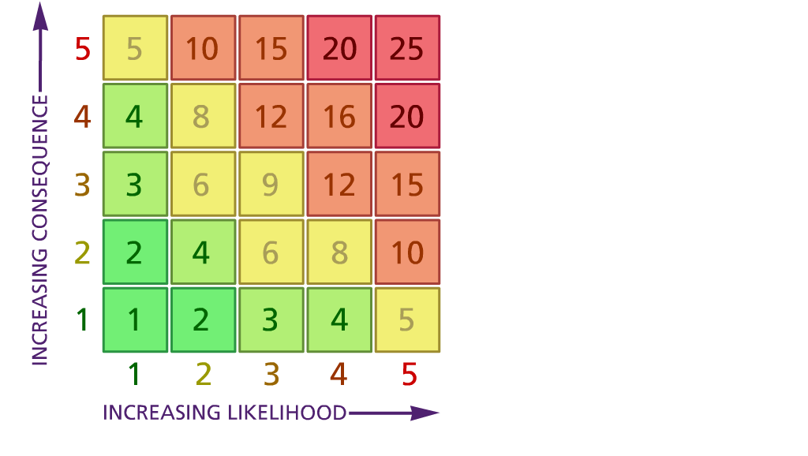

Likelihood: Consequence:

(1) List hazards something with the potential to cause harm here
(2) List groups of people who are especially at risk from the significant hazards which you have identified
- List existing controls here or note where the information may be found. Then try to quantify the level of risk the likelihood of harm arising that remains when the existing controls are in place based on the number of persons affected, how often they are exposed to the hazard and the severity of any consequence. Use this column to list the controls that you might take and develop all or some of that list into a workable action plan. Have regard for the level of risk, the cost of any action and the benefit you expect to gain. Agree the action plan with your team leader and make a note of it overleaf. If it is agreed that no further action is to be taken this too should be noted.
5 – Very likely 5 – Catastrophic

4 – Likely 4 – Major
3 – Fairly likely 3 – Moderate

2 – Unlikely 2 – Minor

1 – Very unlikely 1 – Insignificant

(5) ACTION PLAN

 | 5. Action plan | Responsible | Completed
1 | Communicate to all staff in Sept that the wearing of a mask is optional and is their choice and will be respected. | CD
2
3
4
5
6
 | Action plan agreed by – C Duncan 12/7/2021

