2nd November 2023
Dear Parent and Carers

A new half term and we start by thanking our previous head boy and girl, Riley and Luna for being fantastic role models and welcome our new head girl and boy, Mia and Tom, to the role. We aim to give as many of our Year 6 pupils the opportunity of being a leader as possible, as it promotes confidence, independence and self esteem.

Mental Health Champions
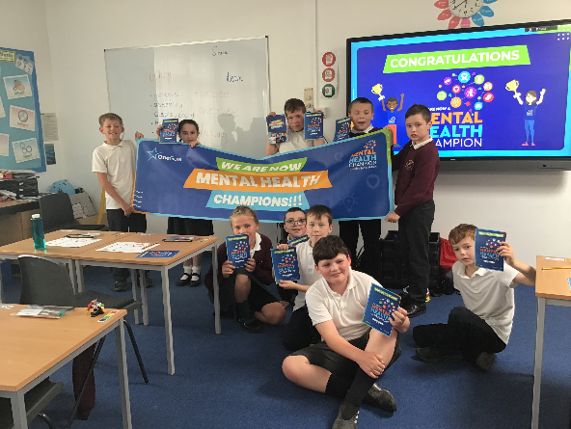
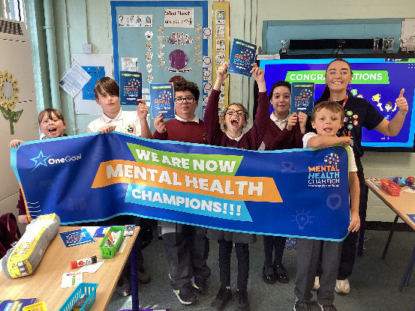
This week some of our classes took part in the mental health champion workshop. They learnt about positive mental health, relaxation techniques, how to cope with worry, how to support pupils struggling on the playground and how to promote being mentally healthy to others. Each child graduated at the end as a mental health champion! Photos are on facebook. It was a brilliant morning and supports our aim of being a positive mental health school.

Absence
Please remember to phone school before 9am each morning your child is absent. Please do not assume that by telling the escort we will receive the message. Michelle will call any family we have not heard from by 9am. Remember your child can still attend school with a cough or cold and we can give them Calpol.

Children in Need
This year Children in Need is on Friday 17th November. We would like them to come to school in pyjamas, as this is what School Council requested. Donations are requested for Children in Need. Please pass all donations to the escort or if you drop off, pass them to Michelle. Please remember their coat!

PE Kits
Please ensure your child has their PE kit in school. Can all items please be named.

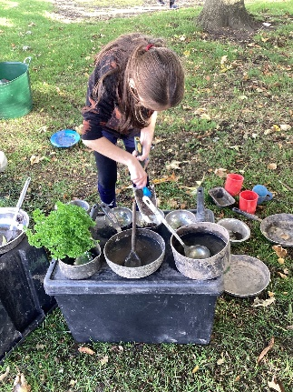
Forest Schools
Michelle from Nestlings comes into school every Thursday afternoon, to work with different classes for a 5 week block on Forest School skills. The children are able to come to school when it is their class’ turn in old clothes, to keep their uniform clean. The children have learnt bushcraft skills, social and life skills and being taught how to complete tasks which bring some risk in a safe way. The children are loving Forest Schools!! Giraffes and Zebras start their 5 week block on the 23rd November.
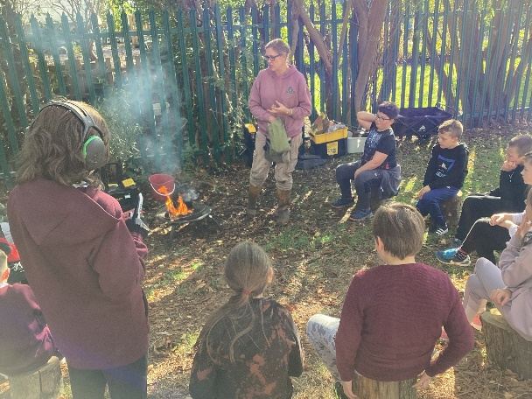
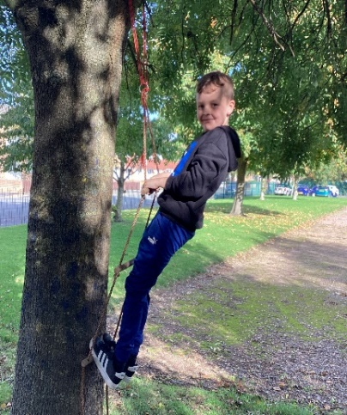
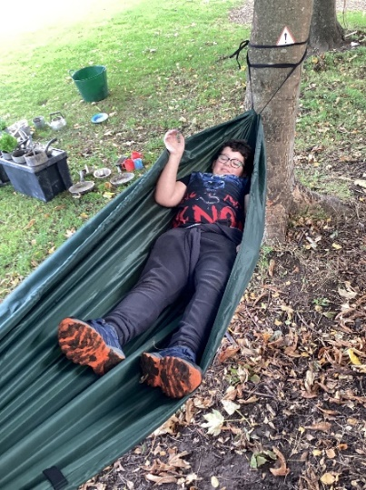

Bikeability
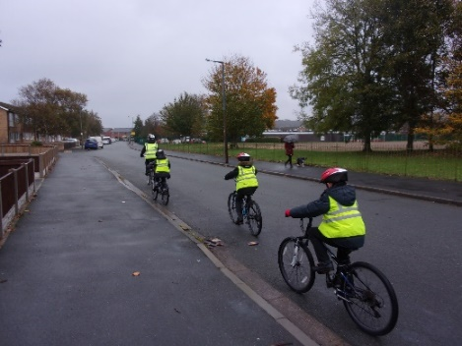
Year 6 pupils will take part in Bikeability this week. For some this will be learning to ride and for others this will be learning to ride on the road. School uniform as normal but please make sure your child wears a warm, waterproof coat. Being able to ride a bike safely is an important life skill, so if you can start practising this at a young age it will really help them. In the Spring and Summer Term we offer bike club at lunchtime to those who can ride a bike.

Coffee Morning
Our next coffee morning with Michelle is on Wednesday 15th November 10-11am. Letters have gone home today and it is on the school Facebook page.

November Dates for the Diary

8th November - Bikeability - children able to ride learn road safety
9th November - Bikeability - children able to ride learn road safety
10th November - Bikeabily – learn to ride
9th November - Forest schools – Foxes/Tigers week 4
10th November - Remembrance day – pupils will reflect together at 11am
15th November - Parent coffee morning with Michelle at 10am.
16th November - Forest schools – Foxes/Tigers week 5 (last one)
- Judo 5 week block starts – Sharks and Owls
- Tennis tournament @ Bidston Tennis – pupils to be decided
17th November - Children in Need Day – Come to school in PJs
- Whole school DT Day
- Camhs Parent coffee morning 10-11am
22nd November - Tennis tournament @ Clare Mount – pupils to be decided
23rd November - Forest schools – Zebras/Giraffes week 1
- Judo Week 2 – Sharks and Owls
30th November - Forest schools – Zebras/Giraffes week 2
- Judo Week 3 – Sharks and Owls

Please make sure you check your emails regularly as this is the way we send important information to you. Also, if you would like to see photos of your child taking part in all of the exciting enrichment activities we offer at school, then please follow us on Facebook.

Thanks for all your support.
If you have any questions about any of the above, please contact me.

Mrs Duncan

