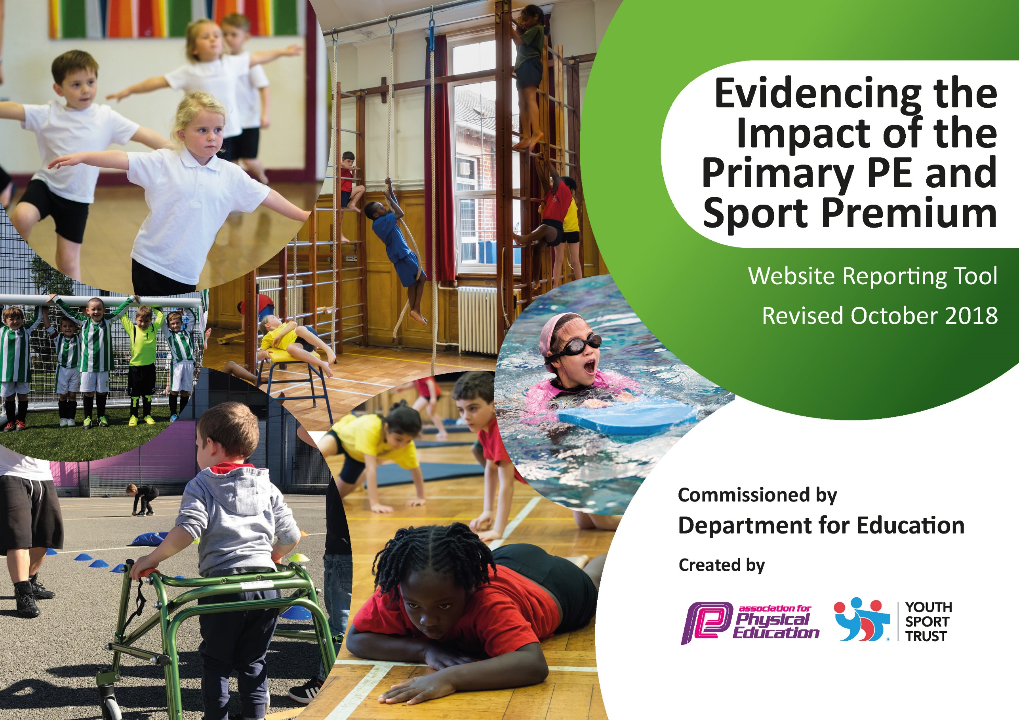
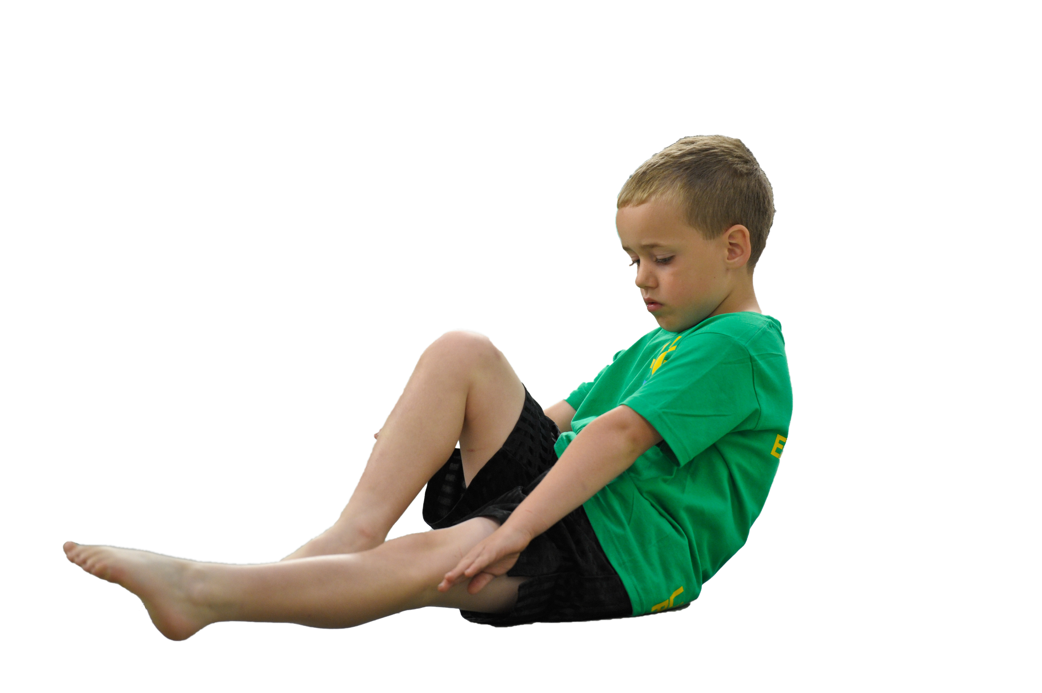
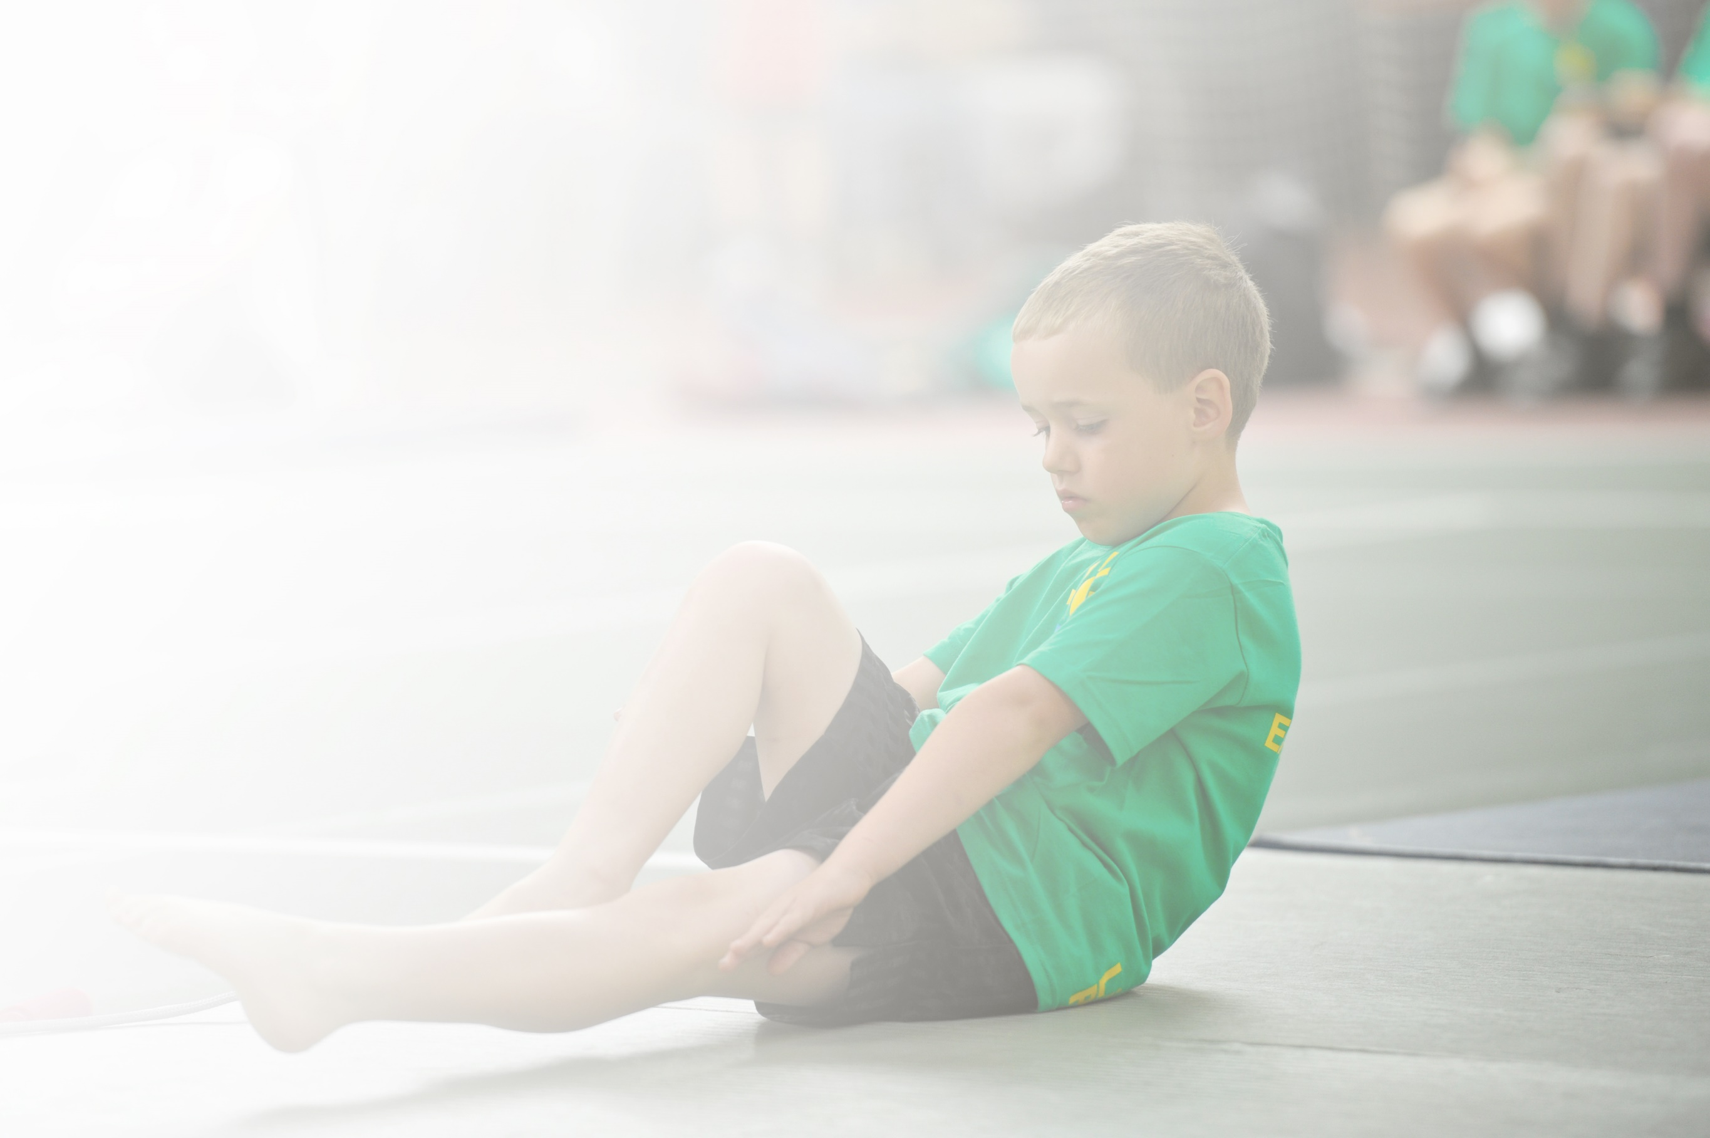
Schools must use the funding to make additional and sustainable improvements to the quality of Physical Education, Sport and Physical Activity (PESPA) they offer. This means that you should use the Primary PE and Sport Premium to:

- Develop or add to the PESPA activities that your school already offer
- Build capacity and capability within the school to ensure that improvements made now will benefit pupils joining the school in future years

Please visit gov.uk for the revised DfE guidance including the 5 key indicators across which schools should demonstrate an improvement. This document will help you to review your provision and to report
your spend. DfE encourages schools to use this template as an effective way of meeting the reporting requirements of the Primary PE and Sport Premium.

We recommend you start by reflecting on the impact of current provision and reviewing the previous
spend. Under the Ofsted Schools Inspection Framework, inspectors will assess how effectively leaders use the Primary PE and Sport Premium and measure its impact on outcomes for pupils, and how effectively governors hold them to account for this.

Schools are required to publish details of how they spend this funding as well as on the impact it has on pupils’ PE and sport participation and attainment by the end of the summer term or by 31 July 2019 at the
latest.
We recommend regularly updating the table and publishing it
on your website throughout the year, as evidence of your
ongoing review into how you are using the money to
secure maximum, sustainable impact. To see an
example of how to complete the table please
click HERE.

Support for review and reflection - considering the 5 key indicators from DfE, what development needs are a priority for your setting and your students now and why? Use the space below to reflect on previous spend, identify current need and priorities for the future.

Key achievements to date: | Areas for further improvement and baseline evidence of need:
- High profile of PE and sport (on school development plan since 2013; AfPE Quality Mark with Distinction 2017; Merseyside Sport Primary School of the year 2016)  - Increased staff knowledge and confidence in PE due to coaching and mentoring (evidenced by HMI best practice case study 2014)  - Increased participation and engagement (evidenced by School Games Award for past 4 years) | - Developing further the physical health and wellbeing provision across the school as identified by the School’s Health Education Survey (SHEU).

Meeting national curriculum requirements for swimming and water safety | Please complete all of the below:
What percentage of your current Year 6 cohort swim competently, confidently and proficiently over a distance of at least 25 metres?  N.B. Even though your children may swim in another year please report on their attainment on leaving  primary school. | 17%
What percentage of your current Year 6 cohort use a range of strokes effectively [for example, front crawl, backstroke and breaststroke]? | 4%
What percentage of your current Year 6 cohort perform safe self-rescue in different water-based situations? | 21%
Schools can choose to use the Primary PE and Sport Premium to provide additional provision for swimming but this must be for activity over and above the national curriculum requirements. Have you used it in this way? | No

Action Plan and Budget Tracking
Capture your intended annual spend against the 5 key indicators. Clarify the success criteria and evidence of impact that you intend to measure to evaluate for students today and for the future.

Academic Year: 2018/19 | Total fund allocated: £16330 | Date Updated: July 2019
Key indicator 1: The engagement of all pupils in regular physical activity – Chief Medical Officer guidelines recommend that primary school children undertake at least 30 minutes of physical activity a day in school |  |  |  | Percentage of total allocation:
 |  |  |  | Approx. 20%
School focus with clarity on intended impact on pupils: | Actions to achieve: | Funding allocated: | Evidence and impact: | Sustainability and suggested next steps:
Increase physical activity levels of children across the whole-school | - Pitch Hire  - Purchase storage for bikes  - Introduce bike maintenance  - HSBC Ready Set Ride Programme  - Use SHEU survey to offer new clubs to less active children  - Fit Fun Fests in partnership with Clare Mount Specialist Sports College designed for less active pupils | £1800  £500+sugar tax  £200  £150  Part of SLA (£3500) | - Pitch hire has allowed a wide range of activities to be provided. It has allowed all classes to receive min. 2 hrs PE per week and extra-curricular activities to continue  - Bike shed has been completed and bikes purchased  - Bike club and cycling on School Games Day has seen an increase in participants.  - SHEU survey informed introduction of dodgeball club, running club.  - Fit Fun Fests have helped to encourage less active children to become more active.  - Regular extra-curricular participation has risen to 69% from 37% (Mar 19)  - 99% of pupils have taken part in inter-school sports competition  - 100% of pupils have taken part in intra-school sports competition | - Bike purchase and maintenance will help continuation of HSBC Ready Set Ride programme to teach pupils to ride a bike. Bike club will run 5x30mins per week for up to 10 children for academic year 2019-20  - Partnership with Ash Coker (Edge Hill University) to measure OM fitness levels, educate children on health and fitness and improve fitness levels  - Continue to provide a wide range of PE and sport activities (informed by SHEU and pupil voice)
Key indicator 2: The profile of PESSPA being raised across the school as a tool for whole school improvement |  |  |  | Percentage of total allocation:
 |  |  |  | Approx. 20 %
School focus with clarity on intended impact on pupils: | Actions to achieve: | Funding allocated: | Evidence and impact: | Sustainability and suggested next steps:
Maintain high profile of PESSPA: further develop provision of PE and mental health (on SDP 2018-19)  Improve and support physical health, fitness and well-being of all pupils  Further develop leadership opportunities (main focus on girls) | - SDP includes PE and mental health as a priority  - PE report at governor’s meetings  - Termly PE staff meetings (focusing on different areas of CPD e.g. leadership, autism, STEP etc.)  - SHEU survey to highlight issues and trends and target support  - Mental Health and Keep Safe Week  - Thumbs Up Mental Health Intervention (CBT)  - Girls Active (YST) with aim of leading whole-school fun fitness sessions and raise activity levels | £2500 TLR  payment  £2500 TLR  release time  £3500 Clare  Mount Sports  College SLA  £150  £400  £4600  Using TLR release as above | - PE and mental health on agenda at all full governors meetings  - Active In Mind in partnership with CM began in June 2019. YST Athlete Mentor Neil Danns led Mental Health Ambassador training for Y6 pupils. Y6 pupils then worked with younger children during PE leadership activities. Ongoing with festival planned (July 2019)  - Staff CPD: following on from last training (leadership) – Girls Active programme running lunch clubs and wake and shake, Class 3 and 6 leadership festival (building on 5 weeks of leadership training), lesson obs reveal high quality leadership opportunities within curriculum lessons  - Staff received further CPD on autism in PE  - SHEU survey helped to identify trends within school and target support to individual and groups of pupils. Interventions such as Next Step, Change4Life clubs etc.  - Girls Active:  - Girls went to Clare Mount and joined lessons with Year 7 girls. Shared experiences, attitudes etc. and led each other through a sports festival  - Girls’ football festival at OM with JMU (March)  - They also led class and whole-school fun fitness sessions.  - Current number of children experiencing regular leadership opportunities (July 19): 46% | - YST My Personal Best to be introduced for academic year 2019-20.  - Active In Mind in partnership with CM began in June 2019 and will continue for the academic year 2019-20  - CPD Autumn 2019 –introduction to My Personal Best

Key indicator 3: Increased confidence, knowledge and skills of all staff in teaching PE and sport |  |  |  | Percentage of total allocation:
 |  |  |  | Approx. 20%
School focus with clarity on intended  impact on pupils: | Actions to achieve: | Funding  allocated: | Evidence and impact: | Sustainability and suggested  next steps:
To further develop the confidence, knowledge and skills of all staff.  To provide bespoke targeted support of PE and sport to meet the needs of staff. | - CPD: staff meetings and from external agencies through partnership with Clare Mount Specialist Sports College  - Coaching and mentoring from TLR and specialist PE staff  - Opportunities for peer lesson observations  - Staff to run extra-curricular sports clubs and activities | £3500  £2500 TLR  £2500 TLR release | - Staff CPD: following on from last training (leadership) – Girls Active programme running lunch clubs and wake and shake, Class 3 and 6 leadership festival (building on 5 weeks of leadership training), lesson obs revealed high quality leadership opportunities within curriculum lessons  - Staff received further CPD on autism in PE  - World In a Box Dance CPD: In partnership with Movema Dance School. 2 members of staff received training and are now beginning to roll out programme in and outside of lessons. OM TA (dance specialist) helped to cascade ‘World in a Box’ to other staff members and children throughout the summer term. Culminated in Class 2 and Class 3 performing in dance festival at Clare Mount in June. Exceptionally positive feedback from staff and pupils. Some of the most disadvantaged and vulnerable of our children took part.  - 6 members of staff have led extra-curricular sports clubs so far this year  - OM teacher visited Clare Mount to observe teaching of ASC pupils and girls in PE  - JW (CM specialist) led bespoke seated volleyball scheme of work with LB to one of our younger ASC classes who face numerous barriers to PE and sport. Very successful outcomes in terms of engagement, inclusion and progress | - Continue to cascade ‘World in a Box’ resource for whole-school during academic year 2019-20  - TA’s to receive CPD for autism in PE. Use Inclusive PE Training Portal.
Key indicator 4: Broader experience of a range of sports and activities offered to all pupils |  |  |  | Percentage of total allocation:
 |  |  |  | Approx. 20%
School focus with clarity on intended  impact on pupils: | Actions to achieve: | Funding  allocated: | Evidence and impact: | Sustainability and suggested  next steps:
Provide a range of sports and activities for all pupils.  Offer a range of opportunities which some children may never experience out of school.  Offer activities and links which promote lifelong physical activity and positive mental health. | - Curriculum enrichment (e.g. judo, bikeability, fencing, OAA etc.  - Extra-curricular festivals and event held by Clare Mount Sports College (e.g. BMX, in-line skating etc.)  - PE Assistant to run a range of extra-curricular clubs and support in lessons | £1000  £3500  £4000 | - Current number of activities offered to children (July 19): 22  - Curriculum enrichment: Judo, Dance; Military Education (not sports premium)  - Extra-curricular festivals e.g. Fit-Fun Fest (trampolining, Zumba, box-fit and tennis). These events involved 24 of our less-active pupils and gave them a range of opportunities they may never experience and which would help promote lifelong physical activity. One child (with ASC), who has never been to a sports club out of school, has now joined trampolining as a result.  - Girls Active:  - Girls went to Clare Mount and joined lessons with Year 7 girls. Shared experiences, attitudes etc. and led each other through a sports festival  - Girls’ football festival at OM with JMU (March)  - Led whole-class and wider-school fun fitness sessions | - YST ‘Active Across Ages’ programme academic year 2019-20. Children will be trained in new inclusive activities and then lead inter-generational activities.  - Curriculum enrichment (e.g. judo, bikeability, fencing, OAA etc.  - Extra-curricular festivals and events held by Clare Mount Sports College (e.g. BMX, in-line skating etc.)  - Employment of former PE apprentice as TA (with PE responsibility). Role includes running of extra-curricular clubs and competitions.
Key indicator 5: Increased participation in competitive sport |  |  |  | Percentage of total allocation:
 |  |  |  | Approx. 20%
School focus with clarity on intended  impact on pupils: | Actions to achieve: | Funding  allocated: | Evidence and impact: | Sustainability and suggested  next steps:
Increase the overall number of children participating in competitive sport. | - SHEU survey results to signpost children to their favourite activities and help design programme of events  - Clare Mount Sports College events  - Fit Fun Fests  - School Games Day and Level 1/2 events  - Girls Active programme | £150  £3500 | Current participation in competitive sport (July 19):  - Regular extra-curricular participation has risen to 69% from 37% (Mar 19)  - 99% of pupils have taken part in inter-school sports competition  - 100% of pupils have taken part in intra-school sports competition | - Continue to offer wide range of activities and use SHEU survey data to inform planning of event  - SSOC (School Sport Organising Committee) training to help child-centred provision and planning

