 | RA 029 – Schools (Primary & Secondary) National Restrictions Addendum v1 | RISK ASSESSMENT  RECORDING FORM

Location or School Orrets Meadow School  Address: | Date assessment  Undertaken 9/11/2020 | Assessment undertaken  by : Jeanne Fairbrother AND C Duncan
Activity or situation:  Schools (Primary & Secondary) - National Restrictions 5th November – 2nd December 2020 | Review  date : ongoing review | Signature: C Duncan

These are a temporary set of measures which sit alongside your latest version RA 029 Full opening of school.

New National Restrictions came into force on Thursday 5 November until 2nd December 2020. Schools have until 9th November to put these into place at the latest.
This addendum reflects new control measures Schools -Primary & Secondary in the following areas which will be affected during the period of the New National Restrictions:
- use of face coverings
- transport
- clinically extremely vulnerable staff & children
- clinically vulnerable staff & children
- wraparound provision and extra-curricular activity
- music, dance & drama
- physical activity in schools
- residential care
Background
Schools continue to remain open for all children and young people as they have since the start of the autumn term for the duration of the national restrictions.
Being at school is vital for children’s/pupils education and for their wellbeing. Time spent out of school is detrimental for children’s/pupils cognitive and academic development, particularly for disadvantaged children. This impact can affect both current levels of education, and children’s/pupils future ability to learn. It continues to be our aim that all pupils, in all year groups, remain in school full-time.
The risk to children themselves of becoming severely ill from coronavirus (COVID-19) is very low and there are negative health impacts of being out of school. For the vast majority of children, the benefits of being back in the classroom far outweigh the low risk from coronavirus (COVID-19) and schools can take action to reduce risks still further.
We published actions for schools during the coronavirus (COVID-19) outbreak guidance to support schools to welcome back all children from the start of the autumn term.
Schools should continue to undertake risk assessments and implement the system of controls set out in this guidance. These measures provide a framework for school leaders to put in place proportionate protective measures for pupils and staff. If schools follow the guidance and maximise control measures, they can be confident they are managing risk effectively.
We would expect schools to ensure any changes required in light of national restrictions are in place as soon as practically possible, and by Monday 9 November at the latest.

1) Hazard / Activity | 2) Who can be harmed and how? | 3) What controls exist to reduce the risk?  Have you followed the hierarchy of controls (eliminate, substitute etc) | Risk Score  C X L | 4) Any further action
Face coverings – failure of visitors, staff to wear a face covering according to guidance | Staff, pupils, parents, visitors increased risk of transmission of Coronavirus (COVID 19) | Primary schools and education settings teaching year 6 and below,  - no change to the existing position. It is not mandatory for staff and visitors to wear face coverings. However at Orrets Meadow we have decided that all staff (unless exempt) will wear masks outside their bubbles.  - In situations where social distancing between adults in settings is not possible (for example when moving around in corridors and communal areas), settings have the discretion to recommend the use of face coverings for adults on site, for both staff and visitors. | 3X2=6
Transport- increased risk of transmission failing to follow guidance | Staff, pupils, parents, visitors increased risk of transmission of Coronavirus (COVID 19) | - School follows the transport guidance when arranging transport to and from schools from the autumn term.  - Travel in or out of local areas should be avoided, and parents, carers and staff should look to reduce the number of journeys they make - but travelling to deliver and access education is still permitted.  - Staff, children and their parents and carers are encouraged to walk or cycle when travelling to and from school where this is possible, and to plan ahead and avoid busy times and routes on public transport. This will allow social distancing to be practised. | 3X2=6
Visitors to the setting increasing the risk of transmission | Staff, pupils, parents, visitors increased risk of transmission of Coronavirus (COVID 19) | - The setting will restrict all visits to the setting to those that are absolutely necessary.  • Visits that allow a vulnerable child to meet a social worker, key worker or other  necessary support will continue on site. | 3X2=6
Clinically extremely vulnerable Children at increased risk of contracting Covid 19 | Staff, pupils, parents, visitors increased risk of transmission of Coronavirus (COVID 19) | - Most children originally identified as clinically extremely vulnerable no longer need to follow original shielding advice.  - Parents advised to speak to their child’s GP or specialist clinician if they have not already done so, to understand whether their child should still be classed as clinically extremely vulnerable.  - Those children whose doctors have confirmed they are still clinically extremely vulnerable are advised not to attend childcare or nursery during the period this advice is in place.  - Children who live with someone who is clinically extremely vulnerable, but who are not clinically extremely vulnerable themselves, should still attend education or childcare.  - Where a meeting with a GP or specialist clinician has not taken place, the public health advice is that the child is still clinically extremely vulnerable and should not attend school. In these situations, schools must offer clinically extremely vulnerable children access to remote education.  - Parents of clinically extremely vulnerable children will be receiving a letter shortly confirming this advice. | 3X2=6
Clinically extremely vulnerable  Staff Children at increased risk of contracting Covid 19 | Staff, pupils, parents, visitors increased risk of transmission of Coronavirus (COVID 19) | - Those individuals who are clinically extremely vulnerable are advised to work from home and not to go into work. Individuals in this group will have been identified through a letter from the NHS or from their GP and may have been advised to shield in the past. Staff should talk to their employers about how they will be supported, including to work from home where possible, during the period of national restrictions.  - All other staff should continue to attend work, including those living in a household with someone who is clinically extremely vulnerable. | 3X2=6
Clinically vulnerable staff and children at increased risk of contracting Covid 19 | Staff, pupils, parents, visitors increased risk of transmission of Coronavirus (COVID 19) | - Staff and children who are clinically vulnerable or have underlying health conditions but are not clinically extremely vulnerable should continue to attend school in line with current guidance.  - School will carry out a risk assessment on each member of staff identified as clinically vulnerable | 3x2=6
Extra-curricular activities increased risk of contracting Covid 19 | Staff, pupils, parents, visitors increased risk of transmission of Coronavirus (COVID 19) | - School will continue to offer before and after school educational provision to their pupils (including PE, sport, music, dance and drama), and may also provide other supervised activities for children where it is reasonably necessary to enable their parents or carers to work, seek work attend education or training, or where the provision is to support respite care (for vulnerable children).  - Parents are advised that they should only be using them for these purposes.  - School may also continue to use external providers to offer these activities but will request risk assessments from them to ensure they operate within the protective measures outlined in the relevant government guidance, such as the actions for schools during the coronavirus (COVID-19) outbreak and protective measures for holiday and after-school clubs and other out-of-school settings guidance. | 3x2=6
Music, dance and drama  Increased risk of transmission from not following guidance | Staff, pupils, parents, visitors increased risk of transmission of Coronavirus (COVID 19) | - Music, dance and drama can be undertaken in school so long as safety precautions are undertaken. Advice is provided in the full opening guidance for schools.  - School will continue to offer before and after school educational provision to their pupils (including PE, sport, music, dance and drama), and may also provide other supervised activities for children where it is reasonably necessary to enable their parents or carers to work, seek work attend education or training, or where the provision is to support respite care (for vulnerable children).  - Parents are advised that they should only be using them for these purposes. | 3X2=6
Sport and physical education Increased risk of transmission from not following guidance | Staff, pupils, parents, visitors increased risk of transmission of Coronavirus (COVID 19) | - School has the flexibility to decide how physical education, sport and physical activity will be provided whilst following the measures in their system of controls.  - Only sports whose national governing bodies have developed guidance under the principles of the government’s guidance on team sport and been approved by the government are permitted.  - School will only provide team sports listed on the return to recreational team sport framework.  - Competition between different schools should not take place, in line with the wider restrictions on grassroots sport.  - Pupils will be kept in consistent groups and sports equipment thoroughly cleaned between each use by different individual groups.  - Outdoor sports are prioritised where possible, and large indoor spaces used where it is not, maximising natural ventilation flows (through opening windows and doors or using air conditioning systems wherever possible), distancing between pupils and paying scrupulous attention to cleaning and hygiene.  - School is able to work with external coaches, clubs and organisations for curricular activities where they are satisfied that it is safe to do so.  - School has considered carefully how such arrangements can operate within our wider protective measures.  - See also https://www.gov.uk/guidance/working-safely-during-coronavirus-covid-19/providers-of-grassroots-sport-and-gym-leisure-facilities  - School remains open and children can participate in PE and sport where it is part of the curriculum or part of the core timetable of the school. | 3X2=6

Risk Rating | Action Required
17 - 25 | Unacceptable – stop activity and make immediate improvements
10 – 16 | Tolerable – but look to improve within specified timescale
5 – 9 | Adequate – but look to improve at review
1 – 4 | Acceptable – no further action but ensure controls are maintained
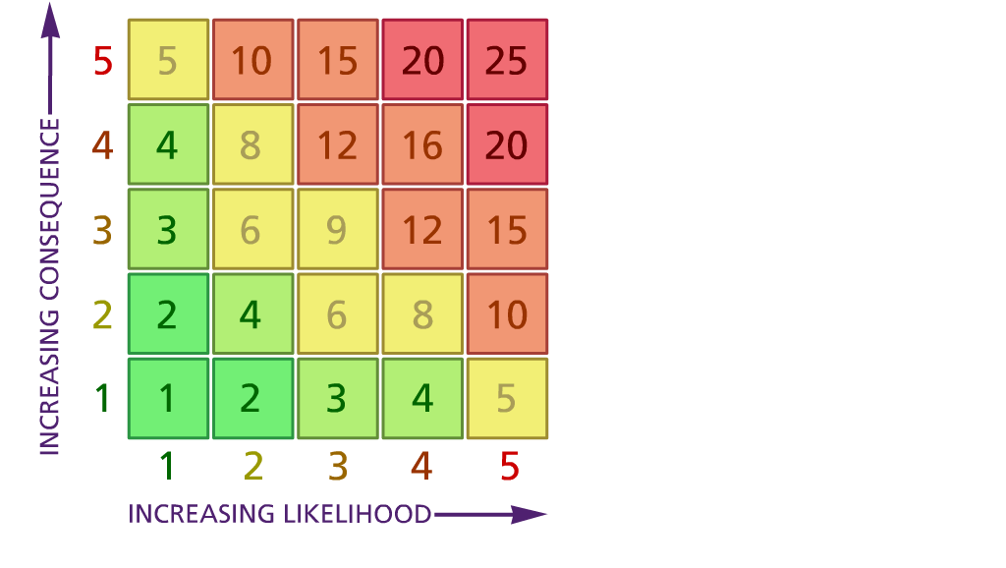

(1) List hazards something with the potential to cause harm here
(2) List groups of people who are especially at risk from the significant hazards which you have identified
- List existing controls here or note where the information may be found. Then try to quantify the level of risk the likelihood of harm arising that remains when the existing controls are in place based on the number of persons affected, how often they are exposed to the hazard and the severity of any consequence. Use this column to list the controls that you might take and develop all or some of that list into a workable action plan. Have regard for the level of risk, the cost of any action and the benefit you expect to gain. Agree the action plan with your team leader and make a note of it overleaf. If it is agreed that no further action is to be taken this too should be noted.

Likelihood: Consequence:

5 – Very likely 5 – Catastrophic

4 – Likely 4 – Major
3 – Fairly likely 3 – Moderate

2 – Unlikely 2 – Minor

1 – Very unlikely 1 – Insignificant

(5) ACTION PLAN
Action required: | Responsible person | Completion date
Action plan agreed with (signature) Date

